Curriculum Vitae

PERSONAL INFORMATION
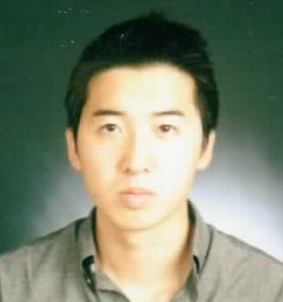
Title: Mr.
Name: Tony Suh
Address: Yongin-si, Suji-gu, Jukjeon-dong
Telephone Number: 010-9676-2476
E-mail: tonydhsuh@gmail.com

education
Date: October 23rd, 2010
Location: Waterloo University, Ontario, Canada
Degree (to be) obtained: 4-Year Honours Bachelor of Arts
Major: Psychology
Dissertation/Thesis: The role of self- serving attribution bias in the coping process &
Electrodermal and heart rate responses to positive and negative commercials

teaching experience
Title: English Teacher
Date: October 2010
Course: English
Location: Seohyun, Bundang
Responsibilities/ Worked as a substitute teacher for Cornerstone International School
Accomplishments: (CIS), teaching 1000 minutes within a span of four days. Was responsible for teaching English to kindergarteners and elementary school students. A high level of performance was demonstrated by being considered as a strong candidate for future job openings.

Title: English Tutor
Date: April 2007 – July 2010
Course: English & Science
Location: Toronto, Ontario
Responsibilities/ Responsible for meeting student needs when they are challenged beyond
Accomplishments: their academic capabilities. Specific duties included helping students to accurately interpret texts, to write correctly, to converse formally, and to guide essay writing. High level of performance demonstrated by parental satisfaction and tutees successful entries into universities.
VOLUNTEER experience
Title: Basketball Instructor
Date: April 2007 – July 2007
Location: Toronto, Ontario
Responsibilities/ Coached a group of students on the fundamentals of basketball. Specific
Accomplishments: duties included, leading various basketball drills, instructing students on how to shoot, pass and dribble, and demonstrating correct ways to execute team plays.

Title: Games Instructor
Date: July 2006
Location: Toronto, Ontario
Responsibilities/ Was responsible for leading and organizing games for children around the
Accomplishments: ages of 5 to 13. Specific duties included communicating rules and instructions to be understood by different age groups, creating an interactive atmosphere where everyone is involved and having fun, and to make certain no one is hurt during the process.

OTHER INFORMATION
Citizenship: Canadian
Languages: Native English speaker with good command of Korean
Current Visa: F4
Interests/Activities:
- Was an active member of the Psychology Student Association (PSA); often organizing dinner plans with professors to network, and to discuss possible thesis topics for opportunities in graduate school.

- Was part of the executive team for the Korean Christian Fellowship (KCF) at the University of Waterloo, we organized events and lead activities for students to enjoy.

- Participated in a small neighbourhood book club organized by university students. We gathered together once a month to discuss and share our thoughts on the books we read.

