CURRICULUM VITAE
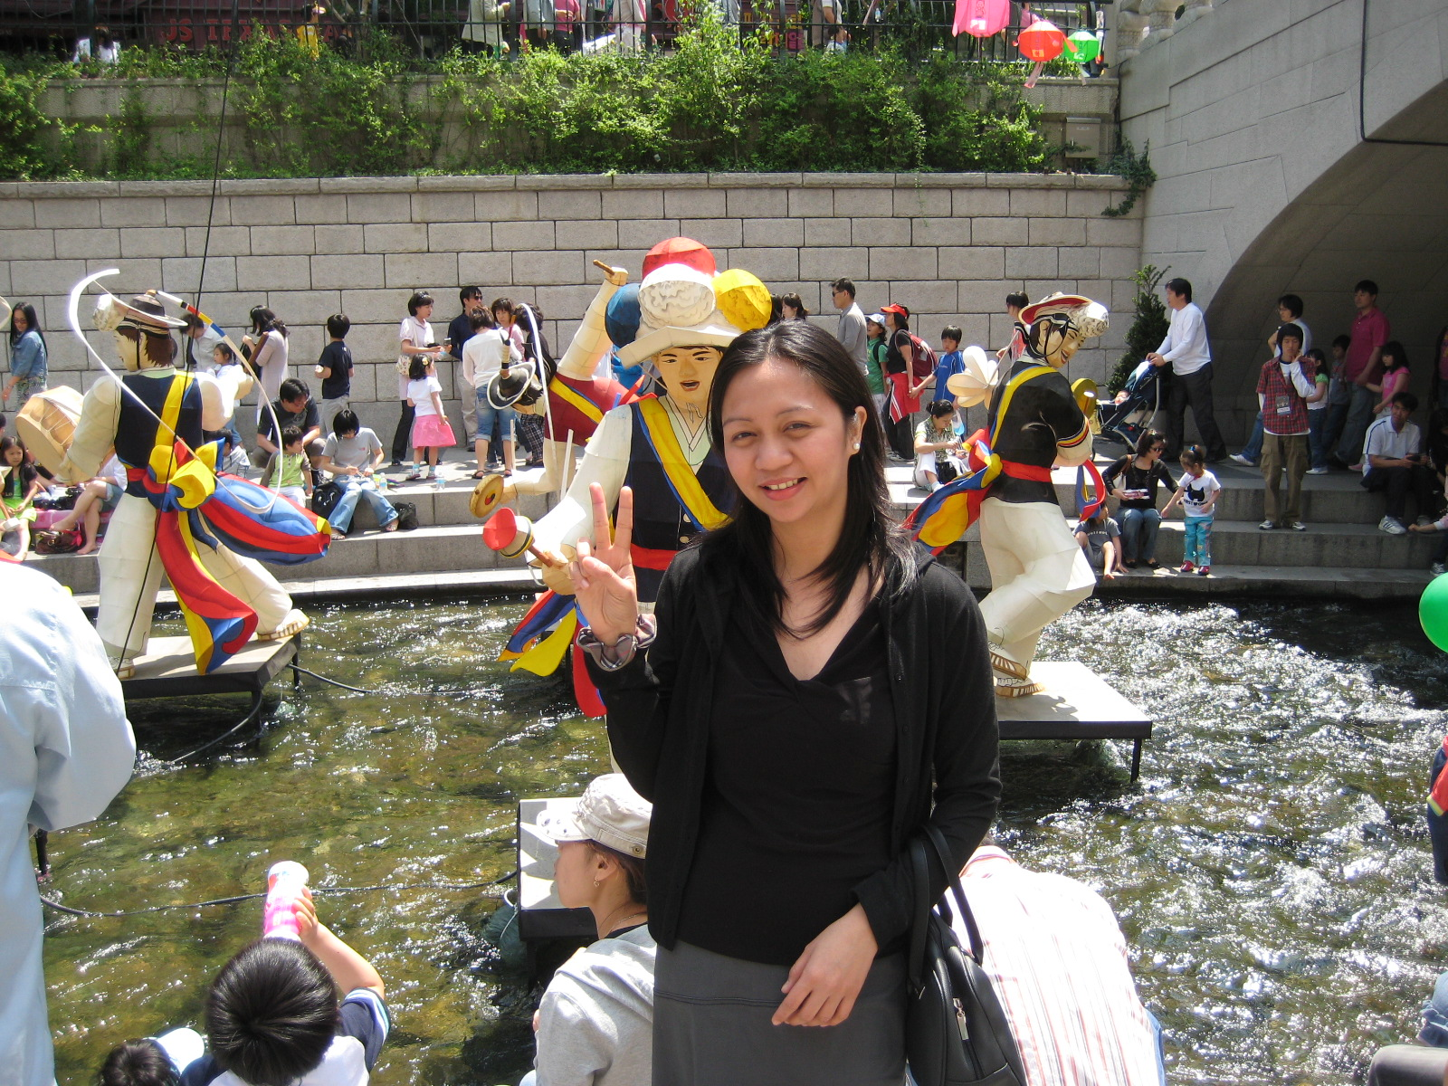

APRIL ROSALYN D. ESTORES
632-2 TS Apt. 3, 302dong 702, Samsung-dong, Yangju-Si, Gyeonggi-Do
Telephone: 010-4452-5015
Date of Birth: July 21, 1979
Nationality: Filipino
Marital Status: Married
EDUCATION
Sahmyook University Graduate School
Seoul, South Korea
Master in Public Health (MA)
March 2008-present

University of the Philippines
Iloilo City, Philippines
BA major in Broadcast Communication and Management
June 1996 - April 2000

TEACHING EXPERIENCES
Mc Graw-Hill Language Academy (MLA)
Yangju City, South Korea
English Teacher – (Kindergarten/Elementary/Middle School)
Subjects in English: Grammar, Conversation, Writing, Math, Science etc.
November 2007 – present

Special Projects:
Speech contest coaching
Toeic Bridge Test Review for Elementary Level
Organized a Christmas Talent Show for Kindergarten
Activity classes for Kindergarten once a week
Organized a Halloween Party for all grades
(Academy website available for reference upon request)

Yangju City English Literacy Program to the Philippines
* a government funded English Literacy program by the Yangju City, S. Korea Public Office.
Ayala-Alabang, Philippines
Head Teacher
Facilitates everyday operations, class schedule management, lesson planning and consultation for English teachers, create performance evaluation reports of student’s progress, teaching English subjects: Grammar, Writing, Listening etc.
June 2006- September 2007

Special Projects:
Term-ender video for parents’ presentation (available for viewing upon request)
Field Trip organizer/tour guide

SKILLS/INTERESTS:
Books, Literature, Movies, Internet, Blogging
Fluent in spoken and written English
Scriptwriting for radio/TV
With experience creative productions
Knowledgeable in organizational work and research
With field work & telemarketing experience
Knowledgeable in computer hardware configurations
Proficient in MS Office applications

