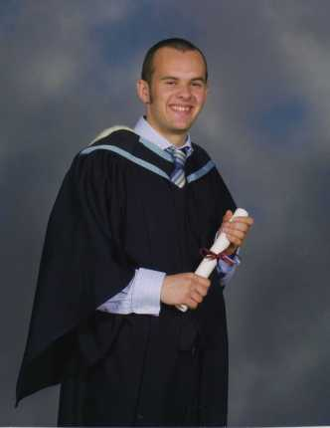 C O N N L A H O U L A H A N
Date of birth : 21st November 1982
Home : Yeongtong, Gyeonggi-do. Korea
Telephone : 01056939048
Mobile : 01056939048
Nationality : Dual – Irish, English
Email : h10houly@hotmail.com

Statement:
I am enthusiastic motivated, conscientious and hard-working. I can work effectively own my own or collectively as part of a team.

Attributes & Skills
Good Interpersonal Skills
Good Communication Skills
Flexible
Computer literate

Job Roles

Goodtree International Character School Mealal Yeongtong and Jamsil.
Position- English Teacher Kindergarten and Elementary

- Co-ordinate and plan daily lessons
- Teach English as a foreign language
- planning, preparing and delivering lessons to Kindergarten and elementary children
- marking/providing appropriate feedback on oral and written work
- devising and writing new materials
- supporting school in all activities
- participating in marketing events for the school
- teaching one to one

October 2002- Sept 2006
Position- Customer Service and Trade Supervisor
Sainbury’s Armagh

- Co-ordinate and controlled daily task/duties.
- Provided supervision of staff ensuring all staff rotas were adequately covered.
- Enhanced employee performance and attendance through daily mentoring, one-to-one discussions and weekly team meetings.
- Provide a quality customer service through interacting with customers and dealing with and dealing with all queries and problems.
- Inventory management- Stock Controls, Ordering of stock, Stock replenishment
- Worked closely with suppliers, both face-to-face and telephone queries and orders.
- Internal Marketing- displaying advertising/promotional information.
- Assist with administration, ensuring all relevant paperwork is completed correctly.
- Comply with Health and Safety standards within the store, as laid down in the Health and Safety at Work Order (NI) 1978, including COSHH Regulations.

November 1998- March 2002
Armagh City Film-house
Supervisor
- My roles included directly dealing with patrons, while ensuring high level of service and customer care
- Accounting for stock, cash and inventory
- Supervision of staff ensuring Cleanliness of the Cinema
- Monitoring of specific areas of the Film-house
- Operating cash registers to accept bookings

Education
1994-2001
St. Patrick Grammar Armagh
- 10 GCSE’s including Mathematics, English, Double Award Science, History, Information Systems, French, Religious Studies, Physical Education and English Literature.

- Three A-Levels- Ancient History (a), English (c) and Religious Studies (d).

2001-2005
Queens University Belfast
- BA Major/Minor Ancient History And Modern History

Interests/Life Skills
Work Experience Teaching (Armagh C.B.P.S)
Teach & Play musical instrument
Coached Basketball
Play and Coach Gaelic Football & Soccer
Travelled and Lived Abroad

References
Available on request.

Experience
I graduated from Queen's University Belfast with a Degree in Ancient History and Modern History. After this I spent one year working in a large business called J.S. Sainsbury as a Supervisor in Stock Control and Warehouse. I continued on after this year of work with one year of travelling to South-East Asia and Australia. I found this to be very beneficial in helping me decide what I wanted to do in my future career. I found it fascinating to see new cultures and new places and also to find myself. After a years long travelling I decided that I wanted to give something back to these regions and in particular Asia, it was then that I decided that teaching English would be captivating for me and also a stepping stone in the direction of my ambition to teach Primary School children. I took a position teaching kindergarten and elementary in Yeongtong, Suwon. I am thoroughly enjoying my time and would like to extend my experience. I have thought long and hard about this extension and I am excited about a new challenge. My experience working at home, travelling and now teaching in Korea have really given me lots of experience. I feel very comfortable teaching and strive to become a better teacher all the time. I work hard and take every task seriously. I have touched on every aspect of teaching and have thought meticulously about my skills and my personality and feel that both teaching away in a foreign country as well as teaching full-time at home is what I want and also what I believe is the future for me. This is why I intend to teach English in Korea for a longer period of time and then after my time undertake my final year of study to become a teacher of Primary School Children, in order to gain more information about teaching I am currently looking to undertake a TEFL Course (Teaching English as a Foreign Language).

Availability

April 2009.

