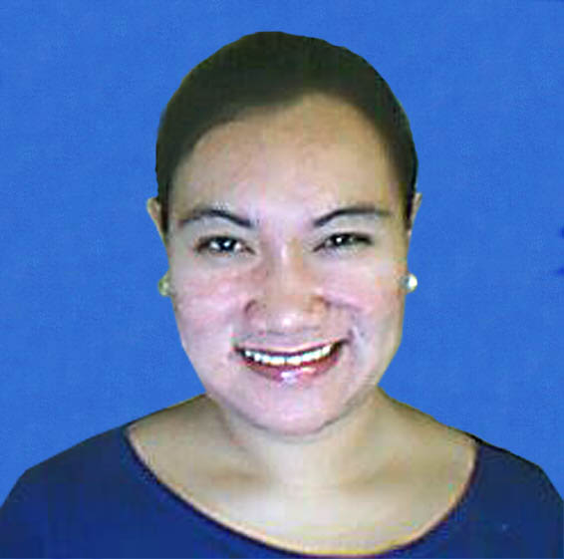
JACQUELINE M. ESCONDO
313 San Roque St. Cabrera Pasay City Contact No.: 02-8432830 /0917-8719691
Professional License Number:0952418 E-mail: Jacqueline_727@yahoo.com.ph

Job Objective: To contribute my skills, knowledge and ideas and help in the molding of children’s capabilities to become a productive person for the next generation.

WORK EXPERIENCES

COMPANY POSITION FROM-TO

HownWhy Global ESL Teacher September2008 – present
- Teaching grammar, reading and TOEFL to Korean students in various ages.
- Preparing lesson materials and test as well.

Freelance (man-to-man) Private tutor to Korean April 2008 – August 2008
- Teaching and enhancing students grammar, reading and comprehension

Roxas College Classroom Teacher April 2007 – March 2008
- Teach various subjects to elementary department and also a part-time English teacher in College department.

HowTalk Group International ESL Teacher May 2006-February 2007
- Teaching and enhancing student’s grammar, reading and comprehension in various age.
- Making Quality assessment, evaluating and coaching new teachers.

Part-time Private tutor to Korean October 2006 - February 2007
- Teaching and enhancing students grammar, reading and comprehension

Lexter Printing Corp. Office Staff October 2004 - July 2005
- Accepting calls, making job order, encoding and other related clerical work.

RL Hotel Coffee Shop Attendant May 2003-October 2004
- Cashiering, do food preparation and food serving

EDUCATIONAL ATTAINMENT:

SCHOOL YEAR GRADUATED
TERTIARY: Jose Rizal University 2006
COURSE: Bachelor in Elementary Education major in English
SECONDARY: Blessed Elena Academy 2000
ELEMANTARY: Blessed Elena Academy 1996

CO-CURRICULAR ACTIVITIES:
- Young Educators Society (Member)

PROFESSIONAL ORGANIZATION:
- National Organization of Professional Teachers Inc.

TRAINING

SCHOOL
On-Campus Training Jose Rizal University Elementary Department
November 2005-January 2006
Off-Campus Training Plainview Elementary School
January-February 2006

PERSONAL INFORMATION:

DATE OF BIRTH: March 3, 1983
PLACE OF BIRTH: Quezon City
CITIZENSHIP: Filipino
HEIGHT: 5’6
WEIGHT: 150 lbs.

SPECIAL SKILLS
- Proficient in MS Office application and Internet browsing. Playing volleyball and badminton, cross-stitching and singing, knowledgeable in lay-outing and Adobe Photoshop.

SEMINARS ATTENDED

Attitudes that Attracts Success
- HowTalk Group International. 17th flr. Trafalgar bldg.
H.V. Dela Costa Makati City
- November 2, 2006

Seminar for Demonstration Teaching
- Jose Rizal University Student lounge
- September 3, 2005

Lesson Planning Expo 2005 A series of seminar (History Subject)
- JRU Audio - Visual Room
- January 22, 2005

Lesson Planning Expo 2005 A series of seminar (English Subject)
- JRU Audio - Visual Room
- January 18, 2005

CHARACTER REFENCES

Ms. Irene Alca
- Manager
- HownWhy Global

Ms. Ives Ilagan
- Manager
- HowTalk Group International

Dr. Chenita Dapito
- Professor, Adviser of Young Educators Society
- Jose Rizal University

I hereby certify that the above information are true and correct to the best of my knowledge.
Thank you!

Sincerely yours,

Jacqueline M. Escondo

20 years old to travel
Side by side level 1 unit 8 25 minutes
Link
Monday 5pm

