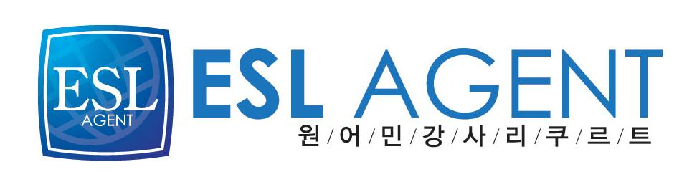
이에스엘 에이전트
김경이 팀장(Julie Kim)
02-2675-0582

Erica M. Lefstein
Levittown, NY 11756

Objective

My objective is to obtain a position as an educator with a focus in English.

Certifications

International TEFL Teacher Training
South Korea
August 2007

Experience
English Teacher, April 2009-April 2010
Dongsan Middle School, Incheon, South Korea
- Teacher of English grammar and vocabulary
- Teacher of conversational English
- Prepare lessons that will assist students in being able to survive in an English speaking environment
English Teacher, 2007
LCI Kids Club, Incheon, South Korea

• Taught basic English vocabulary, phonics, and reading to kindergarten and elementary
aged students.
• Prepared lessons according to syllabus.
• Created and administered written and verbal tests on a monthly basis.
• Administered placement tests to incoming students
• Assessed student performance throughout the term.
• Chaperoned field trips

Relevant Interests
Reading is an activity that gives me great pleasure. The opportunity to teach others how
to do the same would be a rewarding experience.

Education
Master of Science, Adult Education, 2005
Buffalo State College, Buffalo, NY

Bachelor of Arts, Psychology, 2003
Buffalo State College, Buffalo, NY

