Grace Melanie Harry
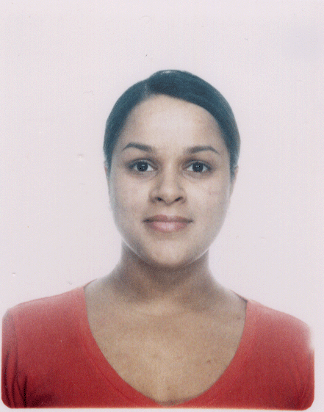
Email: graceharry@gmail.com

Personal Details

Birth: Jamaica, 11/12/82
Marital Status: Married
Citizenship: Canadian
Mother Tongue: English

Education

2006 Bachelor’s Degree (Philosophy)
University of Western Ontario, London, Ontario, Canada

TESL/TEFL Training

2006 Oxford Seminars TESL Certificate, Toronto, Canada.

Work Experience

2002- 2005 Activity Instructor/Organizer, Tyndall Nursing Home, Toronto, Canada
2005 Volunteer work in a Grade 7/8 classroom, Markham Public School, Toronto, Canada.
2005-06 Administer of Psychological Tests, Cordoba Medical Clinic, Thornhill, Canada
2006 Teacher at the Wall Street Institute, Quito, Ecuador.
2006-07 Teacher at the Benedict Language School, Quito, Ecuador.
2007- Oct 07 Teacher at Dream Kids Kindergarten/Elementary English School, Seoul, South Korea.
Oct 07-Oct 08 Teacher at Avalon English. Suji, Yongin, South Korea.

Relevant Skills & Experience

Foreign Languages: Spanish and French
Overseas Travel: England, Bahamas, Jamaica, United States, South America, Korea, Japan
Interests: Literature, languages, running, yoga, film, anthropology, psychology, sociology and philosophy

References

Available upon request.

