Jo Whitham
18 Seaton Close, Whitton, Twickenham, TW2 7AS
photographybyjo@hotmail.com | 07709111725

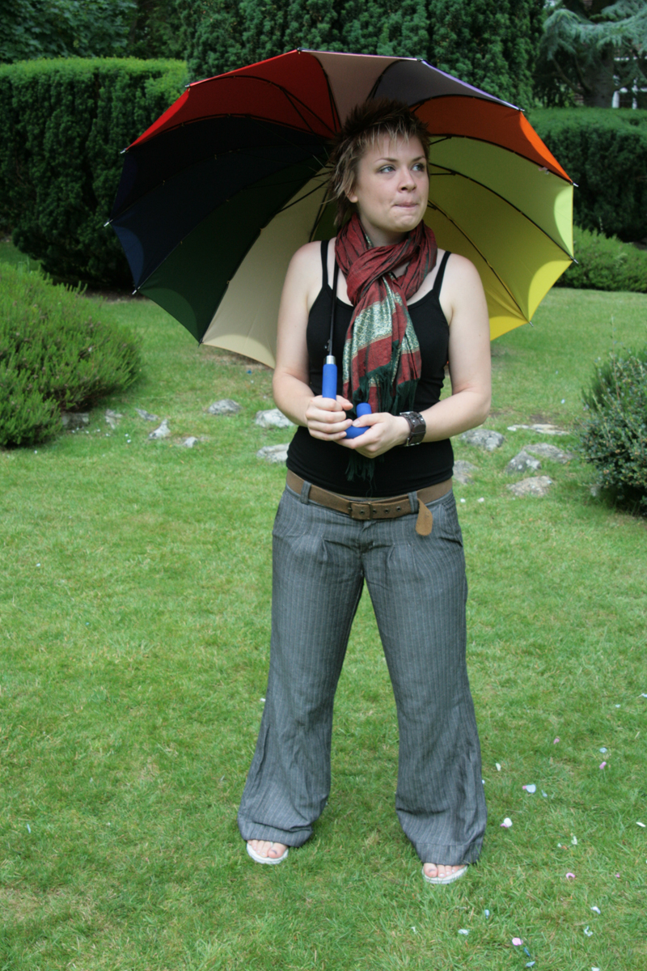
Personal Profile
I regard myself as a highly creative and imaginative individual with the ability to adapt easily to change and the determination to succeed. I am a team player with an enthusiastic, reliable and positive personality. I thrive in a challenging environment and enjoy learning, taking advantage of the opportunity to progress and gain knowledge wherever possible. I enjoy working with children and young people have a particular interest in creative learning, young people’s participation and pupil voice.

Key skills/experience
- First class BA (hons) degree in Photography
- Experience in working with children and young people in school and other educational settings and in planning and delivering creative learning projects
- Experience of teaching photography to children and adults
- Working knowledge of Adobe design software including Adobe CS3 Dreamweaver/ Photoshop/ Indesign and Illustrator as well as Microsoft Office programs.
- Experience of event management
- Excellent written and verbal communications skills
- Wide experience of working with people of all ages and in various customer service and learning environments

Career History
Creative Junction CIC, Slough | Core Team member | April 2008 – Present
Creative Junction was formed in April 08 when Creative Partnerships Slough de-merged from the Arts Council to become an independent organisation, working with Learning settings, the cultural sector and creative industries to deliver powerful and innovate work across these sectors. Creative Junction has a flexible working ethos and so responsibilities can alter on a rolling basis; currently my responsibilities include design and imagery, celebrating the programme through photography, building and maintaining the website, showcasing our work online, event management, managing work experience and student placements, curating exhibitions, leading workshops for adults and young people in creative learning and photography, building relationships and various office administration. As part of my role I focus on young people’s voice and developing young people as leaders and attend various conferences and training relating to this area in order to feed back to the team. Recently I have been working on a Creative Partnerships project as a Creative Partner for Newlands Girls School in Maidenhead, teaching photography with a focus on literacy and the use of imagery as a tool for communication. As part of this project we have been making links with an orphanage for abandoned girls in India where we were are learning about each other and our cultures through photographic discussions and creative writing. www.creativejunction.org.uk

Creative Partnerships- Thames Valley | Team Assistant | February 2007-April 2008
Creative Partnerships is the governments’ flagship Creative Learning Programme, designed to develop the skills of young people across England, raising aspirations and equipping them for their futures. This role entailed ensuring the smooth running of the Creative Partnerships office and team, whilst adhering to guidelines set by Arts Council England. I was responsible for assisting with office finance, placing orders, dealing with invoices, raising purchase orders, answering queries from partners and Arts Council finance officers, monitoring and evaluation of the programme, collecting and disseminating figures and updating monitoring reports, working on the ‘front line’ dealing with enquiries via email and over the phone, booking appointments and managing calendar entries, organising events, booking venues and dealing with catering, photography and updating the Creative Partnerships image bank and website, communications and liaising with newspapers, overseeing the production of publications, managing the work experience program and ensuring the gallery/exhibition was up to date amongst many other things. www.creative-partnerships.com

Debenhams, Manchester | Loss Prevention Assistant | June 2006-January 2007
As a Loss Prevention Assistant my role entailed supporting the store team in the delivery of excellent customer service and ensuring that the store, staff and stock remained safe and secure. I advised on how to reduce stock loss and assisted in the training of security procedures as well as implementing company loss prevention policies and best practices and helping to identify, support and maintain the stores stock loss action plan. I was also responsible for the store opening and closing and emergency call out procedures. The role required a highly proactive individual with a logical and organised approach, good communication skills and the ability to manage shifting priorities.
Debenhams, Manchester | Supervisor – Young Fashion | July 2005 – June 2006
As a Supervisor it was essential to drive the highest levels of customer service at all times and ensure excellent product presentation and availability. Duties ranged from; managing staff and dealing with problems efficiently to assisting customers and colleagues with queries, purchases and complaints and included selling and promoting products and merchandising. I also undertook a variety of training courses qualifying as a skills coach enabling me to train and mentor both new and existing staff.
Manchester Metropolitan University Library | Library Assistant | March 2004 -June 2005
This was a part time role to subsidise my university studies. Responsibilities included a variety of administration tasks, the issuing of books and ordering of stock, dealing with customer queries, shelving, opening/closing library, announcements and working occasionally as security officer.

Training
I was very fortunate whilst working for Creative Partnerships and Creative Junction that personal professional development was key. I substituted a high salary for the chance to work with an organisation where I was able to develop many skills and to improve my knowledge as much as possible, including in my own professional practice (photography). I have undertaken countless training courses relating to my role, for example in finance, monitoring and evaluation as well as:

TEFL course | London Regents College | February 2009 (To be completed)
Philosophy for Children (P4C) Level One | Cippenham Junior School – SAPRE | October 2008
Young People as Creative Leaders | ENYAN, Manchester | January 2009
Young People’s Voice | Participation Works, Birmingham | November 2008
Adobe Dreamweaver Training | Happy Computers, London | January 2008
Time management Training | Arts Council England
First Aid Training | Debenhams

Education
Manchester Metropolitan University
September 2002 -June 2005
BA (Hons) Photography: First Class

Wimbledon School of Art
September 2001 -June 2002
BTEC Foundation Diploma in Art and Design: Merit

Richmond upon Thames College
September 1999 -June 2001
A-level Art: B
A-level Photography: B
A-level Graphics: B

Chipping Campden School
September 1994 -June 1999
GCSE: 10 (grades A*-B)

Personal Details
Date of Birth
25/01/1983

Interests
Interests Other than my passion for photography and my keen interest in working with children and young people, I love to play rugby. Whilst at university I was captain of the ladies rugby team and since moving back to London I have been playing for Twickenham Ladies RFC. I have spent a lot of time helping in the running of the club, which has included recruitment to attract new players to the sport, building a website and designing flyers and business cards, as well as agreeing sponsorship with a local business in order to pay for new shirts and equipment. I have also organised for members of the team to attend first aid training and other training events in order to develop their learning. I am keen to travel and see the world, to meet new people and to learn and discover new things.

References Available on request

