
Korean Teacher Profile
Full Name  Joel Kenneth O’Donnell |  | 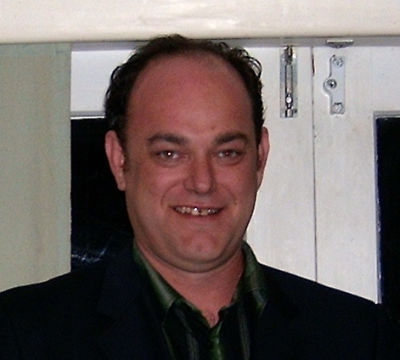  Recent Photo
Age  35 | Gender  Male
Nationality

New Zealander
Health

Good
Qualifications. (Must include - Degree, University)

Bachelor of Business Studies (Massey University, Auckland, New Zealand)
ESL Certified (NZIE, Auckland, New Zealand)
Personal Statement /Comments about reason for seeking work in Korea.

I would love to work in Korea because I love the culture and would love to learn more about it. I also love teaching and think this would be the perfect chance to combine my passions. I love to travel and explore and think living and teaching in Korea would be a great experience.
Work Experience:

2004-2008
Tutor: During my time at Massey University I also tutored many foreign students in English.

2000-2003
Sales Manager: Abel Tasman Sea Shuttle. Responsible for all sales and marketing and training of sales staff.

1998-1999
Team Leader: Goodwill Marketing. Responsible for all sales and training new staff.
New Zealand Institute of Education
Levels 1-3, 62 Anzac Street, Takapuna, Auckland, New Zealand
Ph: (+649) 489 3520 Fax: (+649) 489 6209
Website: www.nzie.ac.nz.

