Resume

John Henry Porter

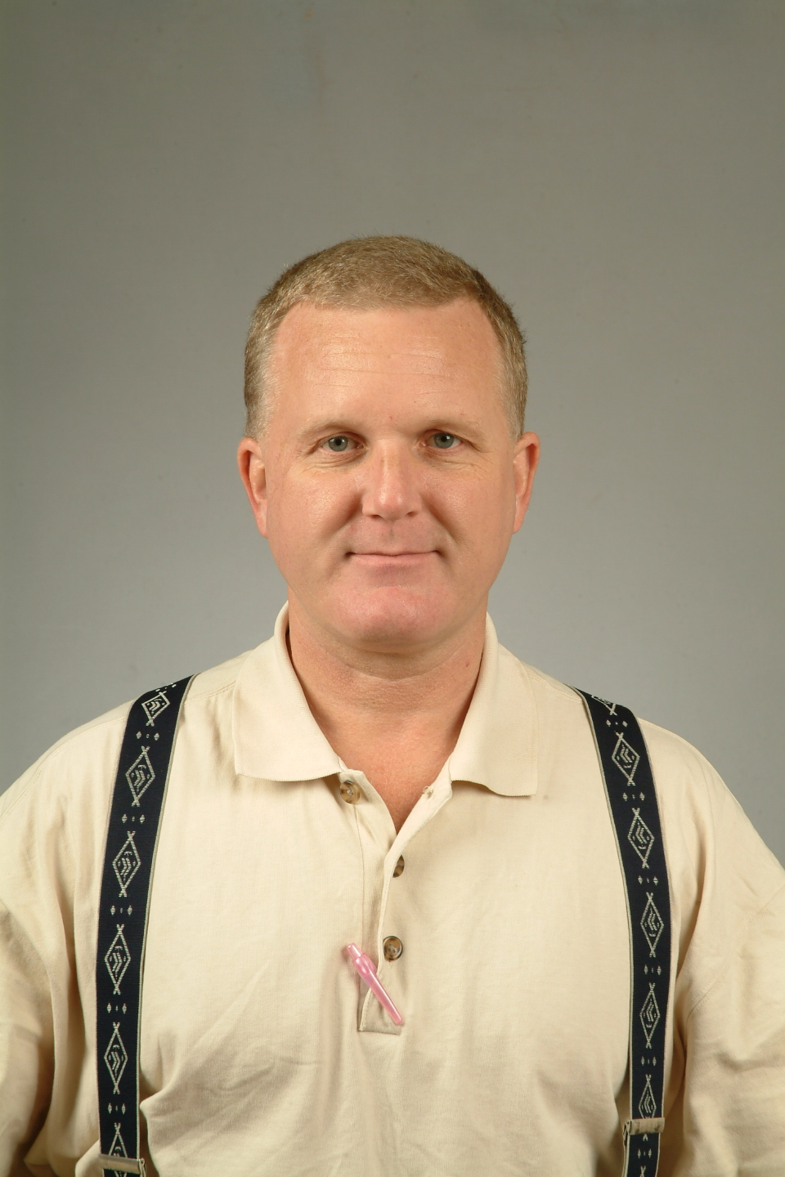

John Henry Porter_____________________________________________
Houston Texas USA, 1-281-461-7399
john_h_porter@yahoo.com

We must have fun learning English; because, otherwise, of course, it’s no fun at all!

EDUCATION
Oct-2004 National Certified Insurance and Coding Specialist,
National Center for Competency Testing
Jun-1992 Teacher Certificate; English
Jun-1991 BA English; University of Texas at San Antonio

EMPLOYMENT

Nov-04 to Feb-06 English Teacher, K-8th schools, Taiwan
Apr-04 to Aug-04 Medical Billing Specialist, River Oaks Pain Management, Houston, TX, USA
Nov-03 to Feb-04 Substitute, Independent School Districts, Deer Park and Pasadena, TX, USA
Jan-02 to Apr-02 Technical Support Engineer, Software support, Sykes Enterprises, Palatka, FL, USA
Apr-01 to Aug-01 Instructor, GED preparation, Americorp Volunteer-Houston READ Commission, TX, USA
Aug-99 to Oct-99 English Teacher, Oxford English Academy, Kunsan, Korea
Mar-99 to July-99 Teacher, Gwangju Foreign School, Gwangju, Korea
Aug-98 to Feb-99 English Teacher, Southmore Intermediate School, Pasadena, TX, USA
Feb-98 to Aug-98 Trainer, Disabled adults, Fairmont Vocational Center, Pasadena, TX, USA
Jun-96 to Jul-97 English Instructor, Military English for army officers, ROK Army Intelligence School, Songnam, Korea
Apr-95 to Apr-96 English Teacher, YBM Sisayongosa Language Institutes, Seoul, Korea
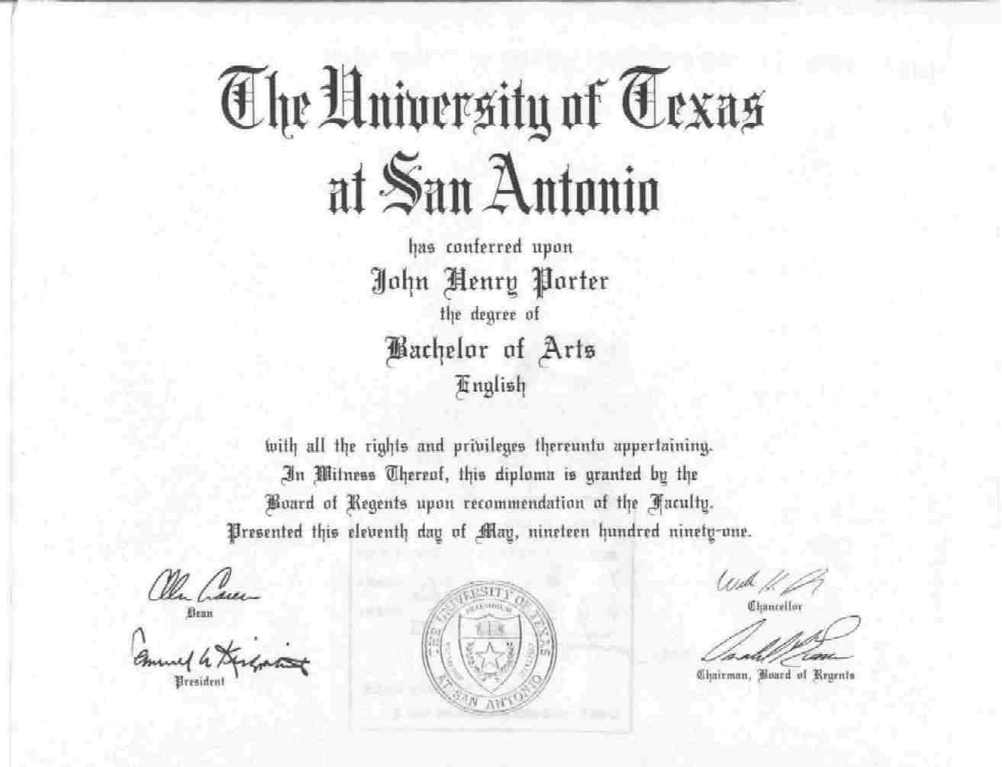

My university transcript is on the following page.
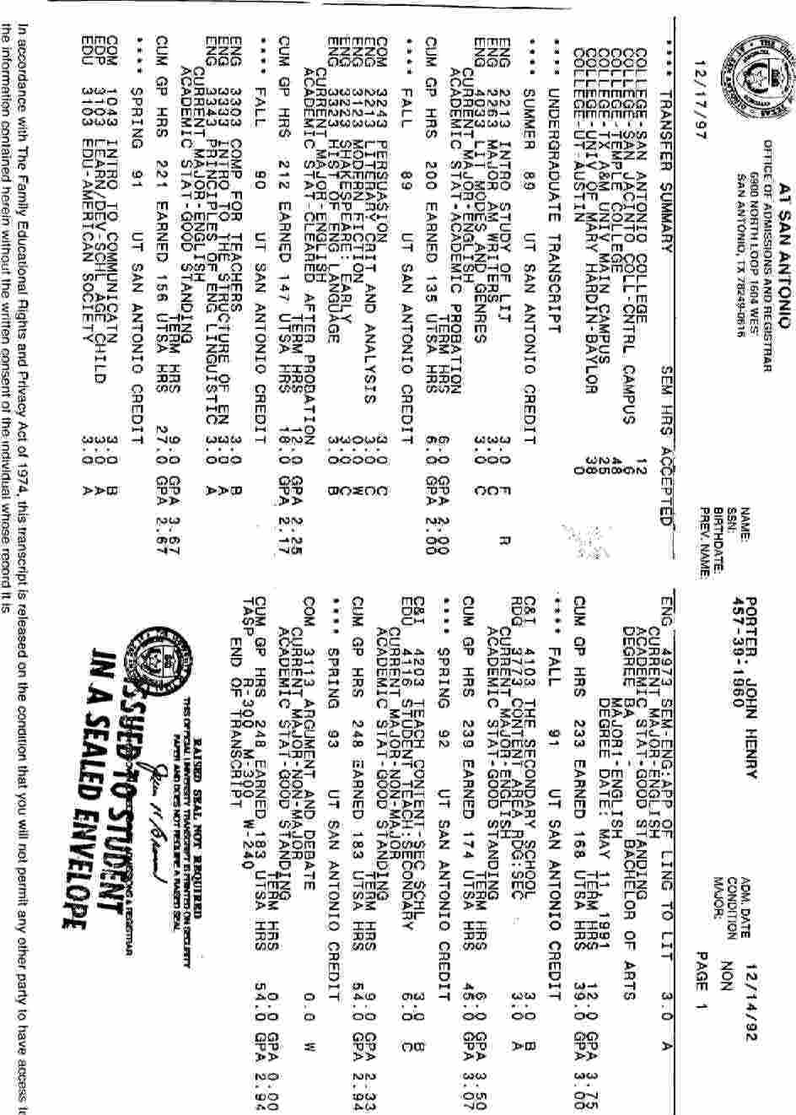
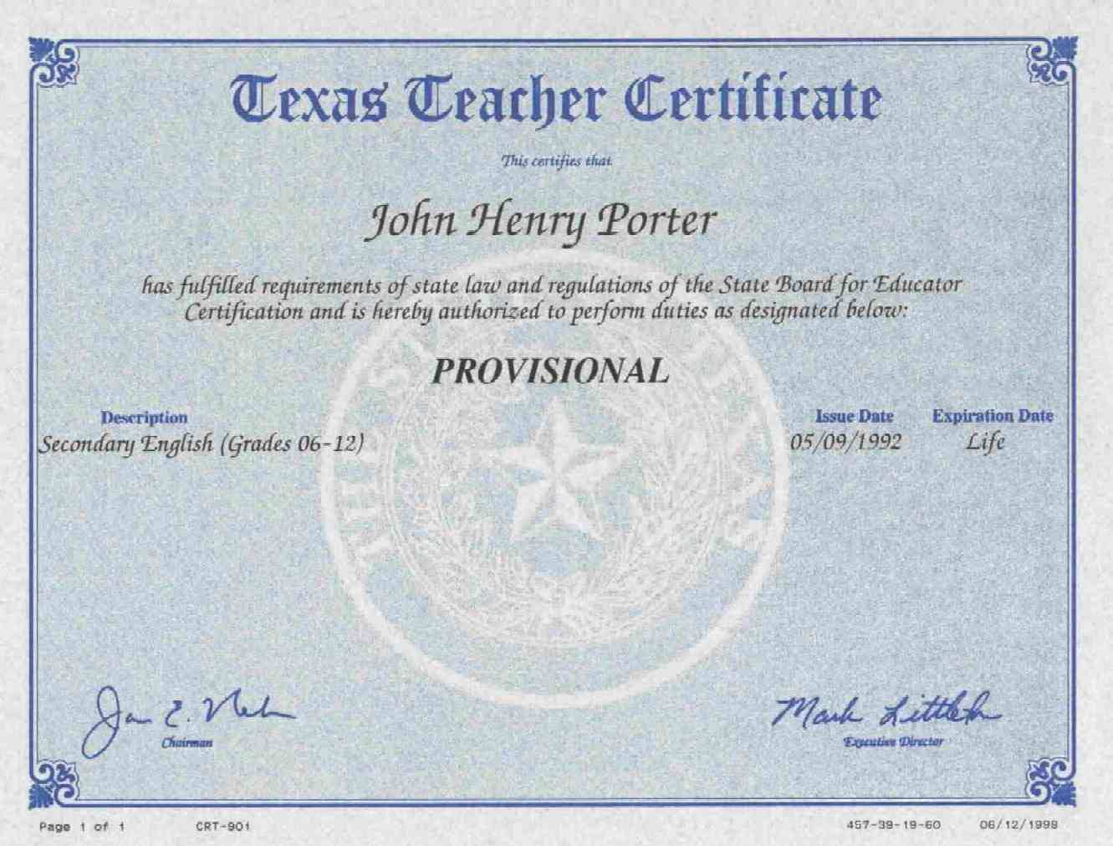

The following link will direct you to the official State Board of Education, Texas, USA, verifying my teacher certification.

https://secure.sbec.state.tx.us/SBECONLINE/virtcertdisplay.asp?spid=708395&mode=C

