Michelle ABARQUEZ
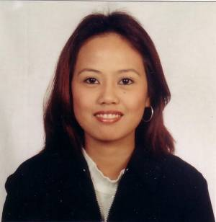

75-13 Hawolgok 1 Dong Song Buk Gu

Seoul, South Korea
Mobile no.: (82)01031445132

lekkzelvis@yahoo.com

Objective: To gain knowledge and further developed skills in rendering quality that will enhance competency in the future.

- Educational Attainment

University of Baguio
Bachelor of Science in Computer Engineering
Graduate
1998-2002
Baguio City

SECONDARY Saint Louise College
Graduated
1994-1998
Valenzuela City, Manila

PRIMARY San Jose Citizen School
Graduated
San Jose City, Nueva Ecija

- Skills Summary

I am hardworking, responsible, flexible, trustworthy and also eager to improve and acquire knowledge skills. Prioritize workload and complete tasks. Tenacious under pressure; persevere with commitments to satisfactory conclusion. Demonstrate respect for authority and organizational structure.
Software; Computer Application in Windows XP, MS Word, MS Excel, spreadsheets and PowerPoint presentation creation. Trouble shooting, Typing, Encoding, Printing. Proficiency in utilizing computer applications
- Work Experience

- Housekeeper Nov. 2006 up to Dec. 2007
Seoul, South Korea
- Duties and Responsibilities
Efficiently cleaning common areas and residents’ rooms in 4-bed facility. Diligently change bed linens, dust, and vacuum and disinfect rooms.

- Babysitter Jan. 2008 up to present
Seoul, South Korea
- Duties and Responsibilities
Serving and feeding meals to the children, bathing and dressing the children or assisting them bathe and dress themselves. Played games with them and kept a watchful eye while they were entertaining themselves to make sure they are safe.

- Personal Information

Date of Birth : April 17, 1981
Age : 28 years old
Status : married
Children : 2
Place of Birth : Sto. Ñiño 1st. San Jose City Nueva Ecija
Nationality : Filipino
Religion : Catholic
Height : 5’4
Weight : 54 Kg.

