Chandra Das Resume
(Last Updated: 2010.08.10)

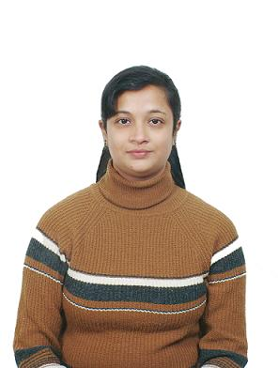
Name | Chandra Das | Visa type | F-2(Work permit)
Highest Education | Bachelor of Education | Date of Birth | 1976.04.16
E-mail | chandradas@gmail.com | Mobile Phone | 010.5144.1604
Nationality | Indian | Duration of Stay in Korea | 8 Years (since 2002)

F  a  m  i  l  y | Relation | Name | Age | Education | Occupation | Stay Together
F  a  m  i  l  y | Spouse | Kumar Brata Das | 35 | Graduate | Manager/Samsung Electronics | Yes
F  a  m  i  l  y | Daughter | Kunjal Das | 6 | Grade 1 | N/A | Yes

Ed  u  c  a  t  i  o  n | Type | Admission | Graduation | Institution | Specialization |  | Location
Ed  u  c  a  t  i  o  n | Bachelor Degree  (3 years) | 1993 | 1996 | M.B.B college | Bachelor of science.(Zoology major) |  | India
Ed  u  c  a  t  i  o  n | Bachelor Degree  (1 year) | 1997 | 1998 | Central University | Bachelor of Education. |  | India.
Ed  u  c  a  t  i  o  n | School  (12 years) | June, 1981 | June, 1992 | Central School | Science, Maths, English |  | India

L  a  n  g  u  a  g  e | English | Fluent |  | O  t  h  e  r  s | Hobby | Gardening
L  a  n  g  u  a  g  e | Korean | Fluent |  | O  t  h  e  r  s | Extra curricular Activity | Interest in Indian music and dance.
L  a  n  g  u  a  g  e | Hindi | Fluent
L  a  n  g  u  a  g  e | Bengali | Fluent

Work History
Jan 2001~ Jul 2010 /Suwon-Korea

Part time teacher in a english language institute in suwon august 2008--- February 2009

Home tutor [Korea]: Jan 2002 ~ Aug 2008

Taught english grammar to Korean middle school and elementary school students as a private tutor.
Experience in having one to one english conversation classes with adults.

CCAP (Unesco sponsored) volunteer lecturer in Indian culture: Since 2003(Give lecture to Korean elementary middle and high school students about India’s history and geography and culture.)
Sep 1998 ~ Feb 2002 / India
n Don Bosco School Agartala: Mar 2001 ~ Feb 2002:
Worked as a subject teacher for middle school students teaching English language and mathematics.
Had the responsibility of managing and conducting extra co-curricular activities in the school.
Was awarded the Best teacher of the year 2001.

Central School Agartala: Aug 1999 ~ Mar 2001:
Worked as a subject teacher for elementary school students teaching Mathematics and English language.
Took active part in all kinds of co-curricular activities held at the school.

Army School Agartala: Sep 1998 ~ Apr 1999
Worked as a subject teacher for middle school students teaching English literature, Hindia and Mathematics.

Korean language Skill (TOPIK Level 3):

Can understand read and write Korean language very well. Able to translate Korean to English with sufficient accuracy. Already translated simple documents from Korean to English.

