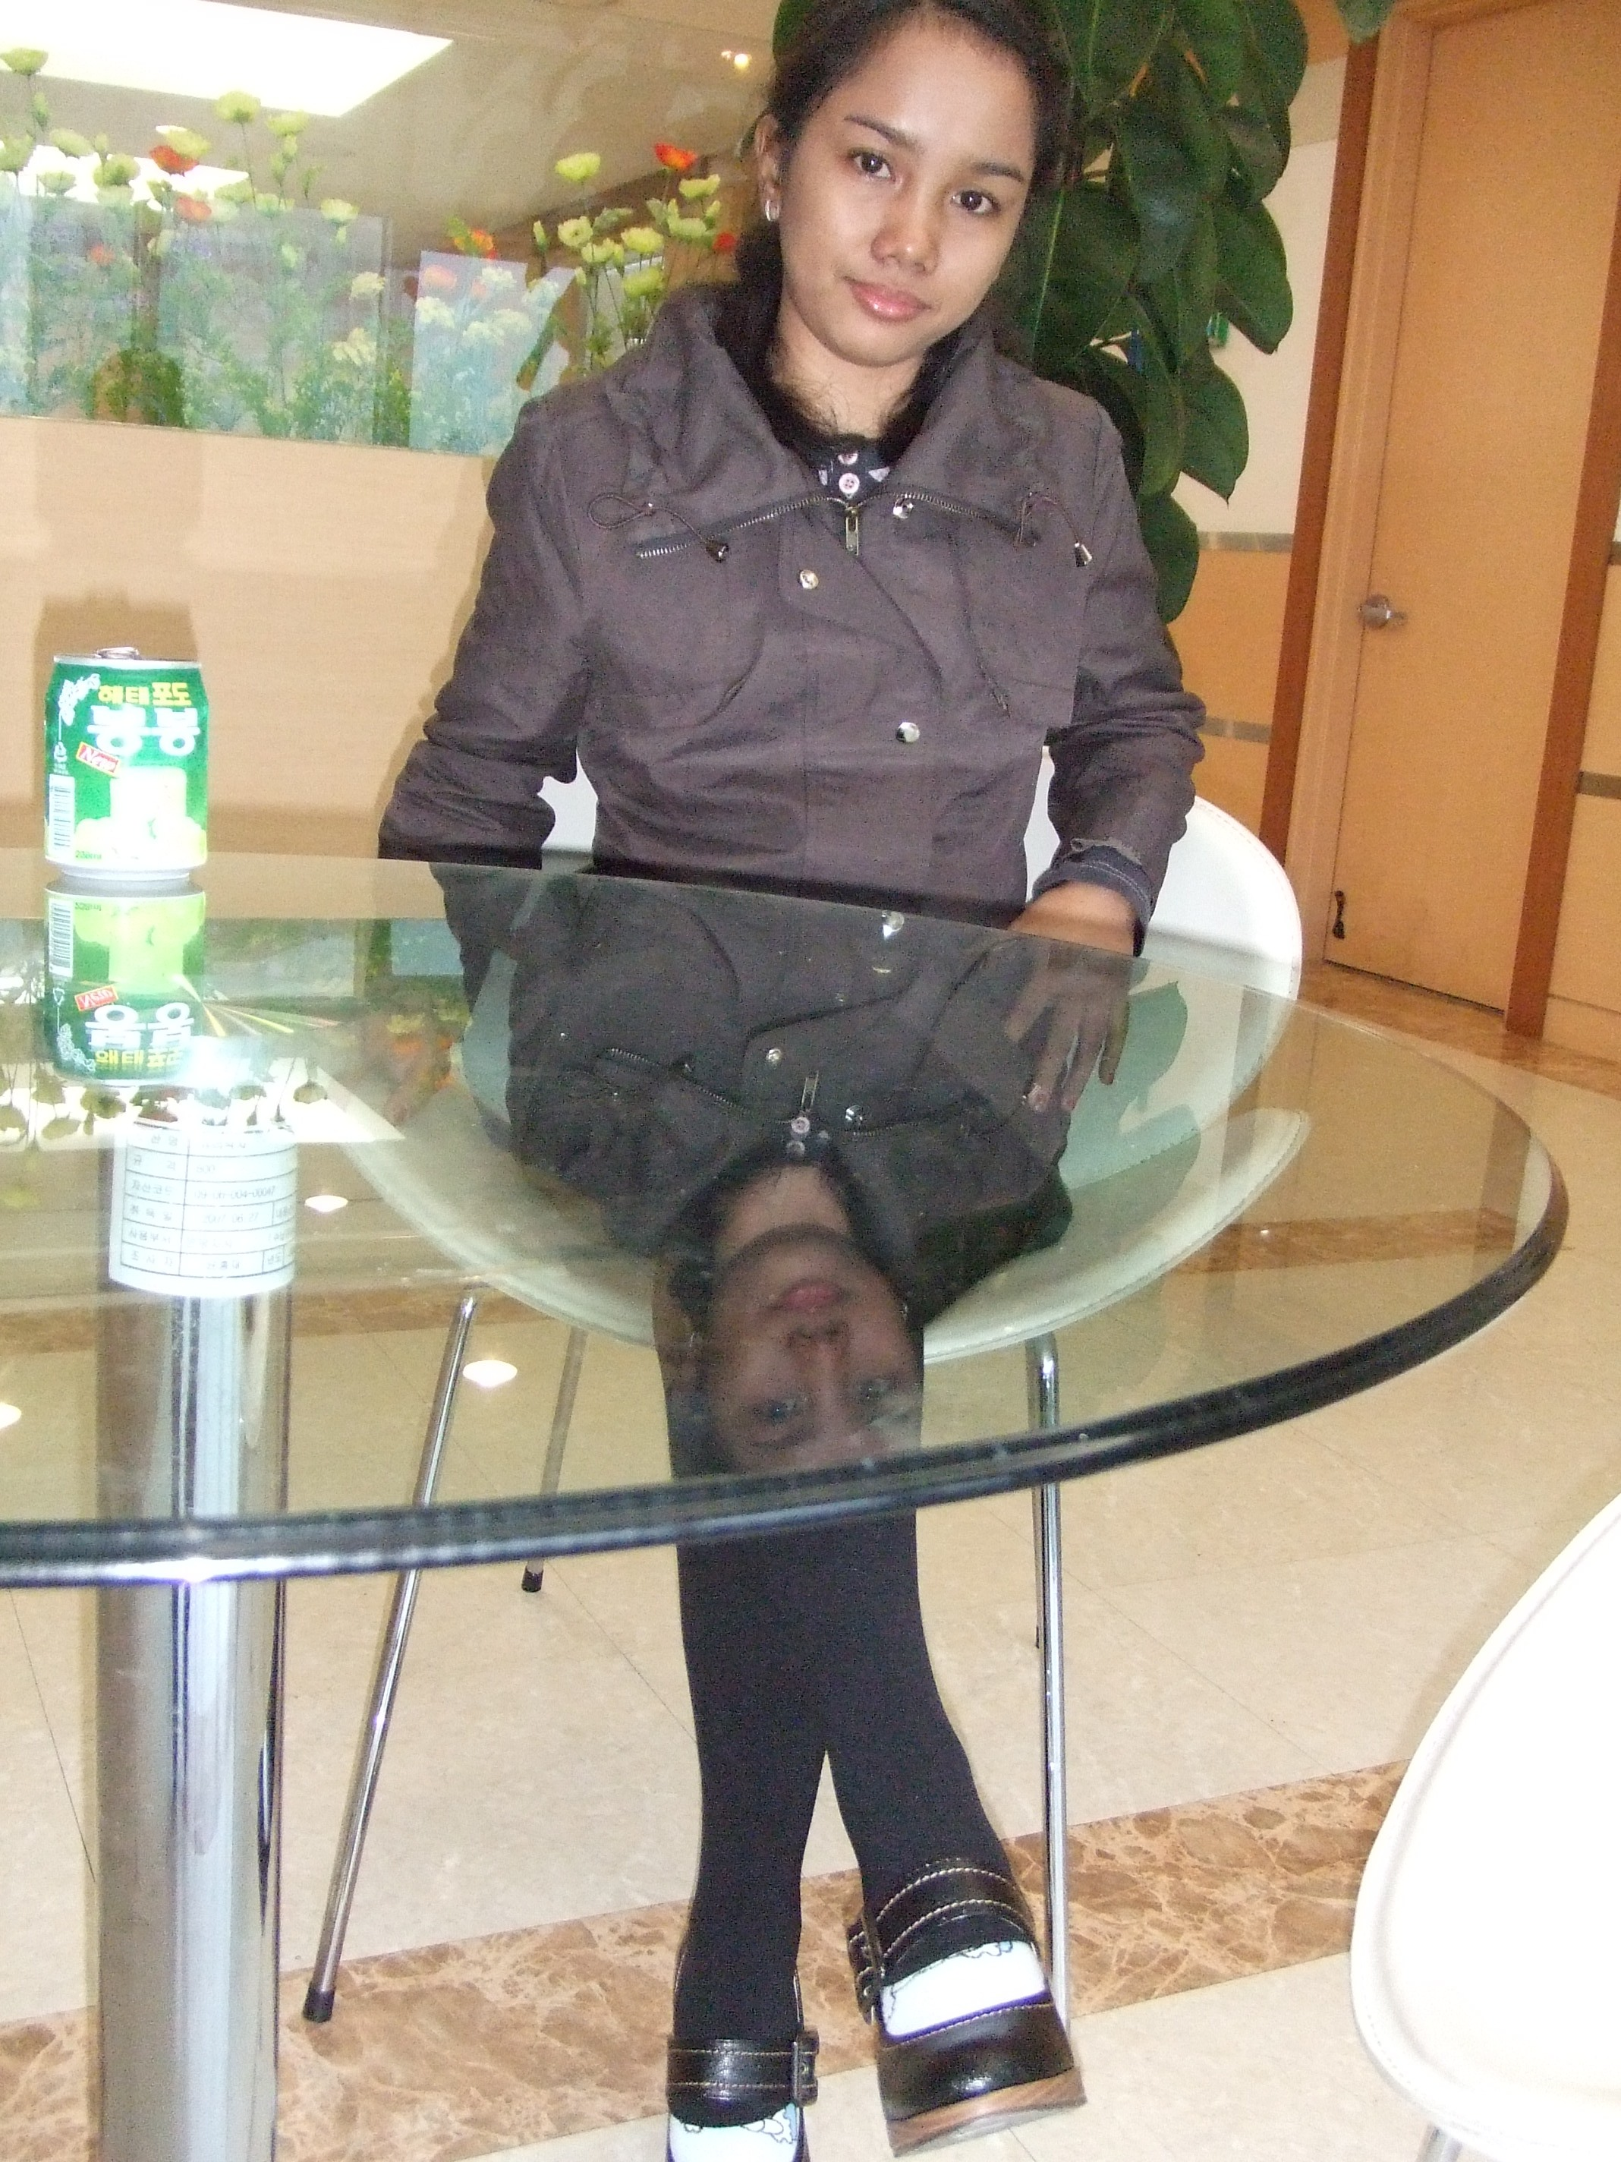
Busa, Mia Rose R.
Mobile No.: 017-241-5087
Home No: 07081355088
Email Add: ms_mae23@yahoo.com

Objective

Be able to contribute for students’ and company’s growth and development and from whatever experiences gained.

Seminars and Trainings Attended

Seminar on General and Professional Education
Leyte Normal University
Tacloban, City
October 4, 2005

Work Experience

National Statistics Office
2007 National Census of Population Enumerator
Naval, Biliran
August 2007

Off-Campus Student Teaching
Caibaan Elementary School
Tacloban, City
February - Mach 2006

Off-Campus Students Teaching
Pawing Elementary School
January-February 2006

On-Campus Student Teaching
San Fernando Elementary School
Tacloban, City
November –December 2005

Profile

- Self motivated and focused.
- Proficient in oral and written communication skills.
- Computer literate in windows application.
- Adequate in educational training on Student Teaching with Community Immersion.
- Very Responsible, Dynamic and highly dedicated worker.

Achievements

LET Licensure Examination for Teachers/ Board Examination for Teachers
Professional Regulation Commission (PRC)
Manila, Philippines
September 2008

Career Service Professional Eligibility
Civil Service Commission
Tacloban, City Philippines
April 2, 2006

Provincial Scholarship (LNU)
Province of Biliran, Philippines
2004-2006

Educational Background

Tertiary: Leyte Normal University
Bachelor of Science in Elementary Education
Tacloban City, Philippines
2002-2006
Bachelor of Science in Elementary Education

Secondary: Manlabang National High School
Caibiran, Biliran Philippines
1998-2002

Primary: Caibiran Central Pilot School
Caibiran, Biliran Philippines
1992-1998

Personal Details

Current Address: 서울시 은평구 구산동 24-24 청송 쉐르빌 302호 South Korea
Birth Place : Caibiran, Biliran Philippines
Birth Date : June 27, 1985
Nationality : Filipino
Civil Status : Married
Spouse : 안상국 Nationality : Korean
Religion : Roman Catholic
Sex : Female

Character References

Mr. Ryan G. Destura
Professor, Social Science 104a
Leyte Normal University
Tacloban, City Philippines

Mr. Reno Tarculas
YFC Coordinator
Caibiran, Biliran Philippines
Mobile #: +639266355635

Mr. Eugenio Iglesias
CFC Chapter head,
Caibiran, Biliran Philippines
Mobile #: +639058345720

Rev. Imelda L. Tiano
Marriage Consultant
Pasay City, Philippines
Mobile #: +639204258455

I hereby certify that all information stated above is true and correct based on my knowledge and belief.

Busa, Mia Rose R.
Applicant

