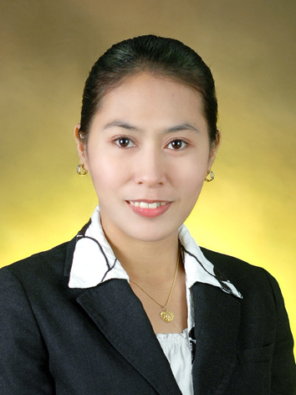
Analyn R. Munoz
Gangseo-gu Hwagok-dong 56-309 Seoul
E-mail:kylene_316@yahoo.com
Phone No. 070-8184-5508
Birthday • December 01, 1984
Marital Status • Married
Nationality • Filipino

Objective

.To teach kindergarten/elementary students in Seoul Korea
Where I can develop my skills and knowledge as a teacher and explore an amazing country.

Education

2001-2005
2 yrs. College Graduate of Vocational Course
Far Eastern University Manila, Philippines)

Work Experience

March 11 to July 01, 2006
Mercantile Store Group INC
SM Center, Sta. Mesa PH.
Cashier

October 2003- March 2004
Far Eastern University
Nicanor Reyes st. Manila PH.
Data Encoder

Seminars Attended/Certificates Awards

March 10, 2004
*UCC University Conference Center
ACS General Assembly and Ceremonies

February 3, 2005
*Far Eastern University Auditorium
Personal and Career Development

November 11, 2009
* A certificate in completion my Korean course

Language Skills

* Fluent Tagalog
* Intermediate Korean
* Intermediate English

Information

F2 Visa Holder…

2/2

