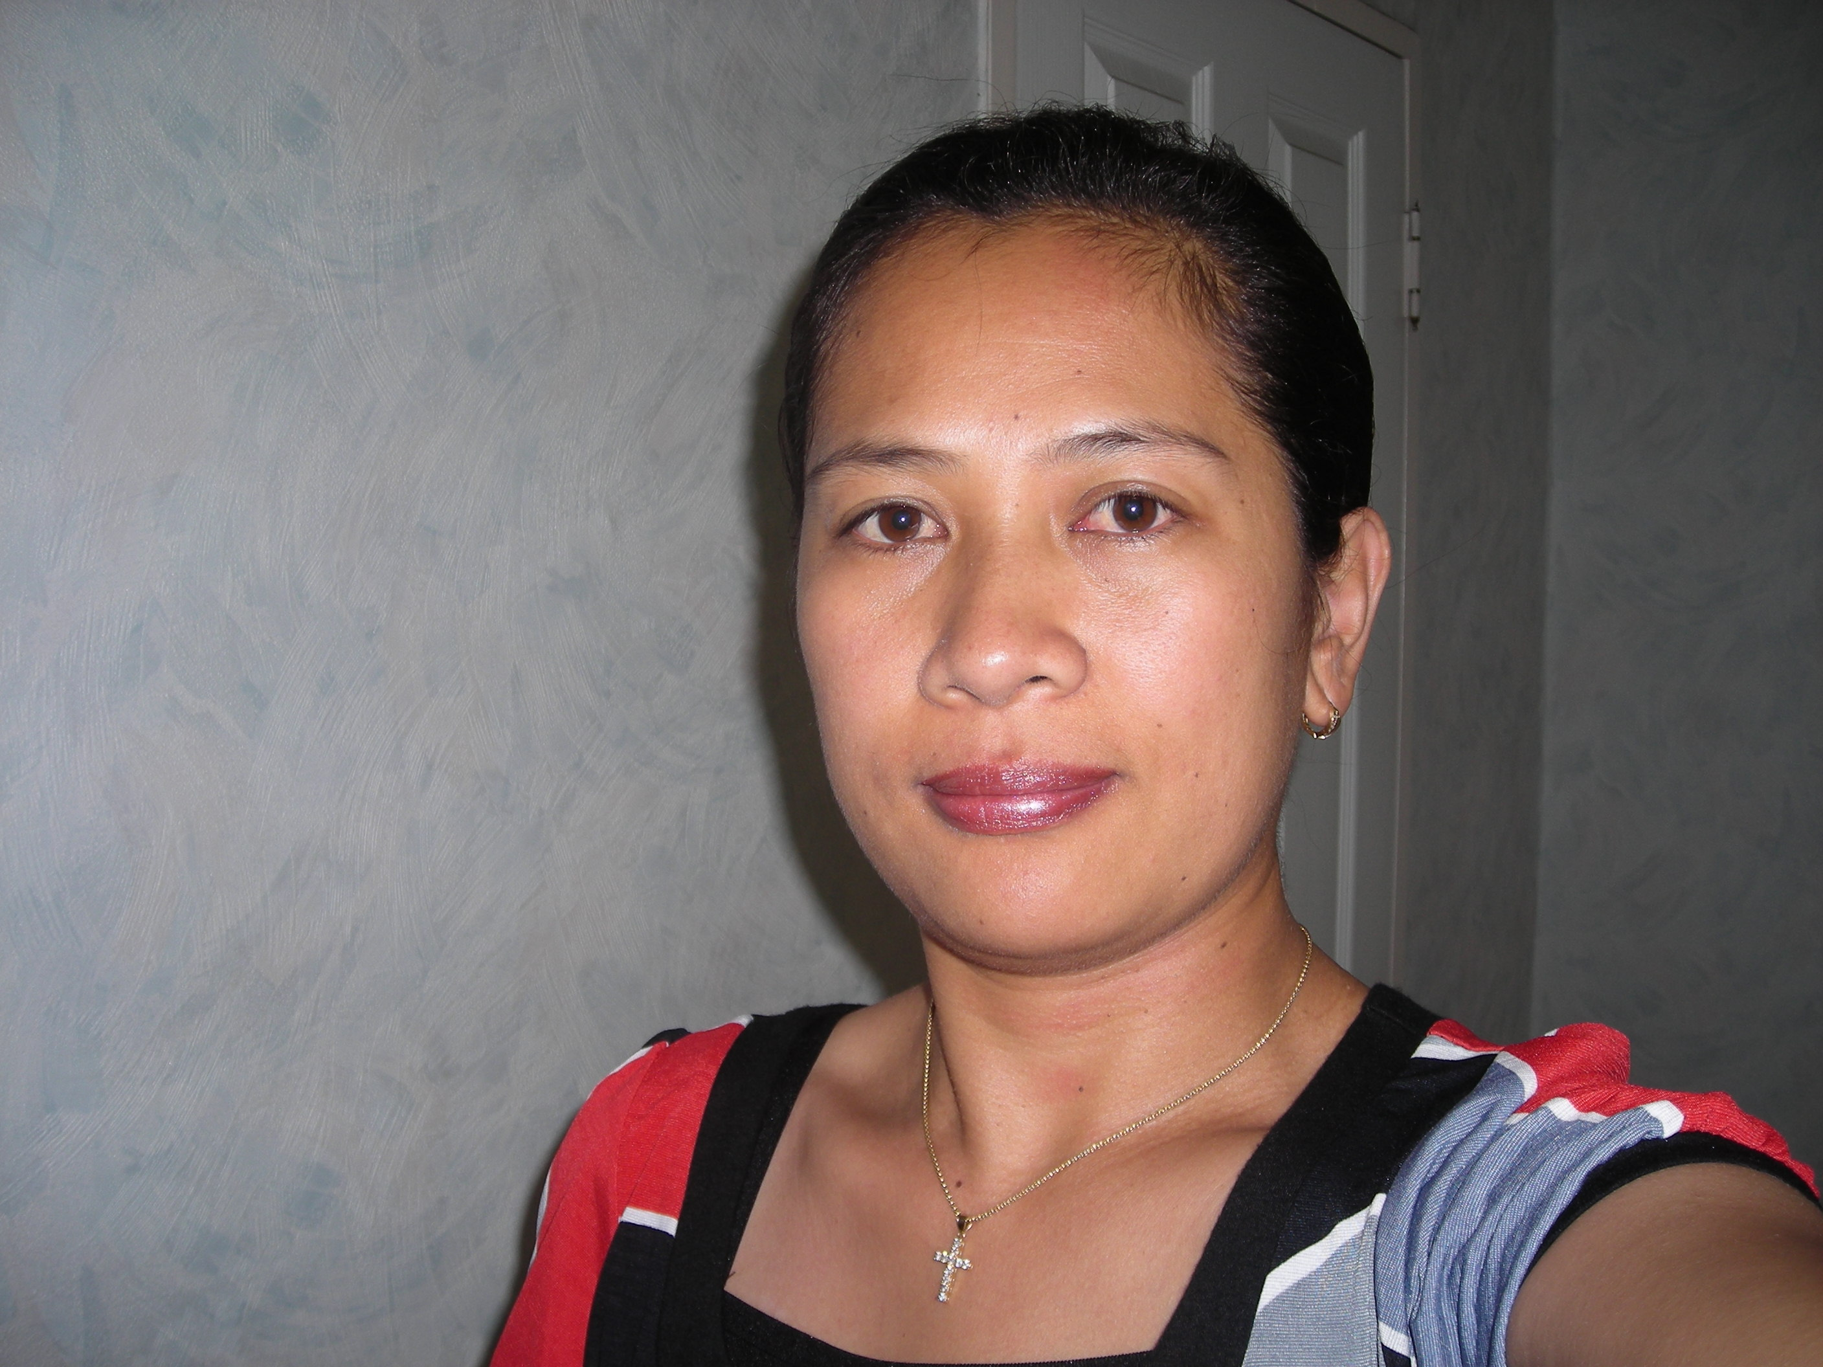
LOUBELYN B. TANGALIN
104-908 Nonhyeon APT Nonhyeon Dong

Kangnam Gu, Seoul

South Korea

Mobile: 010-4849-2625
E-mail: LYNEKIM@MSN.COM

PERSONAL INFORMATION
DATE OF BIRTH: November 28, 1971
HEIGHT: 159 cm
WEIGHT: 59 kg.
SEX: Female
Marital Status : Married
Religion : Roman Catholic

EDUCATION University: Lyceum Northwestern
Bachelor Of Science In Nursing
Graduated 1993
Dagupan City Philippines
Secondary: Saint Louis School Of Campo Filipino

Graduated 1988
Baguio City Philippines
Elementary: Easter School
Graduated 1984
Baguio City Philippines

EXPERIENCE Private Nurse
1997-1999
American Employer
Angeles Balibago Pampanga
Philippines

Staff Nurse(volunteer)
January 2006-July 2006
Baguio General Hospital
Baguio City,Philippines

Bbsssssssssssssssssssssssssssssssssssssss
-
English Teacher (Part Time)
June-July 2008
E-Kids Play Center
Guro,Seoul Korea

English Teacher (Substitute)
August 1-30,2008
E-boyoung Talking club
Daerim Branch, Seoul Korea

English Teacher
March 2009-Present
E-Boyoung Talking Club
Hwagok Branch, Seoul Korea

CERTIFICATIONS
December 1993-passed the NLE
Registered Nurse

INTEREST AND HOBBIES

Reading books,Cross stitching,Surfing the net,meeting people,

SPECIAL SKILLS
Knowledge of the Microsoft word
Fluent in English

SELF INTRODUCTION

I’m 39 years old, married to Korean and blessed with one lovely daughter who is 6 years old now. My main strength in this job is the ability to teach English to students and able to help them express themselves in the English language, which is very important for globalization. My goal as a teacher is not only to teach the English language but share the English literature as well to my students efficiently and effectively. I understand that this job demands a lot of interaction with people, which is an advantage for me since I had taken psychology subjects also during my university studies. In effect of this it gave me a better understanding on how to deal with people well. As a mother I’m also familiar on how to treat children as they grow up. With this knowledge I believe I can handle young students better. I am an extrovert person. I like meeting different kind of people. I also love exploring things instead of staying indoors. I value and respect friends and the people surrounding me so I always try to keep harmonious relationship with people.

