71 Atis St. Juliville Subd. Buhangin, Davao City Mobile #09207176154 | 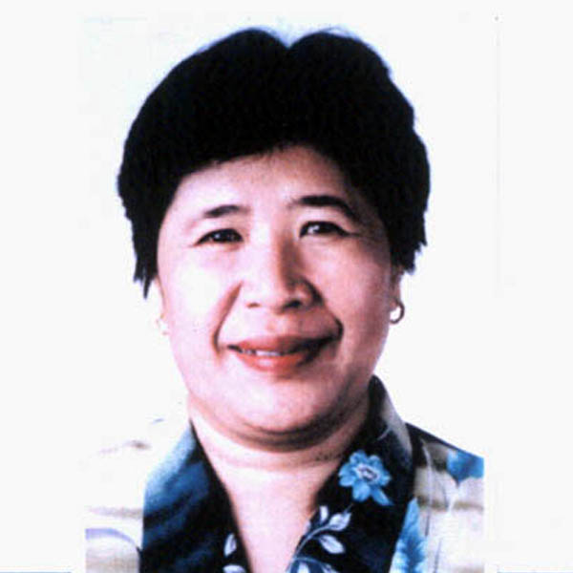  (Email) engski60@yahoo.com
Encarnacion D. Ponce
Objective | To give my full service a Pre School or English teacher to the young by developing their speaking, reading and writing skills so that they become knowledgeable in English
Experience | 1996– present Holy Child School of Davao Davao City  Sunday High School Teacher  - Taught Science Subject in First year  - Develop the love of nature to my students thus learn the value of care in the environment.  - Develop students critical thinking ability
1990-2003 Holy Child School of Davao
Elementary and Secondary Teacher
- Taught Science, Math and English in Elementary level
- Trained students who participated in the speech fest
- Science Club Adviser in High School
Awards Received
Certificate of Recognition
Best in Discipline
Certificate of Appreciation
Cleanliness Drive of the School

1989-1990 Assumption School Of Davao Davao City
Primary Teacher
- Taught Math and English in Grade III and Science in Grade IV.

1988-1990 Doña Pilar Learning Center Davao City .
Acting Head
- Headed the newly operated school
- Taught Grade I class at the same time
- Initiated the parents to put up projects in the school
* prepares activity sheets for student’s use

  - Ateneo de Davao University Branch Comval Prov.

Primary Teacher
  - Immaculate Heart of Mary Academy Mati, Davao Oriental
Secondary Teacher
*Taught Science Subject in First year level
*Trained students who joined in Science project competition
Awards Received
Certificate of Recognition for serving the school for 5 years
Education | 1. MS Environmental Studies Summer 1998  UP Mindanao  Davao City  2. Earned Units In Education SY 1988-1989  University Of Mindanao  Davao City  3. M.A. Theology-Ignatian Spirituality Summer 87  Ateneo de Davao University  Davao City  4.Earned Education Units Summer 83  Holy Cross of Davao College  Davao City  5. RSDC-RSTC Summer Institute Summer 80  Teaching Science in Secondary School  Ateneo de Davao University  Davao City  6. Graduate-San Pedro College SY 1976-1980  Bachelor Of Arts  Major-Environmental Hygiene  Professional Membership  Toastmasters Club
Interests | Sports, playing guitar, gardening, computers.
 | I certify that the above information is true and correct to the best of my knowledge.

