Curriculum Vitae
E.C. Jooste

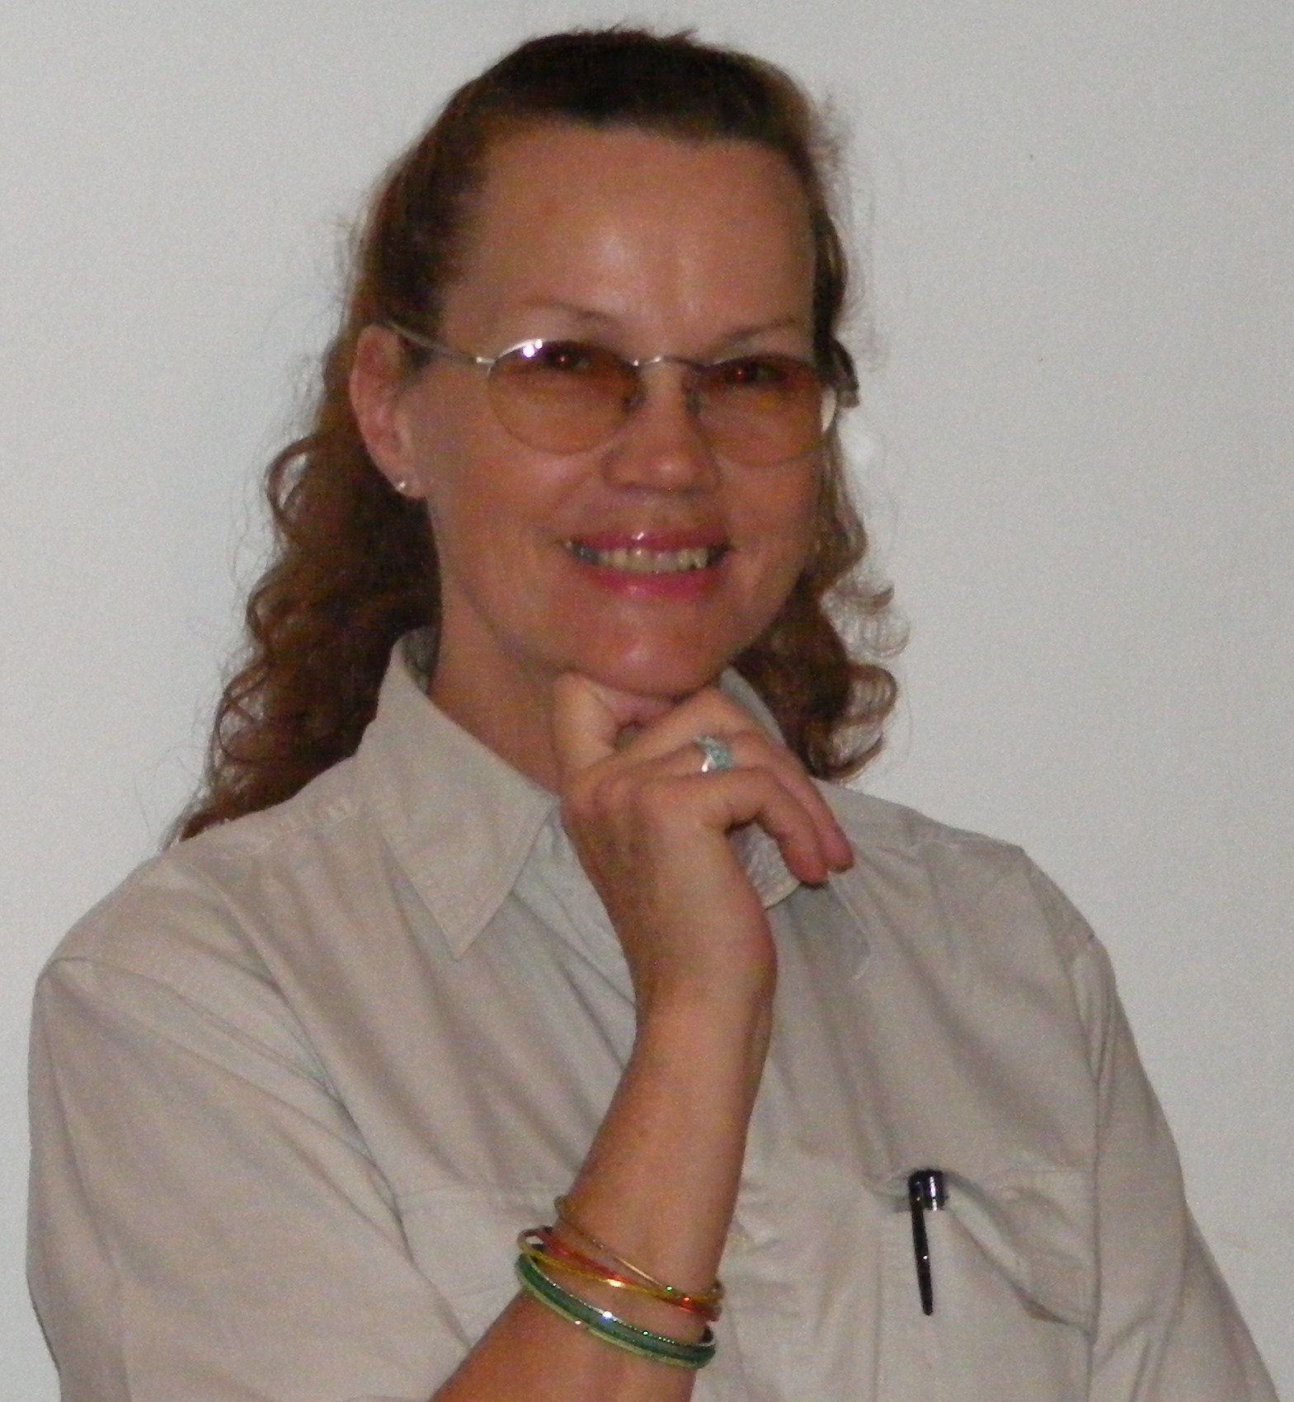

Contact Information:

Tel: 0445332621 (Emergency #) Postal Address: P.O. Box 1904
Cell: 0741018615 (24/7 #) Plettenbergbay
Passport: South African (Valid) 6600
Drivers License: Cod EB (Valid)

Qualifications:

From To Institution Qualification
2002 2002 iiSA C.O.P. Certificate of Proficiency
In Short Term Insurance

2000 2000 Damelin College Diploma Project Management

1992 1992 Birnam Business College Diploma Legal Office Proc.

1990 1999 UNISA (Capped 2000) BA Maj. Anthropology
Min. History of Art with
Psychology II, Sociology I and
Conversational French I

1989 1989 Damelin College Mature Age Matric - 4 subjects
(English, Afrikaans, Criminology and Biblical Studies)

Valid HPCSA Member Reg # BAA0351725 Basic Ambulance Assistant

Presented Paper at International Urban Planning Seminar at Witwatersrand University Jhb in 2000. The paper was titled: ‘ A World Fit for Kids!’ with the focus of the paper being Crime prevention by providing our new generation with suitable role models and providing sports and Walk In Centres in the Inner City and all other suburbs to support and remould the Aids Orphans and Street Children and children of working parents. To prevent crime, rather than to ‘fight’ crime.

Last two Administrative Functions (PA):
- Zurich/SA Eagle Insurance Company Jhb where I served in the Executive Wing for three months as PA to the General Manager Finance to relieve the permanent PA during an extended period of illness/ sick leave. Thereafter I was placed as PA to the Senior Internal Auditor until he left the Company, whereupon I became the PA to the Research and Development Manager who later became the eCommerce Manager. Commenced 01.01.1993 until 03.12.2007 (15 years)

- University of Witwatersrand as Halfday Team Assistant and relief PA in the Faculty of Hydrology aka Water Systems Research Group for Professor David Stevenson where I executed the drawing and filing of Topographical Maps, recorded Digital Rainfall data onto system and produced all diagrams and illustrations required for the Professor's lectures, papers and pamphlets. Commenced 1988 to 1992 (5 years)

Contactable Reference: Linda le Roux Human Resources - Zurich/ SA Eagle Insurance Company Jhb Ph (011) 370 9111

*******

Additional items of interest
Languages:
English, Afrikaans, Conversational French, German and Dutch

General Abilities:
General Computer Skills/ IntraNet and Internet Literate/ Basic Computer Graphics/ MS Projects/ General and Legal Secretarial Office Admin/ Call Centre Skills/ Own Correspondence/ Dicta Typing/ Minutes/ Event and Travel Arrangements/ Supervisory Experience/ Reception/ Hospitality/ First Aid/ Health and Safety/ Advanced 4x4 Driving/ Interior Decoration/ Technical Detailing and Junior Draughting (Civil, Structural, Architectural and Electrical)

Hobbies and Interests:
Running/ Swimming/ Ladies Weights/ Music/ Art/ Performing Arts/ Landscaping

Teaching Experience:
First Aid Instructor's Certificate - Red Cross Society Johannesburg
TEFL/ TESOL Certificate Course - Cape Town
5 months of English Teaching to 5yr to 16 yr old Foreign Students in Korea

Admin Experience and PA Duties at Zurich/SA Eagle:
- Arrange meetings/ functions/ excursions
- Handle enquiries efficiently
- Communicate requested appointments
- Liaise on behalf of manager
- Screen telephone calls
- Receive visitors on behalf of manager
- Maintain constant information exchange
- Make travel/ accommodation arrangements
- Provide Management support
- Type documentation/ schedules etc.
- File and retrieve documents
- File and retrieve confidential and manager's personal information
- Maintain office facilities
- Order/ collect goods
- First Aider and Fire Warden/Health and Safety duties for Floor

The above duties toward eCommerce Manager took priority, however, I was also required to attend to the following secondary duties within the eCommerce Department:

Departmental Secretary/ Team Assistant
- Screen and distribute calls to relevant subordinates of eCommerce Manager
- Take messages and receive/distribute faxes
- Order stationery and other office requirements
- Make travel/accommodation arrangements
- File and retrieve documents
- Forward expense forms, leave forms etc. to Manager and onward
- Maintain kitchen and kitchen supplies procurement
- Take, type and distribute Minutes of Staff Meetings
- Assist in planning and executing of eCommerce Department's contribution to the inter-Departmental Annual Wild Life Fund Raising and Environmental Conservation Awareness Competition.

What is Anthropology?
Anthropology is the study of change within society. Examples of such studies would include anything which involves inter-cultural contact or any change within an established culture. An example of this would be the effect of Western Society introducing it's medicinal, judicial, religious, dietary and monetary practices upon the tribal peoples of developing cultures all over the globe.

Anthropologist have been required to study the ergonomics of space and aircraft for NASA, and The World Bank requested an anthropologist to do pre and post event arbitration and research/reporting required for the building of the Kabora Basa Dam on the banks of the Zambezi River which was inhabited by tribal peoples, to effect the resettlement of these people to a safe area before the banks were flooded.

Also, within the corporate environment anthropologists make good Change consultants to assist Executive by project leading the pre-change research of current circumstances, compiling a comprehensive and professional report, coupled with suggestions and feasability studies of/for the arbitration, management and implementation of the required change. Then, finally, once the change has been implemented, to compile an Impact Report for the Executive.

An Anthropologist might well be utilized to study/research even such mundane, yet financially weighty aspects of corporate life as the wastage of stationery by staff. There is not a single profession which cannot be enhanced by having a qualified Anthropologist on board.

