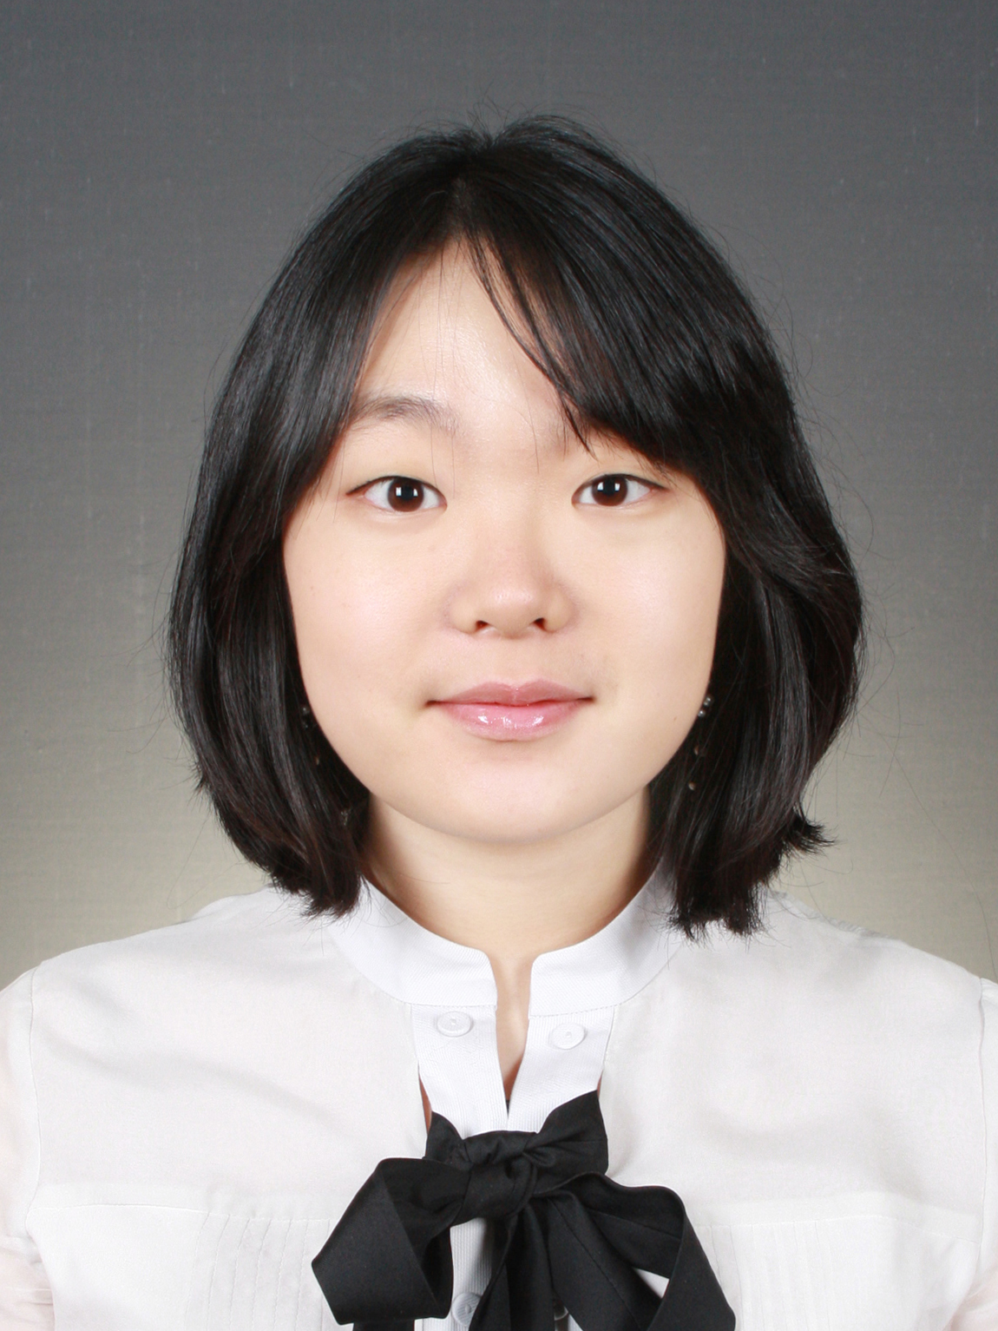
SunnYoung (Sunny) Park

Kukdong APT 5-301, Karak-Dong, SongPa-Gu, Seoul, Korea
Contact No.: 82-2-10-7601-7552
E-mail: sunnshine1016@gmail.com
EDUCATION
Korea University TESOL Certificate Program 03.2009 – 06.2009
Korea University, Seoul, Korea
Bachelor Degree on Educational Studies 09.2004 – 12.2008
Trinity College, Hartford, CT
New York University Summer Program 05.2007 – 07.2007
New York University, New York, NY
Korea University Summer Program 06.2005 – 08.2005
Korea University, Seoul, Korea
High School 09.2000 – 05.2004
Madeira School, McLean, VA
WORK EXPERIENCE
BIS Canada, Bundang, Korea 08.2009 – Current
Full-time ESL Teacher & Administrator
Taught students who needed assistances in English; taught English Musical club; taught after-school homework class; supervised other ESL part-time teachers; helped organizing ESL classes; answered parents’ phone calls; organized club activities; supervised students during recess and to the bus
BIS Canada, Bundang, Korea 06.2009 – 08.2009
Part-time ESL Teacher
Taught students who needed assistances in English
Jack Nicklaus Golf, Seoul, Korea 01. 2009
Part-time English Presenter
Translated Korean power point presentation into English and presented in English for Audi Motor’s
Trinity College, Hartford, CT
Student Activities Office Assistant 01.2008 – 05.2008
Answered questions related to student activities and assisted with financial documents of student-organized clubs
Trinity College, Hartford, CT
Gallows’ Hill Assistant 09.2006 – 05.2007
Managed the coffee machine and the atmosphere of the Gallows’ Hill, which was a student study lounge/café/private library
AGB Neilson Research Company, Seoul, Korea 05.2005 – 06.2005
Intern
Translated Korean documents into English and helped co-workers communicating with foreigners
Trinity College, Hartford, CT
Korean Tutor 01.2005 – 05.2005
Tutored a student under the instructions of a Korean Professor from Yale University

VOLUNTEER EXPERIENCE
June 2009 – July 2009 Educator at Art Bus Project. Art Bus Project, which is sponsored by Space CAN foundation, is a free art education program for underprivileged children. Assisted teaching artists and
September 2003 – December 2003 Assistant Teacher at Country Day School, McLean, VA. Assisted the kindergarten classroom teacher on organizing the class
September 2002 – May 2003 Intern at Congressman Lane Evan’s office, Washington D.C. Organized documents, sorted mails, attended hearings, and greeted visitors.
September 2001 – May 2002 Assistant Teacher at Fairfax Country Day School, Fairfax, VA. Assisted the kindergarten classroom teacher on organizing the class and class tasks
OTHER ACTIVITIES
March 2005 – December 2008 Member of Trinity Dischords (A cappella group)
November 2003 – March 2004 Co-captain of Madeira Varsity Squash Team
November 2001 – March 2003 Member of Madeira Varsity Squash Team

