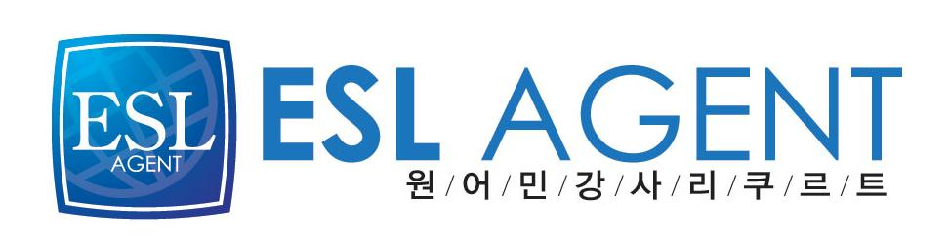
이에스엘 에이전트
최병훈 과장Chris Choe
02-2675-0582

Resume for Patrick D. Thiessen

EDUCATION:

BA in Communications from the Evergreen State College in Olympia, Washington, U.S.A.

EMPLOYMENT:

Mar.2009 – Jan.2010 Teacher at World Class English Institute, Ilsan, South Korea

This was an all adult academy with a variety of students ranging from housewives to business people. I also coached university students preparing to study at international schools.

2004 - 2006 Teacher at Branton Language Institute, Icheon, South Korea

I taught all age groups including children, some adult business students, and some one on one classes with university students preparing for study overseas.

2003 Teacher at Kasey Language School. Donghae , South Korea.

I taught various age groups at the school ranging from elementary to high school students. I also taught on- site for business people at Tong Yang Cement and Korea Electric Power Company.

2001-2002 Teacher at Kwak Youngil Institute, Seongnam, South Korea

I taught elementary through high school students. I also taught advanced level conversation courses to adults and prepared curriculum for the new institute. Students included business people and college students. I also designed specific needs courses for business people in the import /export, manufacturing, and travel industries.

2000-2001 Teacher at Elite English Institute, Seoul, South Korea

My primary duties were teaching elementary age students. I also taught college preparation writing and S.A.T verbal skills courses. I used a prepared curriculum and also created courses for students with specific needs. Additionally, I tutored students in creative writing and speech pronunciation that were preparing for admissions to American Universities.

