ALAN (ALI) ASHOURI

*************RESUME**************

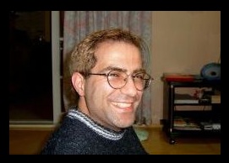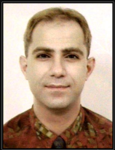

================================
Toronto, Canada
Phone: (Korea) 010-7229-9697
E-Mail : alancanada2@yahoo.ca
F2 Visa (No Teaching Visa needed)
================================

EDUCATION :
- 4-year University Diploma (Alberta and Montreal)
Studies in Music and Computer

LANGUAGE SKILLS :
-English
-Some Korean

SKILLS :
-Teaching English (from Kindergarten to TOEFL...)
-Teaching Computer (Internet, Windows, Microsoft Office)
-Teaching Music

EXPERIENCE :
2001-2009
-Teaching English in Korea (ECC, JungChul, OSS, eFriends, 외대, ChildU)
1997-2000
-Private lessons (Music, Internet, Microsoft Office programs)
-Installation-Troubleshooting PC
-Work in a photoshop (Printing, Restoration and Taking photos)
. . . .

AVAILABLITY :
- June 10th
-Full Time

