Alexander Hyeok Wu Kwon 권혁우 (29)  6’1”(185cm) 220lbs.(100kgs.)  Point of contact:  경상북도 포항시 북구 장성동  Phone number: 010-7725-5926  E-mail: alexthemaster55@yahoo.com  Place of Birth: Republic of Korea  Permanent address:  910 Jana dr.  Smyrna, Tennessee 37167  U.S.A. | 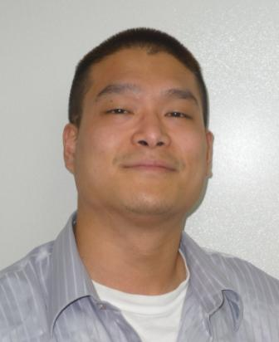

Languages

English (main language) Spoken/Written: excellent

Korean (first language) Spoken/Written: functional

Areas of Competence
- ESL teacher, over 5000 classroom hours  - Research  - Writing | - Public speaking  - Coaching physical education activities  - Group leadership  - Article editorial

IT Skills

- Basic PC and laptop hardware and software

Work Experience

- Currently teaching kindergartens and daycare centers throughout Pohang.

- March 2009 – March 2010 E.C.C./P.S. Way Academy, Pohang – Elementary and middle school students

- September 2007 – March 2009 GNB English Academy, Daesan – Teaching all levels and all ages.

- May – September 2007 Kang’s Language School, Seosan – Elementary school students;

Samsung Total Petrochemical, Daesan – Adults, Basic and Business English;

Hyundae PowerTech, Daesan – Adults, beginners to intermediates;

Seoryeong Elementary School, Seosan (Summer after-school program) – Third and Fourth graders.

- January – April 2007 Home Study, Gangnam – Private Tutoring Institute, Elementary school students

- April 2006-January 2007 Eastern English Academy, Suwon – Elementary and middle school students

Projects and Hobbies

- Former member of Pohang Foreigners Soccer team

- MMA (Mixed-Martial Arts) enthusiast and former competitor with Spirit MC (now defunct)

- Gracie Jiujitsu and combat sport practitioner

______________________________________Etc.__________________________________

Went to the U.S. at the age of 7.

Lived with many different families.

Came to Korea in January of 2006, in search of biological mother.

Received my Korean citizenship in March of 2006.

Additional references will be provided upon request

