Amy Hansen
455-28 Itaewon
Yong San-gu
010-7214-5250
homenglish@live.com

EDUCATION:

Stony Brook University of New York
Stony Brook, New York
Obtained Bachelor of Arts degree in 1994

WORK EXPERIENCE:

Homenglish, Seoul South Korea February 2009 – current
Home study consultant
- Put together a customized curriculum to fit small to medium home schooling, home based learning centers.
- Provide teachers and learning materials to home school centers.
- Source learning materials that is appropriate for home based learning (home schooling) centers.
- Make calls to home schooling centers.
- Travel to Korea to follow up with home schooling center

Challenge, Seoul South Korea May. 2004 – August 2007
Field English Teacher
- Have an extensive experience in teaching professional groups, young adults as well as children of all ages.
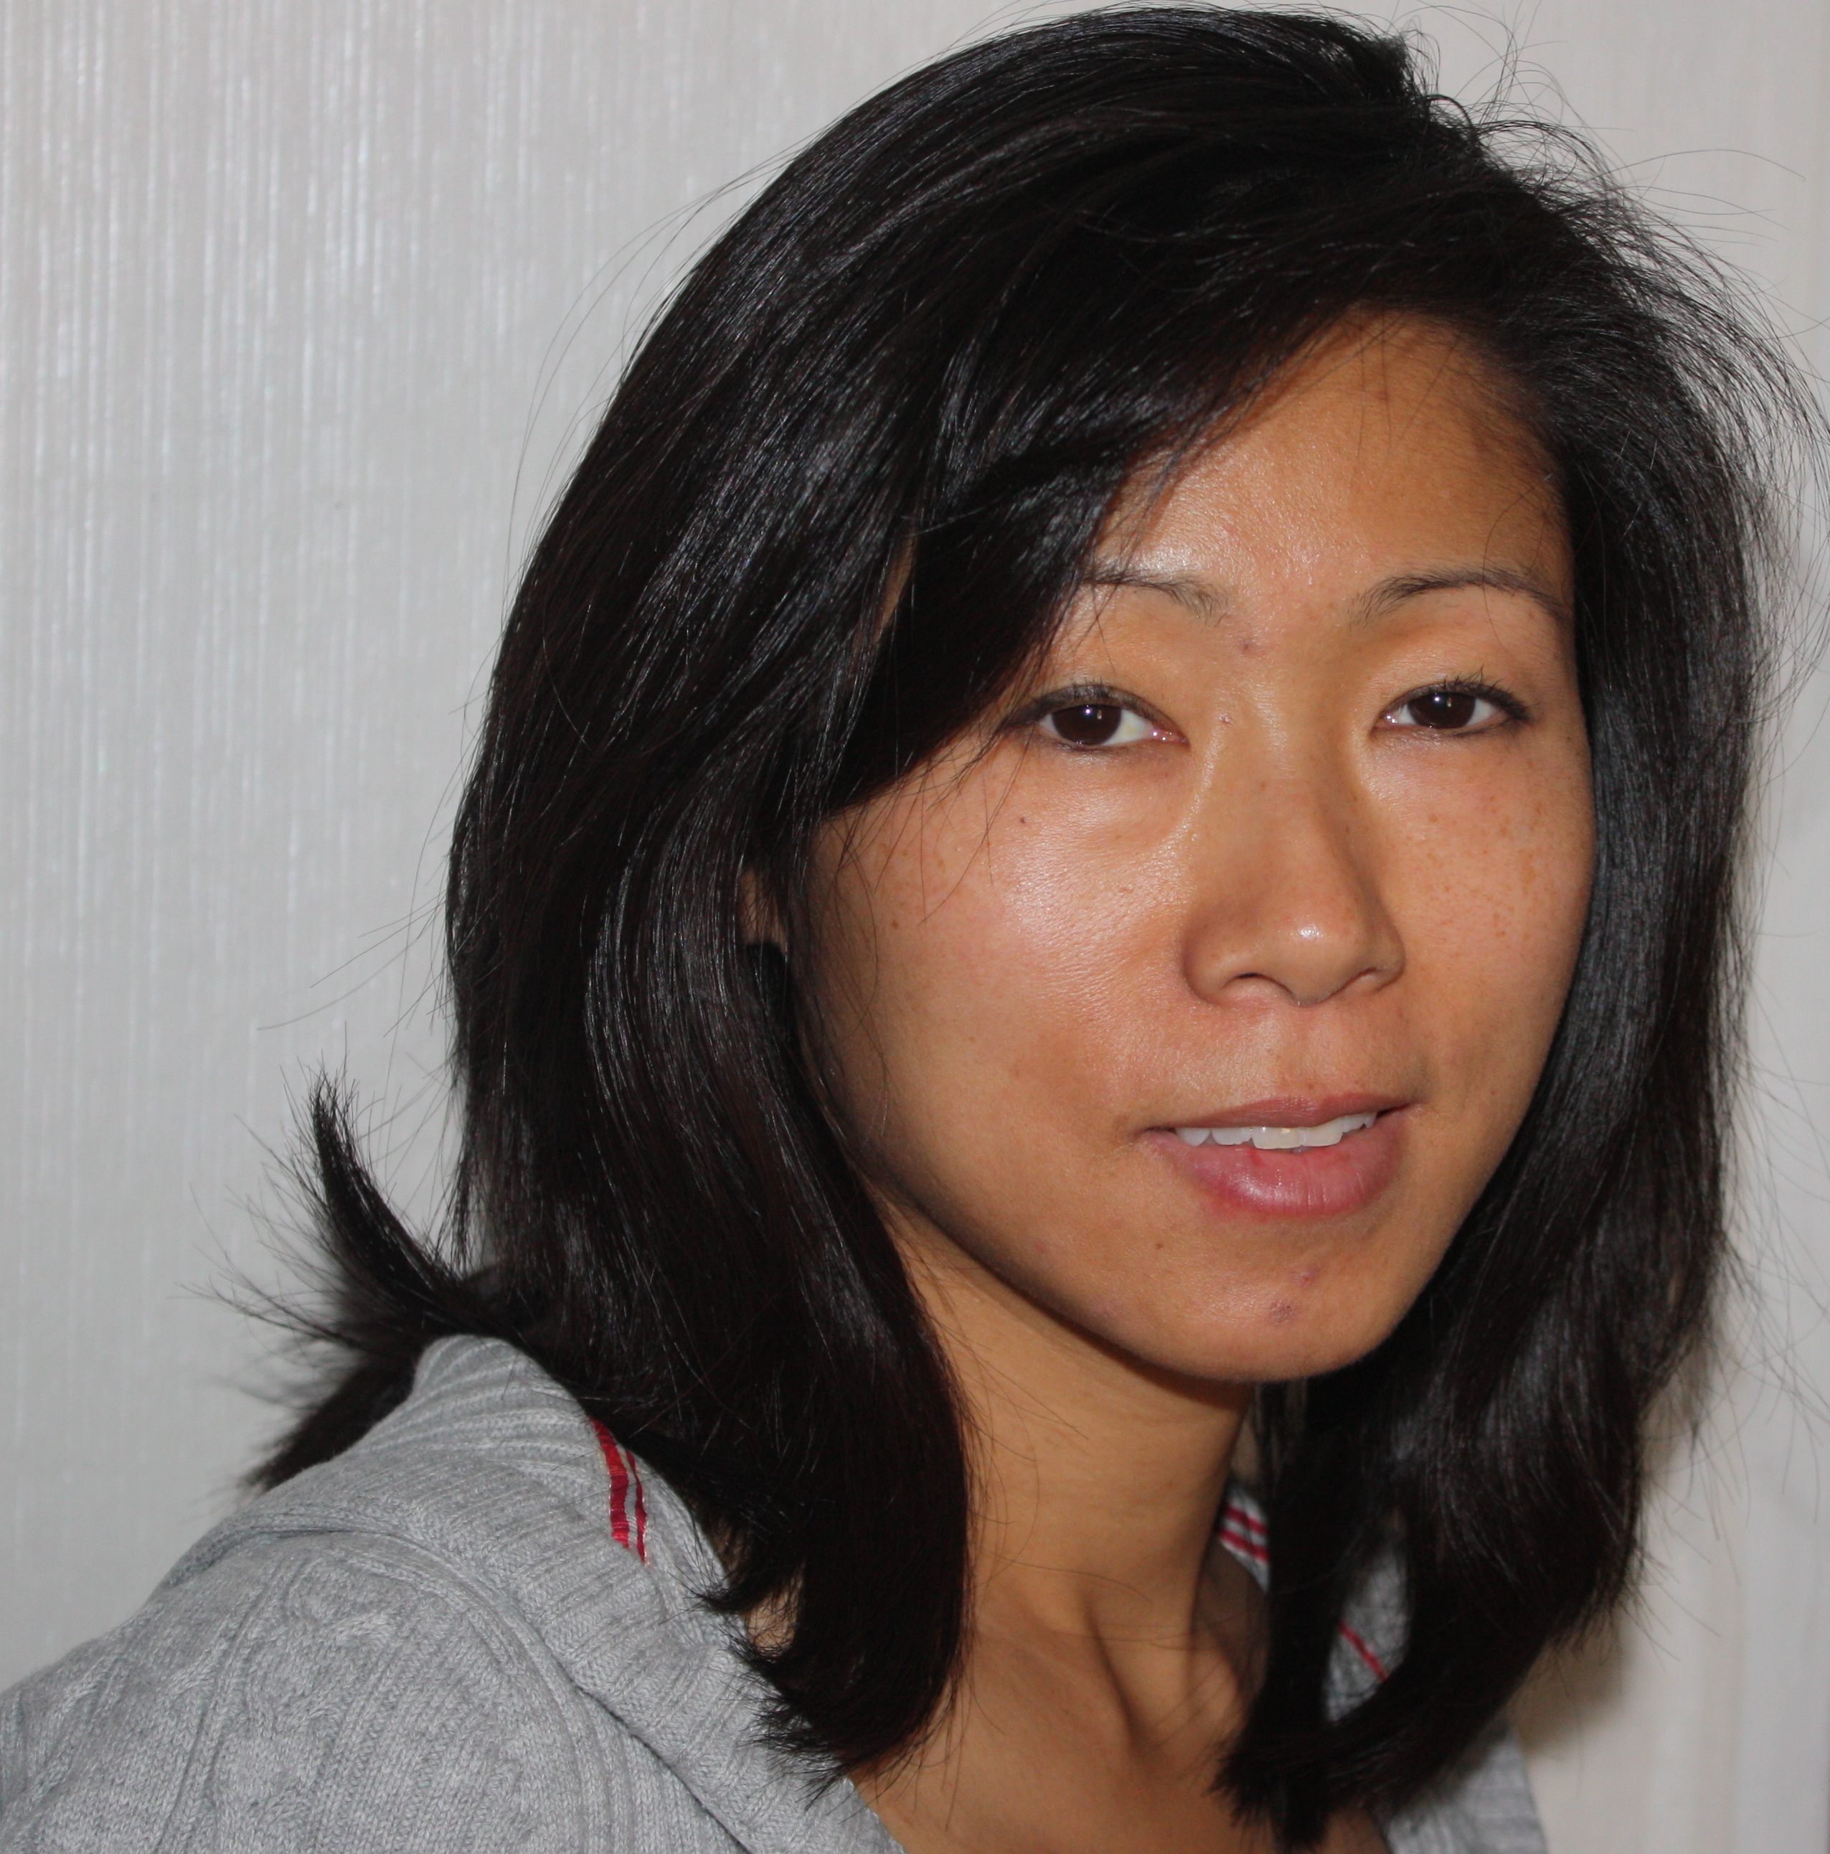
- Taught at LG communications, LG Fashion Corp., Asiana Air, Hysung, G.S. group, Samoo Architect and other major Korean Companies.
- Provided curriculum to fit each corporate ESL training to meet the professionals learning needs

Hanul Education Co., LTD., Seoul, South Korea June. 2002 – August 2005
Head Native Teacher
- Designed ESL (English Second Language) program specific for Elementary, Middle School and High school students for this Academy.
- Put in place a reading program that was to stimulate, motivate and encourage each individual student by using different methodology.
- Train teachers to teach in-house curriculum

Thomson/Delmar Learning, Albany, NY Sept. 1999 –Sept. 2002
Sales/Account Manager
- Streamline academic textbooks and multi media products (DVD, CD/Computer and Video’s) into the academic centers such as: Secondary Schools, Non-profit Job Training Centers and Professional Skill Training Centers.
- Managed 1.2 million dollars territory and had successfully increased territory every year by 20% to 25%, and met my sales goal every year.
- Made many field calls to schools and centers throughout the States.

Amy Hansen
33 Cole Lane
Troy, NY 12180
010-7214-5250
homenglish@live.com

Frederick Atkins, Inc. New York City, NY Sept. 1998 - April 1999
Associate Product Manager
- Managed a cluster of hard goods, Houseware/Cookware lines.
- Liaison between overseas (China, Hong Kong, Indonesia & Taiwan) and domestic retail buyers.
- Product presenter for the shows Frederick Atkins held for buyers and executive members of all department stores.
- Successfully managed multi accounts and was able to meet individual stores by streamlining products based on the stores need.
- Developed and implement a new packaging and its merchandising and was able to tripled Basic Houseware business in 6 months. Attended all shows related to my industry. Published trend reports for bi-annually.

Associated Merchandising Corp., New York City, NY March 1997- April 1998
Associate Product Manager
- Managed full life cycle of product from start to launch.
- Create, maintain and monitor project timelines and follow up with cross functional team members on an ongoing basis
- Source products domestically and from overseas vendors
- Attend new product brainstorming sessions
- Develop merchandise strategy
- Responsible for budge plan: purchasing, allocation and replenishment
- OTB (Open-to-Buy)
- Create tracking matrix to follow up with vendors
- Affective liaison
- Generate monthly business analysis

Deltech Marketing, Inc., New York City, NY March 1995-Sept. 1996
Account Executive/Buyer
- Made sales calls and sourced new products for domestic ASI merchants.
- Liaison for domestic buyers and with overseas vendors.
- Input on packaging and merchandising.
- Responsible for and handling all logistics of importing merchandises.
- OTB (open-to-Buy)

Language Skills:
- Speak and understand basic to intermediate level of Korean Language

