Henry Loyd 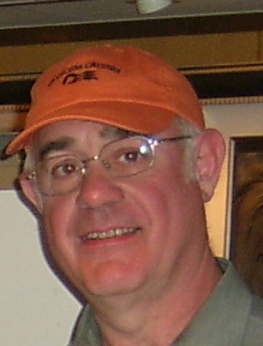
630 Dartmoor
Ann Arbor MI 48103
734-997-9192
hwloydjr@yahoo.com

Objective:
I would like to be able to go to Korea and teach English there. I have retired from the post office.

Experience:

I worked at daesong elementary school where I worked before.

I have worked at Kyonggido English camp in the summer of 2008.

I have worked at Kogas English camp in 2008, teaching English to elementary and middle school children.

I have worked at Access international which is an English language school in Ann Arbor Michigan

I have worked in Korea at daesong elementary school from March 2005-Feb 2006 as an ESL instructor.

US Post Office, Ann Arbor MI: clerk (1982 - 2003)
I started out as a distribution clerk. Then I went to be a dispatch clerk where I supervised the dispatch of all outgoing mail. I then became a Self Service postal technician. I filled and maintain the vending machines that sold stamps. For the last 15 years I work behind the counter. Here I serve the customers. I was also the opening clerk and saw to it the store was always opened on time. I also work as the closing clerk and did the accounting work that came along with running an office. I did receive two major awards while working at the Postal Service, a letter of commendation, and a quality step increase.
General Motors, Willow run MI: Machine operator (1978 - 1982)
I had the responsibility of one machine that made the transmission cases for a front wheel drive vehicles.
US Army, Infantry (1968 - 1970)
I carried a rifle and I learn how to fire a cannon. I was in the Fire direction center.
McDonalds, Ann Arbor MI: Manager (1964 - 1978)
I started out as a part-time worker when I was in high school and worked my way into management. I became a store manager in 1976. I had to do all the responsibilities that come with managing a store.

Education:
I graduated in 1977 with a degree in Business Administration. In 2005 I completed the work required for a minor in TESOL.

Related Coursework:
I have also studied Korean language for two years. I also took classes in English Literature when I studied TESOL.

Interests:
I belong to a church, I like running and many sports, and I like literature.

