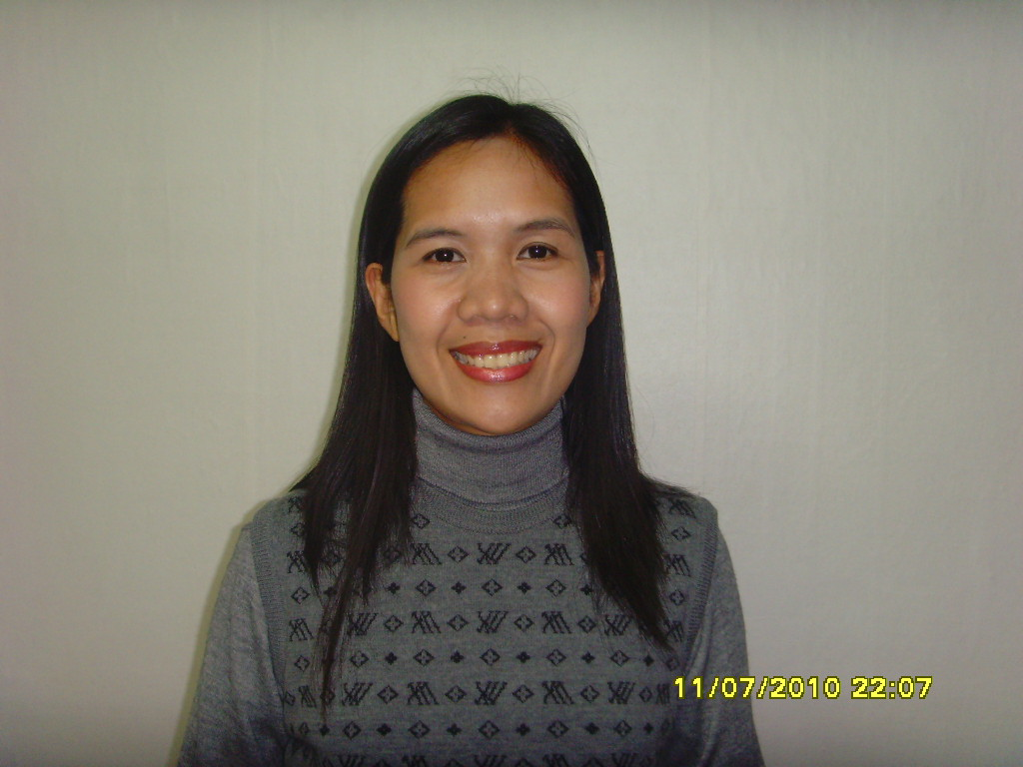

Ma. Lelanie S. Kim (F2-1 visa holder)
Gyeonggi-do Yong-in City

Mobile # 010-4173-9466
010-7771-2928
E-mail address: lanvisele_82@yahoo.com
Skype id : juki.kim

Objective: To obtain an English teaching position in a private institution while providing excellent service to my employer as well as my employer’s clientele.

Work Experiences

March 2010 Eng lish Teacher for Korean students
to October 2010 Location: Gangwondo Pyeongchang South Korea
School: Samyook Academy

Jan. 2009 to Tutor to Korean elementary and high school students
Jan. 2010 Silang Cavite, Philippines
- Teach English as Second Language (ESL) and conversational English to Koreans. Assist on their assignments in school, conduct review lessons for the examinations

July 2008 to Online tutor
Dec. 2008 Dasmarinas, Cavite Philippines
- Teach basic English grammar to advanced English to Korean students of different levels. Practiced them how to read properly and check their vocabulary.

Sept. 2006 to Hanna English Institute
May 2008 Tagaytay, Cavite Philippines
Position: English tutor to Korean students
- Teach English as a Second Language (ESL) to Koreans.
- Assist Korean students with their academic studies.

Jul. 2005 to Department of Education
Aug. 2006 Cebu City, Philippines
Position: Public School Teacher
Assigned to teach all subjects to grade 3 students.

Aug. 2004 to Cebu Philippines
Feb. 2005 English / Academic tutor
- Teach English as a Second Language (ESL) to Koreans.
- Assist primary and secondary Korean students with their academic studies.

Skills

Computer : MS Windows, MS Office (Word and Excel), Internet

Academic Qualifications

2004 – 2004 Cebu Normal University, Philippines
June Nov Masters in Pre-elemenatry Education
Undergraduate

2000 - 2004 Cebu Normal University, Philippines
June May Bachelor of Elementary Education
Graduate

1996 - 2000 Dalaguete National High School, Philippines
Secondary Education- High School Diploma
1990 - 1996 Dalaguete Central Elementary School, Philippines
Primary Education

Personal Background

Born on November 07, 1982 in Poblacion, Dalaguete, Cebu, Philippines. I’m 28 years old, 164cm in height, female and married to a Korean national. I’m holding an F2-1 visa. I have experienced teaching Korean students with different levels of English. With all my experiences and trainings, I believe that I am equipped with all the knowledge and skills needed for the teacher teaching foreigner students. I can teach Phonics, grammar and conversation. I can also speak basic Korean language and still studying to improve my Korean language speaking skill. Dependable, flexible, friendly, hard-working, punctual, team player, honest and patient.

