Resume of Tim Sauder:

Objectives:
To find a teaching or pastoral position
Personal information:

Timothy Sauder:
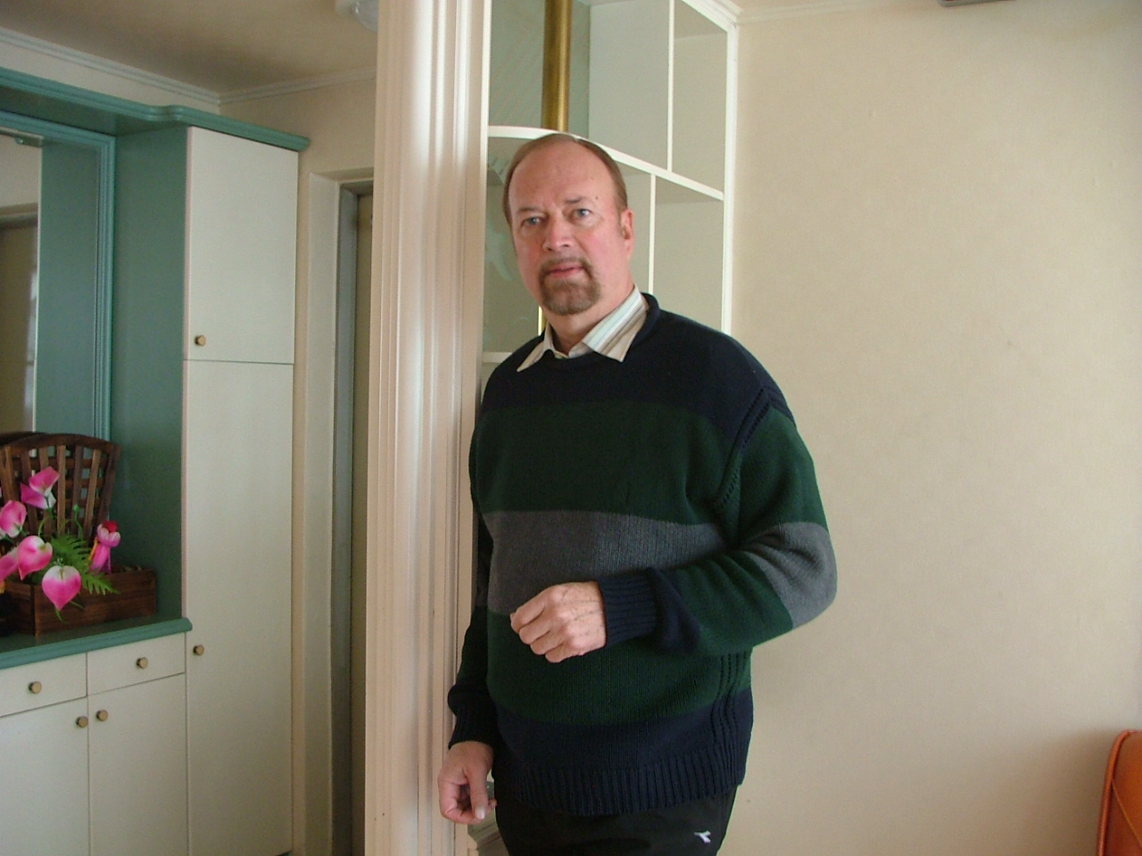

- Statistics:
- Born Kitchener Ontario
- August 22, 1947
- Canadian –
- Detail:
- Married

Summary: Background experience
- Timothy Sauder has owned several businesses mostly related to the kitchen cabinet sales design and installation. Recently he has operated a cabinet installation business in Florida. He lived and owned a retail kitchen business in Canada for 23 years. In the early 90’s he was trained in Texas by Ron Willingham’s organisation ‘Sales training Inc.’ Of Integrity Selling. Certified as a trainer instructor in both sales and customer service he owned Corporate Dynamics of Canada.
- His background and training as a Mennonite pastor and church planter makes him an excellent public speaker.
- In the 70’s and 80’s he was involved in Christian ministry and evangelism on university campuses with several organisations.
- He is a graduate of Oral Roberts University 1973 with a liberal arts degree B.A. Post Graduate studies in business and church management from University of Waterloo Conrad Grebel College.

TOOLS OF THE TRADE –Educational background

*Four years of theology Mennonite studies form Emmanuel Bible College
Kitchener Ontario. Diploma 1970. Accredited Degree 1983.
- B .A. Biblical literature degree Oral Roberts University 1973.
- Post Graduate studies in management and Church Government
Conrad Grebel College in conjunction with Associated Mennonite Biblical Seminaries.
Certificates in Integrity Selling in Texas with Ron Willingham
Customer Service:trainer and teacher.
Grief Counselling with :John Cherry from California.

Creative ministry school :of Youth with a Mission Canada

History of Experience:

- Teaching at KICS school in Cheongcheon campus, Bible and esl.
Korea: Voted top teacher by students.

- Private esl teaching in Panama for 9 months.
- Teacher in Korea with SDA samyook schools in both Jeonju and cheongju. Students voted top teacher in both situations.

- 2005-2007 Owner manager of an installation company in Florida providing the installation of Kitchen cabinets for various companies. As such he was in charge of Job management and co- ordination. Provided problem solving for other companies in management.
- Member and Adult Sunday School teacher in the Mennonite church there. Played an active role in several jobs including cleaning the church on a weekly basis.
- 1983-2004
- He was the owner and manager of ‘Sauder Design’ kitchen design and sales company in Canada.
- Developer of a new format for granite countertops and importer of stone premade for the Canadian market. He developed a dealer network for this product and did training for the dealers in both the installation and sales.
- 1994 Was involved in a church planting situation with the Mennonite Brethren which failed do to lack of co -operation in leadership.
- 1988-1989
- While working in Florida I was involved with a successful church plant called the Gold Coast Christian Fellowship in Boca Raton.
- He managed an assembly plant for kitchens in Florida for a Canadian company. He as in charge of hiring and managing all personal and directing all sales. The company was prepared for to sell and the owner made a huge profit from the sale.
- In1990 He received certification with ‘sales training inc.’ in Texas. Later this was used in Canada to start and operate ‘Corporate Dynamics of Canada.’ This was to give and sell human resource development to the general work place. During this time he was also certified in grief recovery both to train and sell the program to hospitals and other professional persons.
- 1969-1973
- During this time he received two accredited degrees for Christian ministry and also for Liberal Arts.
- 1973-1984
- He was involved in Ministry in various organizations. Training young people and counselling. Involvemen t at this time was also with Youth with a Mission as a leader trainer.
- 1978 Was a leader in Youth with a mission and went on several mission trips one to Argentina.
- 1979-1980 Was a leader in Maranatha ministries from Gainsville Florida doing church planting on university campuses.
- 1973-1976 Was involved with starting a youth ministry in Kitchener which for three years highly influenced the city and the churches in the area. Jacobs Well was known thoughout the area for it’s ministry to youth.
- Speaks English and Spanish.
I am looking for a position if possible in a teaching roll as I have something I feel I can share of valuable from a wide range of theological and personal experience.
I am Mennonite in thinking and hold the Open view of God theologically. I have been involved in a wide range of backgrounds which allows me to appreciate the strengths and weaknesses of others belief systems. Strong teaching ability in church history and Moral Government theology which is Mennonite in form.
I am presently in korea phone 010 5827 0083 or on skype is better. Under Tim Sauder

