LAJANICA TORIBIO y ESGUERRA – KIM
Gang Dong – Gu, SeongNae – Dong 174-17, Seoul South Korea.
Contact Number: 010- 6717-7982
E-mail: ljnc_sgrr@yahoo.com

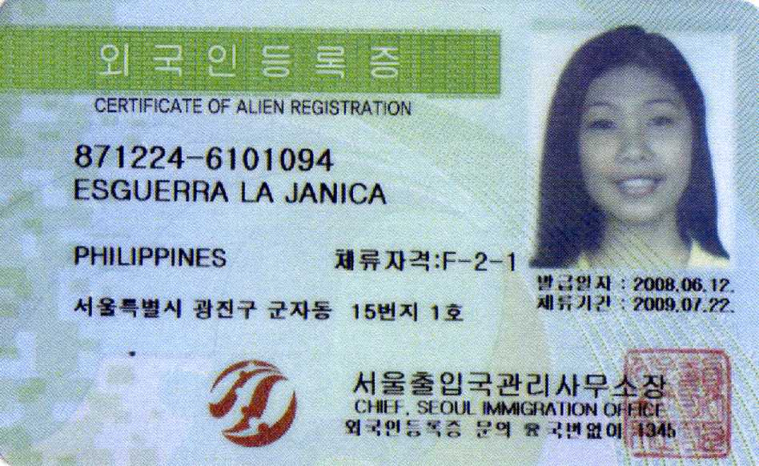
(2010년 까지 체류기간 연장 완료)
OBJECTIVES:
- To help myself acquire knowledge from different experiences in the use of training.
- To become a fulfilled individual that can obtain an entry level position in your company where my skills will be fully utilized in helping your company obtain its targets and goals.
- To sustain my needs.

ABILITY/SKILLS:
- Demonstrated leadership ability. Hard working, trustworthy, punctual, flexible, versatile, accurate and very eager to learn new things.
- Can take dictations and important details.
- Can speak, understand and write in English.
- Also, can speak, read, write and understand some Korean words.
- Microsoft Office Word
- Can drive Automatic Cars.

PERSONAL INFORMATION:
- Age: 25 years old
- Birth Date: December 24, 1987
- Birth Place: Angeles City, Pampanga
- Gender: Female
- Height: 5’7
- Weight: 98lbs.
- Religion: Born Again, Christian
- Nationality: Filipino
- Civil Status: Married
- Spouse: Kim Sung Jin

EDUCATIONAL BACKGROUND:
Primary
- Edilberto M. Ganzon Elementary School
Year: 1995 – 2001
Address: Purok # 4 Baranggay Anunas Angeles City, Pampanga
Secondary
- Angeles City National High School (Vocational School)
Year: 2001 – 2005
Address: Angeles City, Pampanga
Tertiary
- Holy Angel University (4 Year College Degree)
Year: 2005 – 2008
Address: Angeles City, Pampanga
Training Center
- Korean Language & Culture (KLC)
Year: Aug.2008 – Dec.2008
Address: Unit 904, Parc House Condominium, 21 EDSA, Guadalupe Nuevo,
Makati City

Academy
- American TESOL Institute (Teaching English to Speakers of Other Language)
Year: Oct.2009 – Apr.2010
Address: Emerald Avenue, 15floor Strata 100 Building, Ortigas, Pasig City

WORK EXPERIENCE:
- Korea Town Restaurant, Clark Mimosa
Position: Personal Assistant/Cashier (Jan. 2002 – Dec. 2003)
- Futures Holdings Co.Ltd., Fort Bonifacio Global City
Position: Personal Secretary (Jan.2003 – Jan.2005)
- Makati City Elementary School (Mar.2008 – Mar.2009)
Position: Elementary Teacher, (Grade 2 and 3)
- American TESOL Institute (Teaching English to Speakers of Other Language)
Position: ESL Teacher of Korean Students (Mar.2009 – April. 2010)

TRAVELLED COUNTRIES
- Europe
- Seoul, South Korea

I herby certify that the above Information is true and correct
in the best of my knowledge and beliefs.

