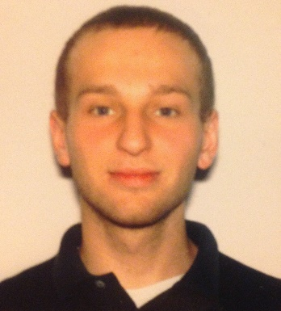
Justin Robbio
14218 Stockwell Lane
Ruskin, FL 33573

Citizenship: USA
Date of Birth: 1995/03/11

Objective Overview
College graduate seeking a teaching position in South Korea.

Education
University of Oregon Eugene, OR, USA
B.S., Double Major in Mathematics and Geological Sciences, June 2017

Experience
Math Tutor Eugene, OR, USA
Teaching and Learning Center, UO 2015 – 2017
- Taught a variety of mathematical subjects to my peers
- Teaching assignments included hands-on help one on one and running group sessions

