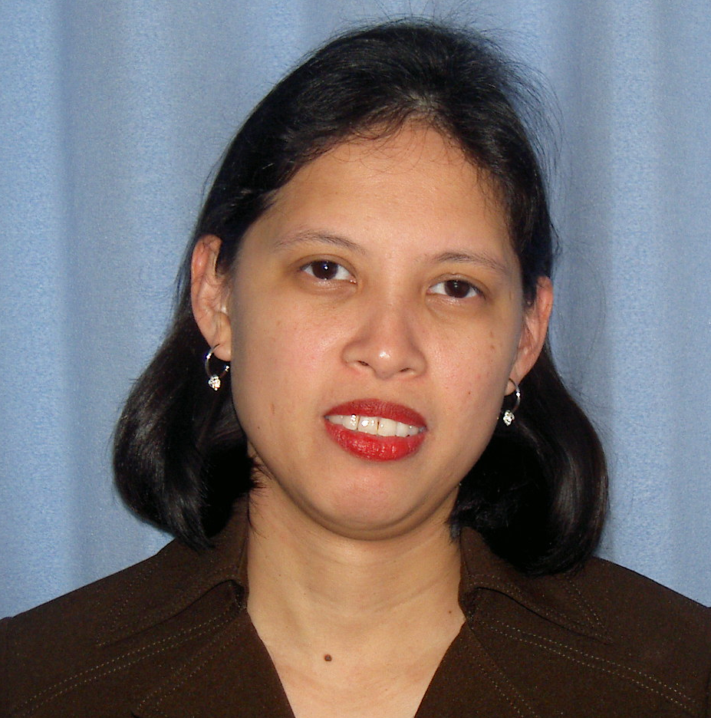
GINA AQUINO DE ASIS
Email Address: ganda4696@yahoo.com
Mobile Phone: (+63) 918-935-0944
Home Address: UPLB-CDC Housing, Purok 6, Puypuy, Bay, Laguna 4033 PHILIPPINES

Educational Attainment:

Graduate Studies: University of the Philippines Los Baños
College, Laguna, Philippines
Master of Management (major: Development Management)
(36 units earned out of 39)

College: University of the Philippines Los Baños
College, Laguna, Philippines
Bachelor of Science in Development Communication
(major: Educational Communication)

Fields of expertise: Development communication; Research and Development Management; ESL/EFL teaching

Recent job: Project Staff, September – February 2009
UPLB Interdisciplinary Program on Climate Change
School of Environmental Science and Management
University of the Philippines Los Baños
College, Laguna PHILIPPINES

Summary of Work Experience:

- On language teaching in the Philippines and Japan
- With TESOL Certificate, 2009 (TESDA-accredited Connective Language Center, Philippines http://www.connectivelanguage.com/)
- Member, English Teachers in Japan since 2004 (http://www.davidenglishhouse.com/en/etj/about.html)

- English language teacher, Socio-cultural and language training program for Kyungnam Province, South Korea
  - For high school students of Kaya University, South Korea held at CEC-UPLB, College, Laguna, Philippines, June – July 2008
  - For mid and high school teachers of Kyungnam University, South Korea held at CEC-UPLB, College, Laguna, Philippines, August – September 2007
  - Handles one-on-one language tutoring on a program-based curriculum
- English language teacher, Dela Cruz English Club, Omiya, Saitama Prefecture, Japan, March 2004 – October 2004 and April 2006 – April 2007(www.delacruz-jp.com)
  - Handles all types of lessons (i.e. daily conversation, travel, MBA, business, etc.) for all levels (novice, average and advanced)
  - Conducts company lessons in Sekisui Hasuda and Tsukuba
  - Gives demo lessons to prospective learners
  - Prepares student evaluation on a regular basis
  - Participates in the School’s activities
- English language teacher in Tokyo, Japan (freelance), March 2004 – April 2007 through www.findateacher.net
  - Conducts EFL lessons to Japanese students and professionals in all levels (elementary, intermediate and advanced) using tailor-fit lesson materials

- At the University of the Philippines from 1994-2005:

- Instructor/tutor of management courses for graduate studies in distance education mode at the University of the Philippines Open University (1997 – 2001) ALL COURSES ARE TAUGHT USING ENGLISH AS THE MEDIUM OF INSTRUCTION
- Conducted research and training programs for various government and non-government companies (involvement ranged from being the coordinator, assistant coordinator, facilitator and trainor) (1994 – 2005)
(Member, Philippine Association of Research Managers, Inc. since 1996)
- Technical assistant to the three highest officials of the College of Agriculture in the University of the Philippines Los Baños (1999 – 2005)
- Graphics design assistant and content editor of the UPLB College of Agriculture official website (2000 – 2005)
- Technical and language editor of various international and national scientific journals and other University-based information and awareness campaign materials (since 1994)
(Member, Philippine Association of Journalists, Inc. since 1999)
- Information/communication materials and multimedia production specialist (1995 – 2005)
- Public Information Associate (1996-2005)

Other Information:
Birthdate: May 29, 1971
Marital status: Widow (with two kids)
Interests/hobbies: internet surfing, blogging, scrapbooking, digital layout design, photography, doing artshops with my children

(updated February 2009)

