Raegan Cerisano
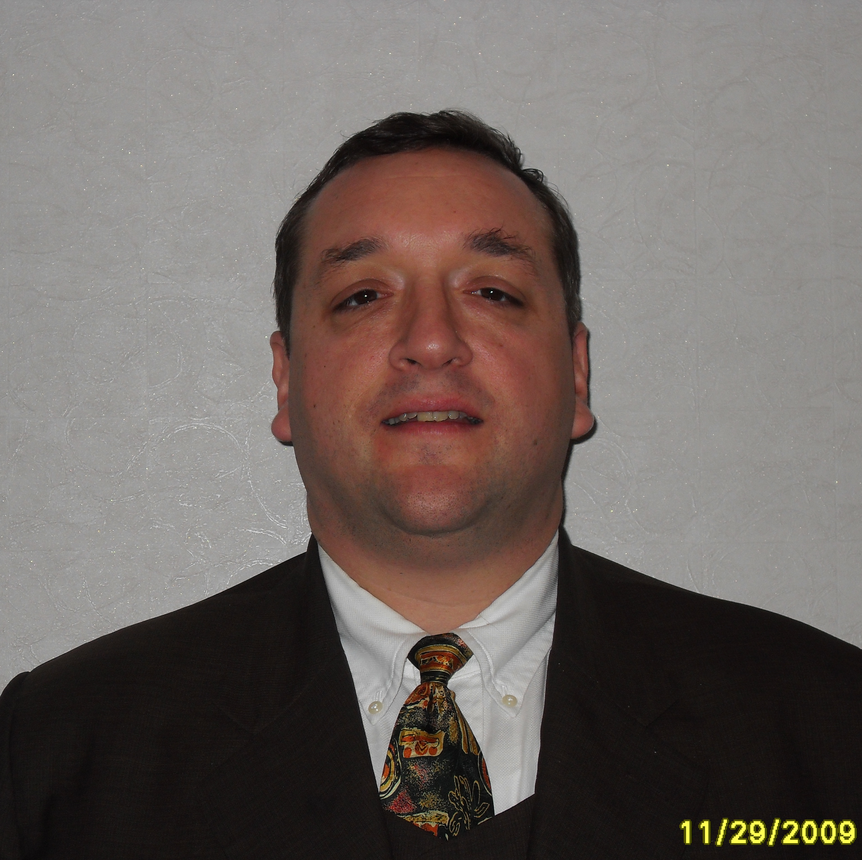
010-3303-6637
r_y_cerisano@hotmail.com

Work History
Mar 2008 – Feb 2010 Anhwa High School
Taught 1st and 2nd grades. Prepared curriculum and delivered and scored mid-term and final exams. Organized and taught summer and winter camps. Taught after school classes and coached the basketball team.

Mar 2004 – Feb 2005 Konji Am Middle School
Team taught all grades. Prepared and taught summer and winter camps by myself.

Mar 2003 – Feb 2004 Shin Sung High School
Taught grades 1 to 3. Prepared the curriculum and all teaching materials. Gave the students exams and assigned the students grades.

Mar 2002 – Feb 2003 Suwon University
Taught freshman and sophomore conversation English. Responsible for preparing the curriculum, writing and giving exams and assigning grades.

Aug 2001 – Feb 2002 KangNam University
Taught freshmen and sophomore conversation classes. Prepared curriculum, exams and assigned grades. Taught adult education classes at a local company.

Education
1999 B. A. in Psychology
Brigham Young University, Provo Utah

1998 Microcomputer Software Certificate
Conestoga College, Kitchener ON Canada

1993 Associates Degree in Accounting
Rick’s College (now B. Y. U. Idaho)

As a teacher in Korea I have had extensive experience in preparing for and teaching students of all levels. I am skilled at motivating and educating learners. I am proficient at preparing curriculum, measuring performance and assigning and reporting grades. I am exited about teaching in 2010.

