Jason Clark  129 Peter Coutts Circle  Palo Alto, CA 94305, USA  (408)646-9376  jasonthomasclark@gmail.com | 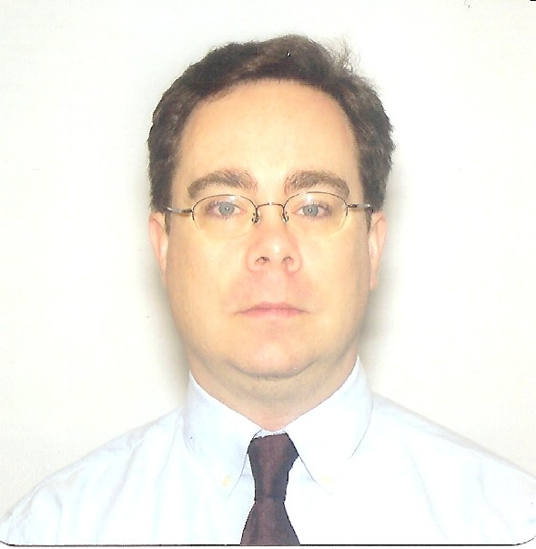

Summary

I have extensive experience in teaching and professional training. As an ESL Teacher, I instructed classes of 10-12 students (children and adults) in English in South Korea. As a Trainer, I prepared and delivered lessons on technical material to groups of 5-10 professional adults.

Experience

ESL Teacher, Top Language Institute, Jeonju, South Korea, 1994 - 1996. I taught Beginner English (phonics, vocabulary, simple sentence structure) to classes of 10 - 12 students aged 11 - 16 years old. My adult classes were in Conversational English with students of varying ability. My duties consisted of preparing and delivery lesson plans and class materials, and assessing students’ progress.

Software Application Engineer, Trimble Navigation, Santa Clara, CA, USA, 1997 - 2000.

Lead Software Application Engineer, Aristasoft, San Jose, CA, USA, 2000 - 2001. For my team of 5 engineers, I designed the curriculum for their training in software support. I developed and delivered lessons in software and database installation and troubleshooting. I also coordinated their training and skill level with deployment to customers for optimal support coverage.

Senior Internet Application Engineer, Berkeley HeartLab, Burlingame, CA, USA, 2001 - 2005.

Internet Application Engineer, ConsumerReviews, San Mateo, CA, USA, 2006 - 2008.

Account Manager, Atypon, Santa Clara, CA, USA, 2009 - 2010. I trained academic pubishing customers in use of the company's online journal distribution tool. I prepared, documented and delivered training sessions to adult professionals over the phone and through online webinars.

Independent Contractor, ModoComm, Palo Alto, CA, USA, 2010 - present. I program applications for iPads to be used as educational tools by Sales Representatives during presentations of pharmaceutical products to doctors and hospitals.

Certifications

ESL/EFL Teaching, ICAL (http://teacher-training.net).
Certificate in Editing, University of California, Berkeley (in progress).

Education

Johns Hopkins University, B.A., English, 1993.
University of Missouri, M.Ed., 2006.

References Available Upon Request

