Christina Lee

4 Hire

**If hired will be available at the end of Aug.

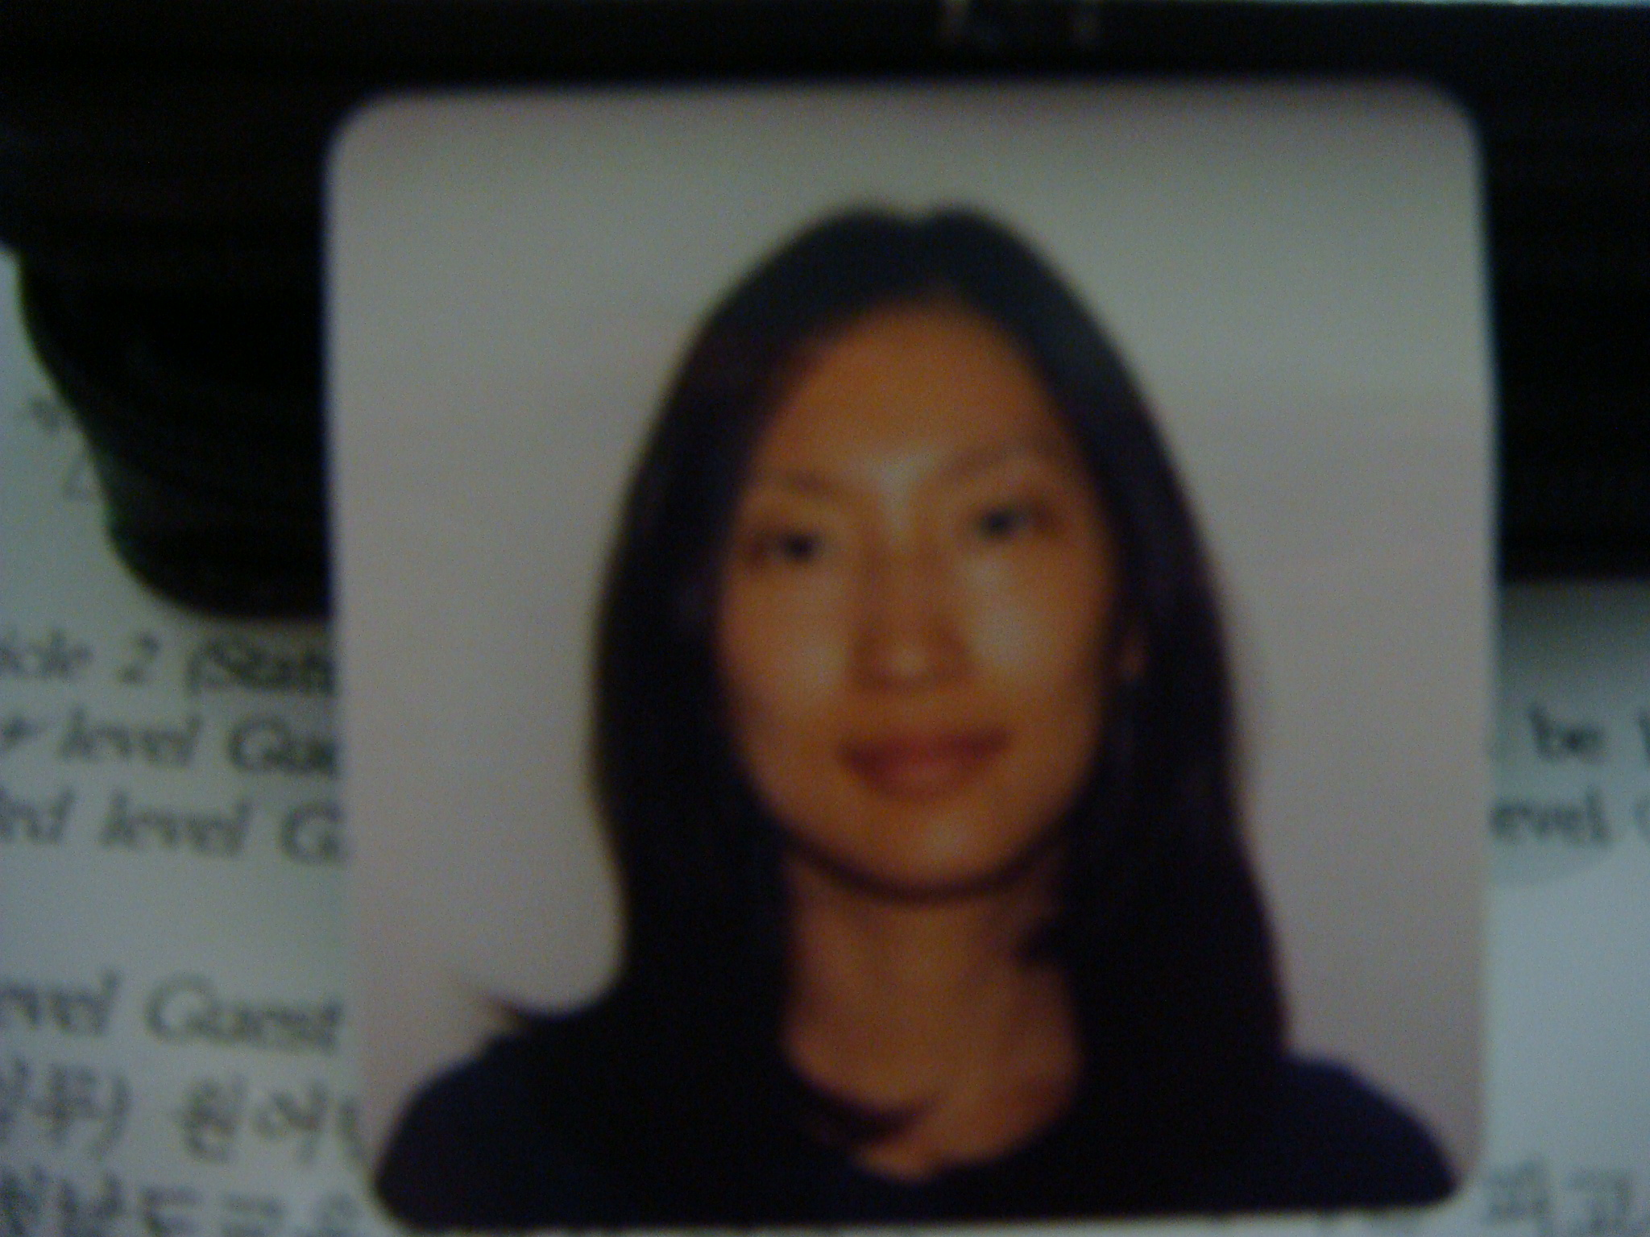
Christina Lee
1331 Ala Kapuna St. #307
Honolulu, HI 96819
C_tina49@hotmail.com
010-9940-0738 (Cell.)

Residency for EPIK program
Choongchungnamdo, Gongju Keumsungdong

Education

University of Hawaii, Manoa
B.A. - Second Language Studies/Interdisciplinary Studies

Experience

Fall ’08 – Present(until Aug.) EPIK Teacher (Keumsung Girls’ High school)
- Conversation/Discussion

Fall ’01- Spring ’05 Teacher/Assistant (Korean Language school)
- Teach basic Korean to elementary students
- Do games to reinforce what was taught

Fall ’03-Fall ’08 Bible study teacher
- Teach about the Bible/God’s words
- Mentor/counselor

Summer ’05-Fall ’08 Sunday School teacher/Praise leader
- Teach elementary students about God
- Do praise & motions (song & dance)
- Using games, crafts, & etc.

Spring ’04 – Spring ’05 Tutor
- Reading comprehension

Fall ’06 – Fall ’08 Receptionist
- Organize files, stock supplies, clean rooms
- Interact with patients

Fall ’05 – Fall ’08 Barista
- Clean, prep, make coffee
- Converse with customers

Fall ’03 – Fall ’04 Receptionist
- Book flights, hotels & etc.
- Order inventory
- Compare rates and research other destinations

**If hired will be available end of Aug.

