RESUME

MUnsoo Thomas Kim
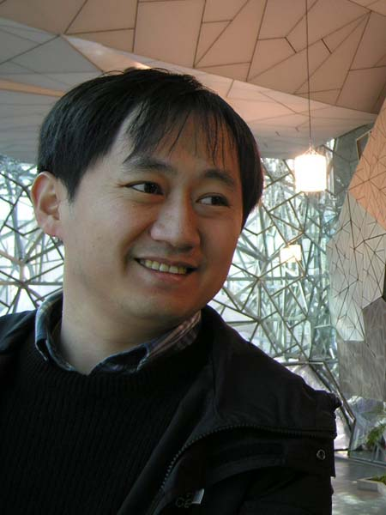

Phone. 010-5186-8332
Email. munsoo@hotmail.com

PROFILE

- An Enthusiastic, responsible, and caring individual with a passionate commitment to student development and the learning experience.
- Superior communication and interpersonal skills to play a bridge role between different cultures and languages and also to foster meaningful relationships with students, staff, and parents.
- A trustworthy and approachable individual with strong work ethics.
- A committed and active team player who effectively collaborates with staff members.
- Attitude to remain flexible, ensuring that every students’ learning styles and abilities are addressed.
- Excellent understanding of Korean culture and how Korean students think and behave.
- Dedicated to providing the best English education and care to students.
- Experiences in
  - Student Motivation
  - Classroom Management
  - Student-Centered Learning
  - Multicultural Awareness
  - Student Assessment
  - Interactive Learning
  - Teaching Korean Students
  - Parent Teacher Communication

QUALIFICATIONS

Cambridge CELTA/Certificate IV in TESOL 2007
International House Sydney

Diploma of Traditional Chinese Medicine 2001 - 2002
Sydney Institute of Traditional Chinese Medicine
Bachelor of Health Science (in Chinese Herbal Medicine) 1998 - 2001
University of Technology, Sydney

Bachelor of Science 1993 - 1996
University of Sydney

Higher School Certificate 1990 - 1992
Epping Boys’ High School

teaching Experience:

Korean army intelligence school

Dec 2007– Current

Native English teacher

Full-time

Teaching English to selected army officers at various levels

Grigos Academy, daichi gangnam

Apr 2008 – Jul 2008

Teaching English and other subjects to Grade3 and Grade7

Part-time

Korean Martyrs and St. Stanislaus Catholic Church Sunday school is located in Sydney

The Korean Martyrs and St. stanislaus catholic church

Jan 1997– Feb 2002

Sunday school teacher Jan 1997 – Jan 2000

Sunday school vice principal Feb 2000 – Feb 2002

Teaching Religion to high school students

employment history:

Samdae Herbal & Acupuncture Clinic is a busy clinic located in Sydney.

Samdae herbal & acupuncture clinic

Aug 2001 – Oct 2007

Traditional Oriental Medicine Practitioner

Full-time Feb 2003 – OCT 2007

Part-time Aug 2001 – Jan 2003

Computer Skills

Windows 2000 & above; Microsoft office including Word

Other Skills

Senior First Aid Certificate 2001– Current

PERSONAL DETAILS

Nationality Australian
(F-4 visa)

Interests: Kumdo, Tennis, and Swimming.

REFEREES WILL BE PROVIDED ON REQUEST

