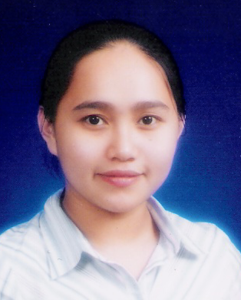
RHEA R. BIÑAR
145 – B Luzon Street, Brgy. Pitogo,
Makati City
728 – 63 – 78 / 09286074633
rhaymar17@yahoo.com

Objectives:

- To be able to pursue a more skillful enhancing job that could lead me to a better future.

- To be able to have a good experience that could help me to be more skillful.

Graduate of: Units earned:

A.B. Political Science Certificate in Teaching
Rizal Technological University University of Makati
Boni Ave., Mandaluyong City J.P. Rizal Ext. West Rembo, Makati City

Personal Information:

Birth Date: August 07, 1984 Father’s Name: Ronilo G. Biñar
Height: 5’0 Occupation: Tailor
Weight: 112 lbs. Mother’s Name: Ruth R. Biñar
Status: Single Occupation: Housewife
Citizenship: Filipino

Job Experiences:

- Presently working at Dialenglish Online School (Home based)
December 2007 up to present

- Education Culture International (ECI)
English Teacher
June – October 2007

MIS Camp in Subic
Master’s International School
Education Culture International (ECI)
(Foreign students – Koreans)
August 8 – 29, 2007
- man to man class
- group class
- Elementary Teacher at Forever in Him School of Makati, Inc.
School Year 2006 – 2007

Achievements:

- Facilitator of Teambuilding and Team Games
April 28 – May 2, 2008 at Magalang, Pampanga

- Youth President (Philippine Evangelism Center under United Pentecostal Church)
2006 up to present

- President ALAY – RTU (Alliance of Leaders Among the Youth) 2002 – 2003
      - Fund Raising – Cake Raffle

      - Outreach Program – “ALAY HANDOG ‘03” in cooperation with
Capt. Severo N. Servillon
Barangay High-way Hills, City of Mandaluyong
January 12, 2003

      - National Capital Region Central Council – ALAY Medical Mission
Barangay Sta. Ana, Pateros, Manila
September 29, 2002

Trainings:

- Self – Survival and Camping Activities
Momarco Adventure Outdoor Center, Sitio Bathala, Tanay Rizal
March 10 & 11, 2001

- COE I – Colliers International Phils., Inc. under HR/Administrative Division
and Property Management Division

- COE II – Nhel Reflex Therapy Clinic

Seminars:

- “ Global Competencies and Alternative Careers for Generation XYZ”
Theater, De La Salle – College of St. Benilde
January 25, 2005

- 2nd Section 5 – NCR District Sunday School Teachers Congress 2003
United Pentecostal Church Alabang
November 15, 2003

- 28th YMCA National Congress of College Students
Theme: “YMCA Leadership is Responsible Citizenry”
Teacher’s Camp Baguio City
December 4 – 8, 2002

- Marcos vs. Manglapus: “A Trial of Abode and Travel” A Symposium
Mini Theater, Rizal Technological University
October 21, 2002
- Student Government Management Program (SGMP)
Plenary Hall, Rizal Technological University
September 20, 2002

- Anti – Drug Campaign Seminar
Barangay Barangka Ibaba, Mandaluyong City
October 13, 2001

- Sunday School Teacher’s Congress
Philippine Evangelism Center
July 20, 2003

- Sunday School Teacher’s Congress
Philippine Evangelism Center
June 12, 2001

References:

- Rev. Celedonio C. Ompad
Resident Pastor
Philippine Evangelism Center
751 – 01 – 98

- Ptr. Arnold S. Dumalagan
Resident Pastor
Jesus Christ Household of Christian Faith
Church International (Full Gospel), Inc.
758 – 20 – 71

- Mr. Nelson P. Robles
Licensed Therapist
1740 Escuela St., Guad. Nuevo, Makati City
882 – 20 – 11

I hereby certify that the above information is true and correct to the best of my knowledge and belief.

_____________________________
Rhea R. Biñar

