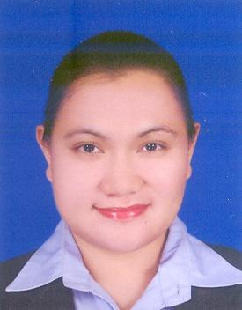
JACQUELINE M. ESCONDO
313 San Roque St. Cabrera Pasay City Contact No.: 02-8432830/0926-4856009
Professional License Number:0952418 E-mail: Jacqueline_727@yahoo.com.ph

Job Objective: To contribute my skills, knowledge and ideas and help in the molding of children’s capabilities to become a productive person for the next generation.

PERSONAL INFORMATION:

DATE OF BIRTH: March 3, 1983
PLACE OF BIRTH: Quezon City
CITIZENSHIP: Filipino
HEIGHT: 5’6
WEIGHT: 150 lbs.

EDUCATIONAL ATTAINMENT:
SCHOOL YEAR GRADUATED
TERTIARY: Jose Rizal University 2006
COURSE: Bachelor in Elementary Education major in English
SECONDARY: Blessed Elena Academy 2000
ELEMANTARY: Blessed Elena Academy 1996

CO-CURRICULAR ACTIVITIES:
- Young Educators Society (Member)
PROFESSIONAL ORGANIZATION:
- National Organization of Professional Teachers Inc.

TRAINING
SCHOOL
On-Campus Training Jose Rizal University Elementary Department
November 2005-January 2006
Off-Campus Training Plainview Elementary School
January-February 2006

WORK EXPERIENCES

COMPANY POSITION FROM-TO

Freelance Private tutor to Korean March 2008 – July 2008
Roxas College of Mindoro Elementary School Teacher June 2007 – March 2008
HowTalk Group International ESL Teacher May 2006-February 2007
Part-time Private tutor to Korean October 2006 - February 2007
Lexter Printing Corp. Office Staff October 2004 - July 2005
RL Hotel Coffee Shop Attendant May 2003-October 2004

SPECIAL SKILLS
- Proficient in MS Office application and Internet browsing. Playing volleyball and badminton, cross-stitching and singing.

SEMINARS ATTENDED

Attitudes that Attracts Success
- HowTalk Group International. 17th flr. Trafalgar bldg.
H.V. Dela Costa Makati City
- November 2, 2006

Seminar for Demonstration Teaching
- Jose Rizal University Student lounge
- September 3, 2005

Lesson Planning Expo 2005 A series of seminar (History Subject)
- JRU Audio - Visual Room
- January 22, 2005

Lesson Planning Expo 2005 A series of seminar (English Subject)
- JRU Audio - Visual Room
- January 18, 2005

CHARACTER REFENCES

Dr. Chenita Dapito
- Professor, Adviser of Young Educators Society
- Jose Rizal University

Ms. Ives Ilagan
- Manager
- HowTal Group International

Ms. Cecille Nabong
- Head Teacher
- HowTalk Group International

