Joseph Tan Yeow Kiat 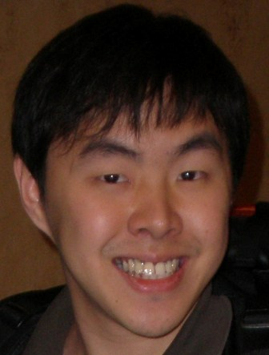 D.O.B: 10th Dec 1981
82055532
joseph.tanyk@gmail.com
Singaporean
________________________________________________________________________

PROFESSIONAL EXPERIENCE

Miyuki Snow International Limited Partnership (Thailand) Aug 2008 – Present
Director/Business Development Manager
- Promote and advertise sales opportunities for the company
- Achieve regional sales targets and diversify branding of company’s products
- Increase clientele contacts and establish good relationships with them.

Overseas Chinese Banking Corporation Aug 2006 – Jul 2008
Banker
- Offer customer service assistance to all banking clients.
- Promote and offer financial products to all interested investors

Parkway Health Jan 2006 – Apr 2006
Laboratory Technician (Pathology)
- Preparations of Pathological Solutions such as Formalin
- Preparations of specimens using the Microtome for pathological examinations

Singapore Armed Forces Aug 2003 - Dec 2005
National Service -- Project Clerk
- Liaise with various commercial pharmaceutical companies to purchase/procure medical items for military usage.
- Coordinate with Singapore Technologies for the distribution and storage of the medical items.
- Build up critical computer skills

Singapore General Hospital Jul 2002 - Dec 2002
Internship
- Rotate to Haematology, Clinical Chemistry, Pathology, Histocytology, Microbiology and Virology laboratories
- Gain valuable hands-on experience in each department

Ricted Kennels Nov 2001 - Feb 2002
Farmer Assistant
- Succeed in the challenge of managing difficult animals
- Give introductory speeches and provide excellent customer service to tour groups

Magic Corner Dec 1997 – Apr 1998
Sales Assistant
  - Achieve sales quota in clothing and accessories month after month
  - Approach tourists in Clarke Quay to improve customer interaction

Bobby Rubino’s Restaurant Nov 1996 - Jun 1997
Waiter
- Provide highest quality service and ensure concerns were reconciled promptly and efficiently, often working extended hours to ensure adequate staffing of restaurant
- Communicate well with managers and colleagues

EDUCATION

Murdoch University Jul 2006 – May 2008
Bachelor of Commerce (Business Management)

Temasek Polytechnic Jul 1999 – May 2003
Diploma in Biomedical Science

SKILLS

IT
MS Word, Excel, Powerpoint, Adobe Applications.

Languages
 | Written | Spoken
English | Very Good | Fluent
Chinese | Very Good | Fluent
Cantonese | NA | Fluent
Thai | NA | Fair

VOLUNTARY WORK
Tsunami Relief Operation Dec 2004 – Jan 2005
- Coordinate purchasing and sending of medical equipment to tsunami-hit areas in Banda Aceh

‘Trash It Out’ Event Feb 2002
- Participate in a community recycling-clean-up event organized by Local Community Centre

HOBBIES
- Reading – Both fiction and non-fiction for new and creative perspectives
- Writing – Stories and Scripts for blogs and short-stories contributors.
- Soccer – For a healthy body and mind

