Debora H. Kang
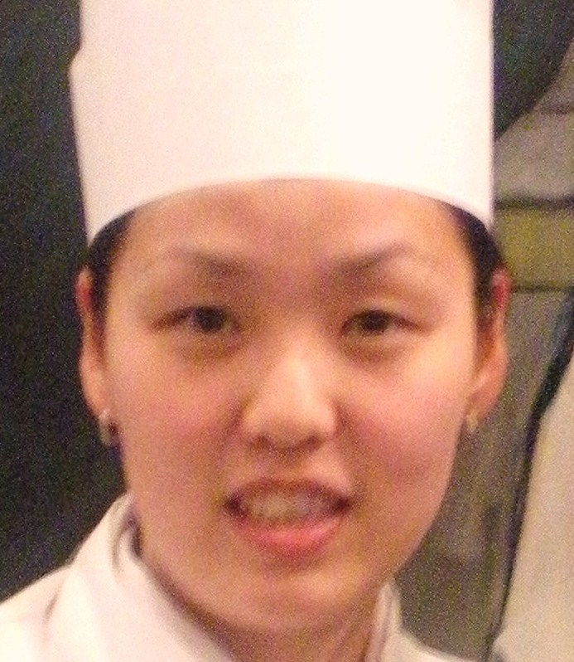
2 Lombard Drive West Caldwell, NJ 07006
서울 강서구 방화2동 에어트리움 본관동 522호
(010) 8744 – 2960
Dempora29@gmail.com

Debora H. Kang Debora H. Kang
Education
The French Culinary Institute, New York, NY
Grand diploma in Pastry Arts March, 2009 - January 2010
- Intensive nine month course of study and 600 hours of hands-on practical training in classic Pastry Arts techniques; curriculum includes tarts and cookies, pate a choux, puff pastry, breads, petits fours, cakes, plated desserts, frozen desserts, sugar and chocolate.

Sook Myung University, South Korea
Korean Traditional Food Certificate May 2007 – Aug 2007

New Jersey Institute Technology, Newark, NJ
Bachelor of Management Information System September 2000 - May 2007

Work Experience
Christine’s Bakeshop, North Plainfield, NJ January, 2009 – January, 2010
Pastry cook & Cake Decorator

Yuki Hana Japanese restaurant, New Jersey, NJ June 2008 – January 2009
Assistant manager

ChildU, Seoul, Korea March 2007 – February 2008
Kindergarten (director) – middle school English teacher

TmaxSoft, Englewood Cliff, NJ March 2006 – February 2007
Administration Assistance

Kiku Hibachi Restaurant, Paramus, NJ September 2005 – February 2007
Full time & Part time kitchen assistance

Chase Manhattan Bank, Fort Lee, NJ May 2005 – February 2006
Financial Advisor assistance

Additional Skills
- Fluent in Korean
- Proficient in MS office

