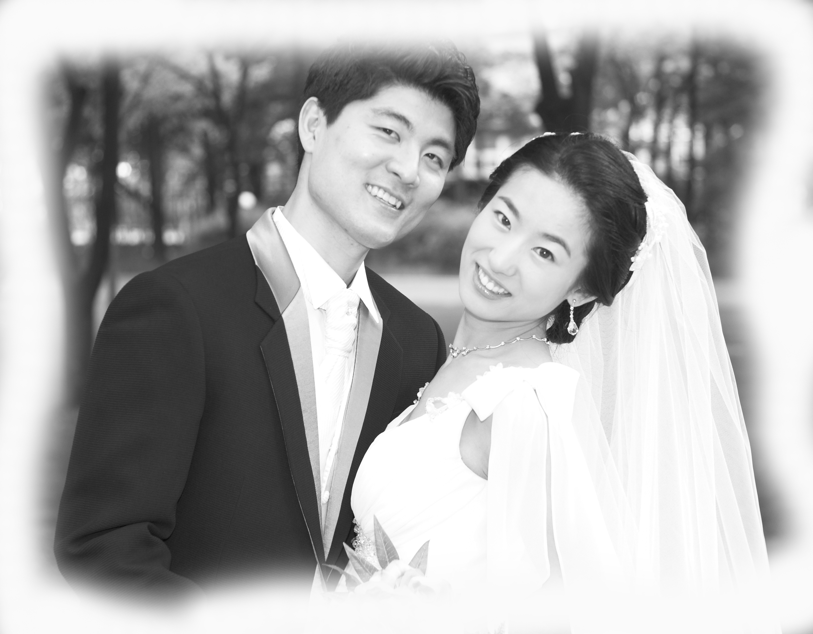
Ben Chun
401-1702 Sampyeong-dong, Bundang-gu, Seongnam-si, Gyeonggi-do, Korea
Tel: 031) 711-8969 Cell:010-4841-8969 ychun119@naver.com

Objective
To obtain a position in the English Teacher

Education:

University of Maryland, Baltimore County
Bachelor of Arts Degree – Visual and Performing Arts, December 2000
Major: Graphic Design
Overall G.P.A.: 3.1/4.0 Major G.P.A.: 3.3/4.0

Certifications
-TESOL Certificate at SookMyung Women’s University, December 2003
-Associate Teacher at Jung-Chul Junior Teacher Qualifying Camp, February 2004
-Wizisland TQC(Teacher’s Qualification Course), January 2006
Skills:
-Excellent classroom management
-Good presentation skills; effective communication in diverse classroom
-Ability relate to different types of people
-Well organized, sound judgment and decision making ability.

Experience:
Ace English Academy
Position: English Teacher
2009-2010 Bundang, Korea
• Teaching elementary & middle students phonics, and conversational English through an activity based curriculum.

Yale Language School
Position: English Teacher
2006 – 2009 Bundang, Korea
• Teaching elementary & middle students phonics, and conversational English through an activity based curriculum.

Wizisland at Juk-Jun
Position: English Teacher
2007 – 2009 Suji, Korea
• developing curriculum to implement programs for kindergarten through 6th grade.

Olive Art School
Position: English Teacher
2007 – 2009 Suji, Korea
• Teaching kindergarten students phonics, and conversational English through an activity based curriculum.

Wizisland at Suji
Position: Executive Officer & English Teacher
2005 – 2006 Suji, Korea
• developing curriculum to implement programs for kindergarten through 6th grade.

Jung-Chul Junior English school
Position: Executive Officer & English Teacher
2004 – 2006 Suji, Korea
• Teaching elementary & middle students phonics, and conversational English through an activity based curriculum.

English Teacher at Ye-Harim Art school
Position: English Teacher
2004 – 2007 Bundang, Korea
• Teaching kindergarten students phonics, and conversational English through an activity based curriculum.

English Teacher at Sol-Ji Kindergarten
Position: English Teacher
2004 – 2005 Bundang, Korea
• Taught kindergarten students English conversation and phonics though activities and play

Wizisland at Main Branch
Position: Executive Officer & English Teacher
2004 – 2005 Bundang, Korea
• Involved in preparing and developing an updated curriculum for Wizisland franchise including assessment modules and methods of teaching.

Tutor
2003 – 2005 Bundang, Korea
• Taught ninth-grade English class
• Developed lesson plan; graded tests and papers

English Teacher at Jung-Chul Junior School
Position: English Teacher
2003 – 2004 Bundang, Korea
• Taught elementary school students focusing on phonics and Basic English Communication
• Used task-based materials to build vocabulary and encourage conversation
• Role-plays were done in English to enhance fluency of the language

Sunday School Teacher St. Andrew Kim Catholic Church
1995 – 2002 College Park, Maryland
• Taught seventh-grade bible class (10-15 students)

Private Tennis Instructor
1993 – 2002 Silver Spring, Maryland
• Administer private tennis lessons to improve fitness and health of 20 clients throughout Maryland and Virginia
•Provide excellent tennis instruction to a diverse clientele

Youth Counselor Woodstock Korean Youth Center
2000-2001 Baltimore, Maryland
• Taught daily living skills to groups of 15-20 troubled teens from diverse backgrounds
• Supervised group activities; motivated residents
• Successfully reduced withdrawal rates

Citizenship
• U.S. Citizen

