JACLYN EVANGELISTA SUYAT 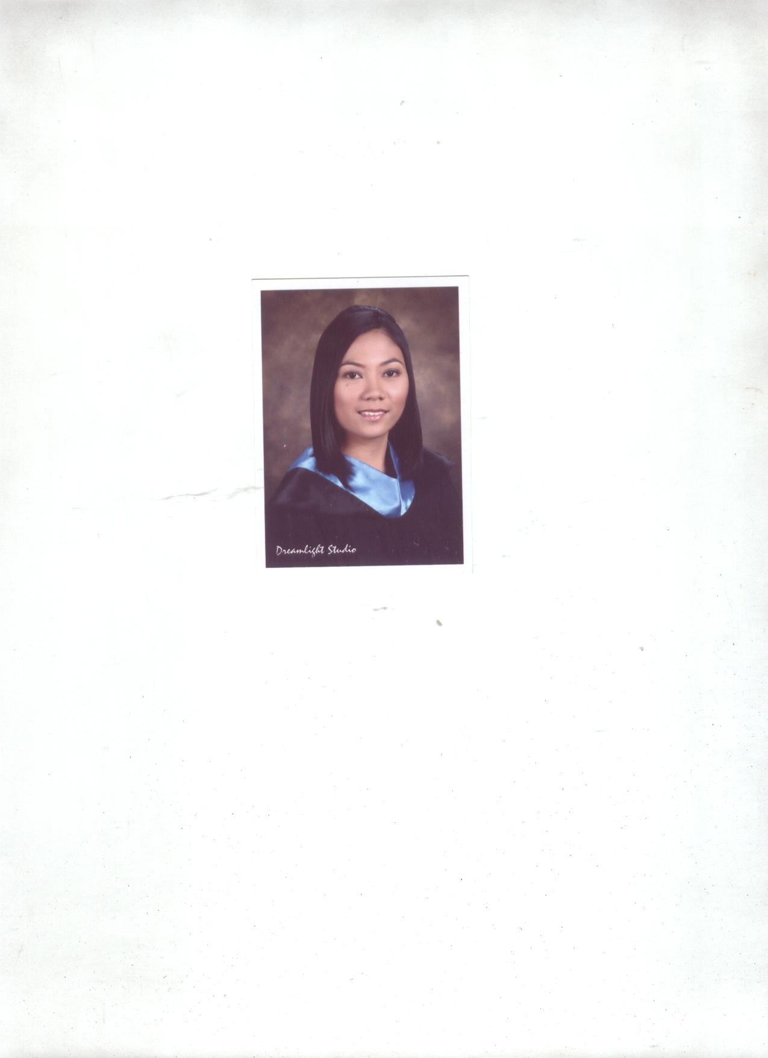
Blk 30 Lot 20 Kapisanan St. Karangalan Village, Pasig City
Cell no. 09295608683
Email: jakie_rowling@yahoo.com

Career Objectives

To continue to grow in leadership and knowledge in a challenging position in education, excel in innovative technology application and field of teaching, interact and share with team members and colleagues, develop world class solution to real world challenges.

Professional Qualification

Self-motivated, hardworking, fast learner, efficient, resourceful, responsible, can work independently with minimum supervision, honest and energetic as an English teacher.

Education
Bachelor of Elementary Education
English Concentrator

College 2004-2008 The National Teacher College
Quiapo, Manila

Secondary 1999-2003 Manaoag National High School
Manaoag, Pangasinan

Elementary 1993-1999 Cabanbanan Elementary School
Cabanbanan, Manaoag Pangasinan
Organizations:

English Club 2004-2008

Gawi Club 2004-2008

Rizalista Club 2004-2008
License
Licensure Examination for Teacher Board Passer, September 2008
Elementary Level
Field of Specialization: English

Seminars and Trainings

July 2010- Present Video and Online English Associate in Academy 21, Strata 2000 Ortigas
Center, Pasig City
June- May 2008-2010 Reading, Language, Science and Filipino teacher in elementary and high
school in Good Shepherd Montessori School, Malinao, Pasig City
May 31,2008 Experience English Teacher’s Seminar, Ateneo de Manila University Loyola Heights, Quezon City
November 21, 2008 PASAPRISA Seminar –Workshop on Teaching Strategies –Division Conference Hall, Division of Pasig City
February 11-13, 2009 PASAPRISA Seminar – Workshop of School Registrars, English, & Mathematics Coordinators, Division Conference Hall, Division of Pasig City
May 30,2009 Experience English Teacher’s Seminar, Ateneo de Manila University Loyola Heights, Quezon City
July 30, 31, August 11 and 12, 2009 District Young Writers’ Conference and Contest (Teacher Representative)
June-October 2007 Student Teacher in The National Teachers College Quiapo, Manila

November 2007 - February 2008 Student Teacher in Pinaglabanan San Juan

References

Ms. Mary Jean Calumno Pre- school Teacher, Good Shepherd Montessori School
Mobile Number: 09077819615
Mrs. Milagros M. Molina Professor in The National Teachers College
Mobile Number 09196252632
Mr. Ryan Lamson Teacher in The National Techers College
Mobile Number: 09289523337

I hereby declare that the above-mentioned information is correct up to my knowledge and bear the responsibility for the correctness of the above-mentioned particulars.

JACLYN E. SUYAT
Applicant

