Young-Min (Josh) Roh 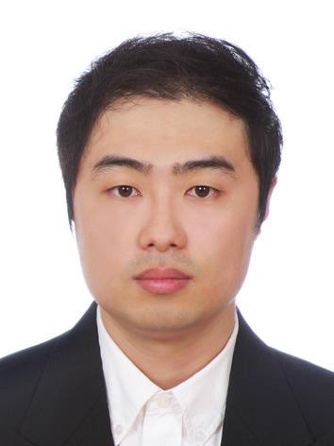
성남시 하대원동
중원구 110 번지
010-7671-8486
Dl_incognito@hotmail.com

Personal Details

Birth: South Korea
Citizenship: Canadian
Mother Tongue: Korean
Marital Status: Single
Health: Excellent

Education

2004 - Current: Bachelor of Arts Degree - Music
York University, Toronto, Canada

2011: TESOL Certification
Oxford Seminars, Ontario, Canada

WORK EXPERIENCE

August 2010 - January 2011 Wabora Japanese Korean restaurant

Kitchen Staff - Cook and Appetizer Prep

February 2009 – May 2010 Tim Horton’s Keele & Wilson

Cashier - Window

February 2008 – Octobert 2008 Tim Horton’s Keele & Lawrence

Cashier – Window, Driver through

September 2005 – May 2006 Dominion (now gone) Thornhill

Produce department – Working with vegetables, plants, fruits

November 2003 – March 2004 Galleria Supermarket Thornhill

Production department – Receiving delivery, Organizing sections, filling up, etc

December 2002 – October 2003 Mcdonald’s Hwy 7 & Leslie

Store Front – Making fries at busy time, cashier, receiving store delivery

September 2006 – Current

Tutoring English (ESL) as well as piano for young children

June 2007 – August 2007 Teaching English

Taught english from Elementary students to 1:1 adult English lessons at 이보영의 토킹클럽. Located at 구리.

VOLUNTEER

Currently serving in a church as choir pianist

Also in a University Club called AICCC (Christian Club) and serving as a praise team pianist

Been to native mission July 2000, August 2003, August 2006, and August 2008-11-27

Skills & Experience

Foreign Language: Japanese (Basic)
Travel: US, Europe
Interests: Soccer, Baseball, Music Production, Piano
Skills: Leadership, Adaption, Communication, Organization

REFERENCES

Available upon request

