RESUME
1. Applying job |  |  |  |  | 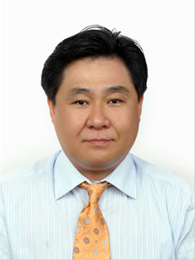Photo  3X4
Full time E.S.L Basic English Conversation & Private English Instructor
2. Personal Data
Full Name | David Kim | Phone | 02-907-3798
Birthday | 11/ 09 / 1965 | Mobile | 010 – 9947 - 4377
E-mail | djkor00@ yahoo.com | Fax
Address | Seoul city Dobon-gu SSang Mun 3 Dong 123-8
3. Education
Period | Name of school |  |  | Location | Degree
1976-1978 | Alexandria Ave. Elementary School |  |  | Los Angeles Calf. | Transpire
1978-1982 | NCL- U.S.C. Reading Center |  |  | Los Angeles Calf. | Graduate With Diploma
1982-1985 | Bel Mont High School |  |  | Los Angeles Cal. | Graduate With Diploma
1985 - 1987  2033 - 2007 | Los Angeles City College  Calvin Theological & Seiminary |  |  | Los Ageles Cal.  Yong San Seoul Korea | Drop  B.A in Theology
4. Experience
Period | Name | Details
2003-2005 | Private tutor | Private English Instructor & E.S.L. Basic English conversation
2005-2006 | Pick-up phone | Telephone English Conversation & Kinder Phonics & Basic English conversation, Text Books
2006-2007 | Yoon ‘s English Academy | 3rd grade Elementary Phonics & Basic English conversation
5. Skills
Computer | Just average computer Skill
 | Auto mechanic
 | Panting homes / Auto mobiles
Languages
6. Activities
I enjoy palying Golf and other Sports, I also enjoy R/C racing and using the Interment.
My greatest enjoy is that reading and Volunteering my time to doing missionary work.
7. Self Introduction

