 | Name | Min Kim |  |  |  |  | 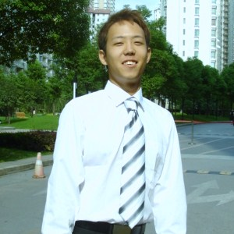
 | Birthdate | 1985. 07 . 19 |  | Gender | Male
 | Contact Number | 010-9655-2314
 | e-mail | Mkim013@ucr.edu
 | Address | 上海市 南丹东路 223弄 2号302
 | Educational  Background | School | Time |  |  | Major
 | Educational  Background | Cerritos High School | 1999-2003
 | Educational  Background | University of California, Riverside | 2003-2007 |  |  | Psychology
 | Experience | Institute | Time |  |  | Duty
 | Experience | Jung-Jin Academy | 2008.03-2008.06 |  |  | Middle and High school English instructor
 | Experience | Private tutor | 2004.7~2004.09
 | Experience |  | 2007.9~
 | The reason applying for this job | My name is Min Kim, a 1.5 generation from United States. I lived in the States for more than half of my life, and graduated from University of California, Riverside in 2007 as a psychology major. I’m bilingual but speak English more fluently. I’m currently studying Mandarin in Shanghai, and I’ll be moving to Korea on beginning of February. I have couple distinguished experience as an English instructor, which fits perfectly to the condition that’s offered in this position. First of all, I have taught many young students who attend international school. Their ages vary in between twelve to eighteen years old. Second experience was at a Korean private institute located in China called Jung-Jing Hakwon. I have taught Korean students in two different classes: middle school grammar, and high school reading comprehension. During the time I’ve taught in this institute, I’ve learned to cope with young students, different ways of teaching methods, and most importantly I’ve learned what students really need when studying English. Therefore, I strongly believe that this is a great opportunity to further my experience as an English instructor.

