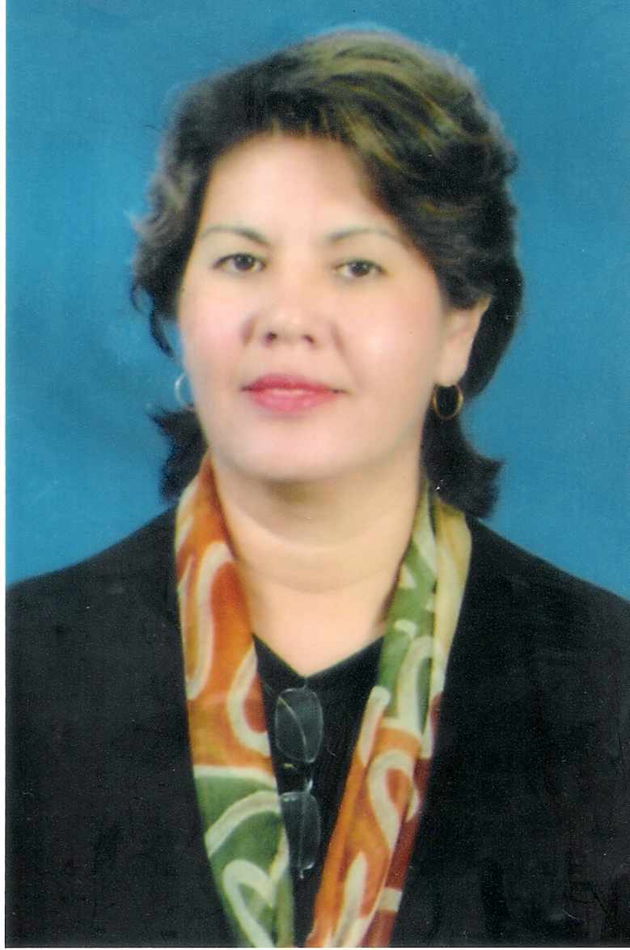
Bertha Lucia Smart
579-32, 302 ho
Songnae2-dong, Sosa-gu
Bucheon City,
Gyeonggi-do 422 820

Mobile: (010) 86 85 80 27
luciasmart333777@yahoo.co.uk

Profile

My teaching jobs have included working in two secondary schools, two technical colleges, one further education college, an education department in a corrective institution and a university, in a variety of locations. This has enabled me to broaden my outlook and challenged me to be a problem solver in a wide selection of environments. I consider myself to be a good team player, as well as having good interpersonal, administrative and communicative skills.

CAREER DEVELOPMENT

August 2008-present Korea International Christian School, Bucheon City, Gyeonggi-do. 382-3 Songnae-dong, Sosa-gu, Bucheon City. Tel. 032 668 2213-5.

Teacher Elementary and Secondary Departments. Subjects taught: English Writing and Grammar, Fundamentals of Math, Bible Truths at Elementary and Middle and High School

Sept. 2005 - May 2008 Suan Dusit Rajahbhat University, Hua Hin, Petchaburi, THAILAND
Teacher of English for Hotel 1, English for Hotel 2, English for Hotel 3, English for Hotel 4 and English for Tourism at the Faculty of Airline, Hotel and Tourism Studies. Post-18 students.
Reason for leaving: To take up a post in South Korea, along with my husband.

  - Premier Educational Services
Lowdham, Nottinghamshire, England. Head of the Education Department.( Reported to Les Bolam)

Teacher of Business, English for Speakers of Other Languages (ESOL), Spanish, Marketing at Lowdham, Nottinghamshire. Here I taught a wide variety of courses, among those Planning a Successful business, also English for Speakers of Other Languages, coaching the students for the Pitman exams (a British awarding body), Beginners, Intermediate, Upper Intermediate and Advanced level; also Spanish and a Marketing certificate course, certified by the Chartered Institute of Marketing in England.

Reason for leaving: Left for Thailand, along with family.

  - People’s College, Nottingham, England.

Teacher of Spanish. This is a further education college and I taught here on Saturdays. It was a holiday Spanish course for people who wanted to go on holidays to Spanish speaking countries. Reported to: John Scott, Head of Saturday classes.
1991– 1992 Sultan Saiful Rijal Technical College
Bandar Seri Begawan, Brunei, S. E. Asia.

Teacher of Communication in Business and Office Practice to Secretarial students. Teacher of International Trade to the students of the National Diploma in Business Studies. Reported to: Richard Waugh, Head of Dept. Business and Management. Number of students at college: approx. 500.

The college is the only technical college in the capital and at the time I was teaching it was center to British examination awarding bodies, such as British Technical Educational Council (BTEC), Royal Society of Arts (RSA), whose courses we were teaching at the Department of Business and Management, being visited by BTEC moderators from England. International Trade was a BTEC option that was introduced when I joined the department, as I have a first degree in International Business. I had the challenge of adapting the syllabus to the Brunei context, as well as motivating the students to broaden their perspective to an international outlook. I taught secretarial students, drawing from my wide experience in secretarial/administrative roles.
Reason for leaving: Family demands/ MBA focus.

1987-1988 The French School, Bahrain, Arabian Gulf.
Teacher of Spanish Language. Reported to: Headteacher.

Approx. Number of students : 100.
This school is a school where French expatriate students are taught the French curriculum. I taught the students of Secondary Years 4 and 5 (roughly equivalent to Years 10 and 11 in the British curriculum). The levels taught by me were Beginners and Intermediate.
Reason for leaving: To accompany husband to a new posting in Brunei.

- Institute of Foreign Trade and Marketing, Bogotá, Colombia.
Teacher of English/English for International Trade.

Reported directly to he owner/director of the Institute/College, Mr. Marco De la Rota. Approx. number of students: 100.

This is a private technical college, which majored in the areas of Marketing and Foreign Trade. I taught Basic English as a foreign language to students of 1st Year and English for International Trade in the second year. For this post I drew on my language skills as well as my background in International Trade.
Reason for leaving: To join husband in Singapore.

QUALIFICATIONS : EDUCATION AND TRAINING

Sept 2004-May 2005 Post-graduate Certificate of Education (PGCE) in Post Compulsory Education, Nottingham Trent University, Nottingham, England.

Sept 2002-Jan 2003 City & Guilds Teaching certificate in Further Education, Stage 2, People’s college, Nottingham, England.

Sept 2001- City & Guilds Teaching Certificate in Further Education,
Jan 2002 Stage 1. People’s College, Nottingham.

1994–1998 MBA, Master in Business Administration.
Heriot-Watt University, Edinburgh, Scotland.

1975-1979 BSc International Business. Universidad Jorge Tadeo
Lozano, Bogotá, Colombia.

- Secretarial Diploma, Pittsburgh Academy, Bogotá, Colombia.

1966– 1973 Secondary Education. Colegio Nuestra Senora del Rosario,
Bogotá, Colombia.

SEMINARS/OTHER TRAINING

1. ESOL (Core curriculum training – 2002-2003 ) Dept. of Education and Skills, England.
2. ESOL (English for Speakers of Other Languages) Skills for Life . 2004. . Presented by
City and Guilds, East Midlands Region, England.
3. .Cambridge ESOL Skills for Life certificates training. University of Cambridge, ESOL examinations. 2004.
4. Enabling Technology. Supporting Students with learning difficulties and disabilities in education and in life. National Institute of Adult Continuing Education (NIACE), 2004. Leicester, England.

PERSONAL

-Date of Birth : May 7, 1954.
-Marital Status: Married, to Neil Gordon Smart. One son.
-Nationality: British
-Languages: English, Spanish, and some French.
-Interests: Current affairs, reading, swimming.
-Volunteer experience : KACA, Institute for handicapped children, BSB, Brunei.

REFERENCES

- Dr. Robert Bell. Korea Nazarene University, Police Administration Dept. Visiting lecturer. Associate Pastor Mokmin Church, English Ministry. Email address: bobknu@ yahoo.com. Cell phone: 011 640 0281.

- Mr. Phil Galley. Lecturer Seoul Theological University. E-mail address: pgalley8308@yahoo.com. Cell phone: 010 8308 6269.

