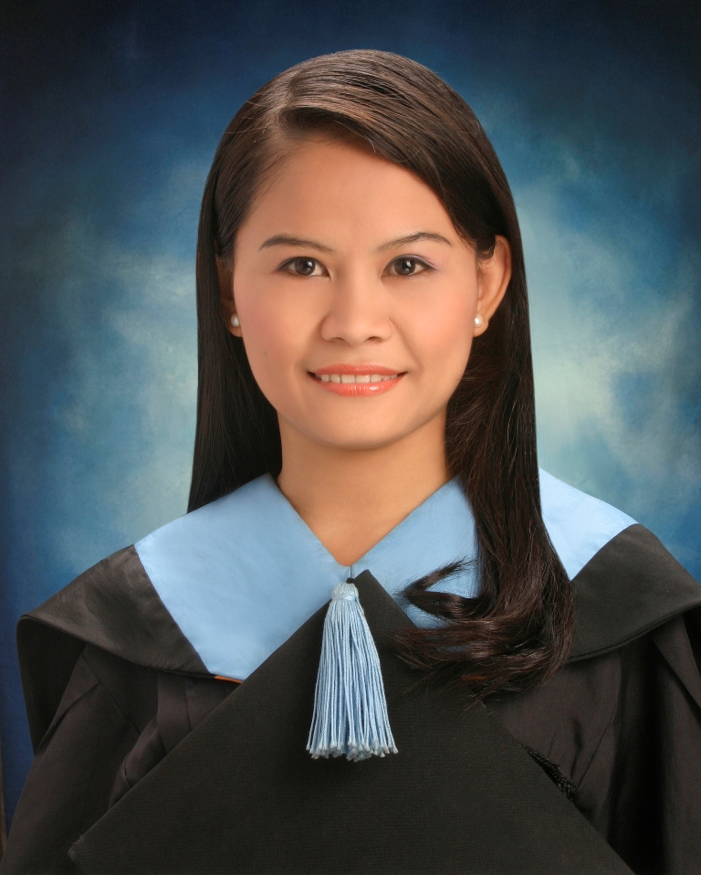

______________________________________________________________________

ANGELIE VERALLO SAWYER
A-904 Globee, Hanguk University of Foreign Studies 270 Imundong, Dongdaemungu, Seoul 130-791 Korea
+821055051157
gelie_2006@yahoo.com
______________________________________________________________________

Objective
To apply for a teaching position in a reputable language school using pedagogical skills, mastery of the subject content, teaching ethics and other requisites relevant to the optimum development of every second language teacher.

Profile
- Dynamic and result-oriented ESL teacher committed to inculcate a passion for learning, creating multicultural awareness through teaching the fundamentals of the English language.
- A trustworthy and approachable individual with excellent communication skills to cooperatively work with parents and faculty members to meet the needs of students and promote the philosophy and goals of the school.
- A strong talent to develop and implement creative, hands-on curricula that reaches every student and allows him / her to succeed and realize individual goals.

Education

Cebu Normal University, Cebu Philippines
Bachelor of Secondary Education, cum laude - major in English, 2009
Philippines Teacher’s Exam Board Passer

Seminars/ Trainings

- Participated in a two-day seminar on Living Values Education Program organized by the international organization the Advocates for Living Values Education (ALIVE) held at the Cebu Normal University Convention Hall dated June 19 and 20, 2008
- Participated as one of the usherettes in the 3rd National ICT’s in Basic Education Congress organized by DepEd and Intel held at Waterfront Cebu Lahug dated September 10-11, 2008
- Attended seminar on Personality Development organized by the Educator’s Club of Cebu Normal University at the Convention Hall dated December 8, 2008
- Attended a one-month Leadership Training Program of CNS E-lamp Cebu concluded November 28, 2009

Teaching Experience/ Exposure
- Handled 1st year to 4th year high school students as well as grade four and grade six elementary students of Cebu Normal University- Integrated Laboratory School
- Worked as a part-time ESL instructor of Korean children in Panagdait, Mabolo, Cebu City, Philippines.
- Worked full time for CNS E-lamp Cebu as an online ESL instructor of Korean children and adult students employed by LG and Samsung.

Skills

- Using MS applications (such as Word, Excel, Publisher and PowerPoint)
- Video editing using Windows Movie Maker
- Creative writing skills in fiction and non-fiction
- Impressive talent in acting, declaiming and dancing
- Making audio-visual applications for educational purposes

Awards/ Accomplishments

- 3rd Honorable Mention in Elementary
- Consistent Class Top 1 in High School
- Full paid ACG Scholar in High School
- Nominee for the Doña Modesta Gaisano Scholarship
- Consistent Academic Excellence Awardee or Dean’s Lister in College
- 3rd Prize Winner of the Dramatic- Duo Competition of ESOL Month 2008
- Class Secretary from 1st year to 2nd year college
- Class Vice- President in 3rd year
- Graduated Cum Laude in College
- Passed Licensure Examination for Teachers in Philippines

Organizations/ Affiliations

USJ-R Little Theatre’s Club, Member
CNU Educators Club, Member
CNU English Fellows Organization, Member
Cebu Normal University Alumni Association, Member
CNS E-lamp Cebu Management, Group Leader

Personal Interests

Reading, social networking, surfing the net, watching theatrical presentations and attending professional development seminars

Character References

Dr. Filomena T. Dayagbil
Dean, College of Teacher Education
Cebu Normal University
Cebu City, Philippines
+639176281068

Mrs. Monique E. Cordova
Student Teaching Mentor, ILS
Cebu Normal University
Cebu City, Philippines
+639178806577

Ms. Maria Eden V. Camocamo
English Instructor, ESOL
Cebu Normal University
Cebu City, Philippines
+639165135792

Ms. Sylvia Song
Korean Manager
CNS E-lamp Education, Inc.
Cebu City, Philippines
+639155004064

