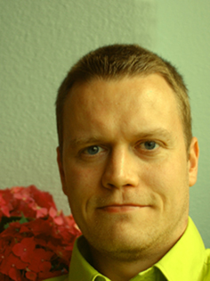
Karl Ómarsson
Yongsangu, Yongsandong2ga 31-6
Seoul, South Korea
Tel. 02 794 2591 mobile 010 3055 2591
spanolux@gmail.com

Education

2009
Tesol Certificate, Saint George International, Teacher of English to Speakers of Other Languages

2007-2008
M.A. Theory And Practice Of Transnational Art; University of the Arts London (www.transnational.org.uk)

2002-2005
B.A. Fine Art; Iceland Academy of the Arts (www.lhi.is)

2001-2002
The Rekjavik School of Art, foundation studies

Languages
English-Fluent
Icelandic-Fluent
Computer skills
IT, Outlook, Word, Excel, Power Point, Photoshop, Illustrator, Final Cut Pro, Concorde, Windows Workstation

Work experience

Period Job title Employer Reference

Currently English Teacher on request on request

2009-2010 Front of House Camden Art Centre Maxine Hodson
Assistant London +44(0)20 7472 5500

2006-2007 Artist assistant Rúrí Rúrí
(www.ruri.is) tel. +354 568 5506
ruri.art@centrum.is

2000-2006 Dispensing Actavis Helgi Guðmundsson
and blending (www.actavis.com) tel. +354 550 3300
Pharmaceuticals

