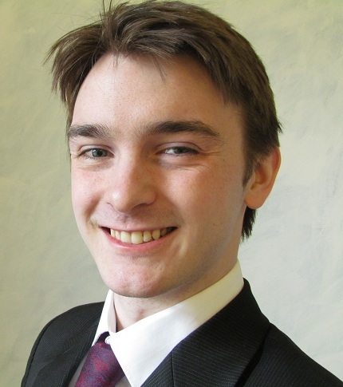
Stuart Watson

78 Constitution Street
Dundee
DD3 6JG
United Kingdom

Date of Birth: 21st of January, 1988
Phone Number: (+44) 07969 465943
Email: swatso48@caledonian.ac.uk
Skype ID : Skipperoo_

Personal Profile____________________________________________

An experienced, passionate and hard-working teacher. Extremely professional and dependable with a friendly attitude and good interpersonal skills. Has been commended on his ability to create a positive, fun and effective learning environment by both students and fellow teachers.
Confident and enthusiastic when working independently or as part of a team. A friendly and respectful communicator with a willingness to learn new skills. Very much enjoys living in Korea and learning more about its culture, history, language and people.

Professional Experience______________________________________

2011-2012 EDI Park Jeong English
English Language Teacher Changwon City

- Taught English to students from a wide range of ages and ability levels, with a focus on developing writing, conversation and debate skills.
- Experienced in preparing students for The Test of English Proficiency (TEPS) and the Test of English as a Foreign Language (TOEFL)
- Responsible for creating an effective curriculum to suit the needs and abilities of students.
- Took an active role in meetings and initiatives to develop the services and reputation of the school.
- Trained and assisted new teachers in meeting the expectations of both customers and management.
- Responsible for creating, envigilating and grading examinations.
- Organising and participating in extra-curricular events such as speech contests and interview preparation programs.
- Coordinating and working as part of a team of teachers to provide an efficient, effective and enjoyable education.

Education________________________________________________

- TEFL Scotland
100 Hour Accredited TEFL/TESOL Course

2006 - 2010 Glasgow and Glasgow Caledonian University
Bachelor of Science in Psychology – Upper Second Class Honours.

Personal Details___________________________________________

Nationality: British
Languages: English (Native), French (Beginner), Korean (Beginner)
Interests: Rock climbing, golf, hiking, musical instruments, foreign cultures.

