LaTasha Simms
953-4 Yangchun-gu Sinjeong 4 Dong
Do Yang Labien Officetal 306 Ho
158-859 Seoul, South Korea

Greetings,

My name is LaTasha Simms and I am interested in becoming part of this English camp. I have 2 years experience teaching experience in Korea. That includes teaching adult courses. I have a bachelors degree in Business Administration and I am TESOL certified. I will be attending Yonsei University Graduate School of International Studies this fall.

Thanking you in advance for your consideration

LaTasha Simms

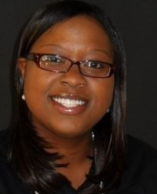

953-4 Yanchun-gu Sinjeong 4 Dong Do yang Labien Officetal  158-859  Seoul, South Korea | Phone 010-7713-9940  E-mail latashasimms@gmail.com
LaTasha Simms
Objective | To obtain part time employment.
Employment | 09/2006- 05/2008 Central State University Wilberforce, OH  Office Assistant/ Data Entry  08/2008- present Kangseo Elementary School Seoul, South Korea  English Teacher  Fall Semester 2009 Kyongin Elementary School Seoul, South Korea  After school program English Teacher  Fall Semester 2009 Galson Elementary School Seoul, South Korea  English Teacher Instructor
Education | 09/99- 06/2002 John F. Kennedy High School Cleveland, OH  High School Diploma  09/2008- 5/2008 Central State University Wilberforce, OH  Bachelors Degree Business Administration
Memberships  References | US Embassy Tutoring Team  May - present  National Society of Minorities in Hospitality Central State University Chapter  President 2006-2008  Lee Hyun Mi  Kangseo Elementary School  010-4355-3629

