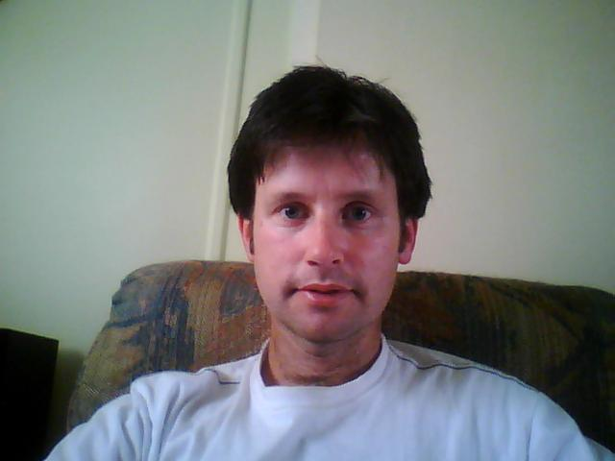
Christopher Wright
70 Ingram Road Nar Nar Goon VIC 3812
Phone: 0412983188
Email: cwright_EM@telstra.com

PROFESSIONAL QUALIFICATIONS
TESOL Certificate 2008
Global TESOL College
Masters of Biomedical Engineering (Distinction) 2001
Swinburne University of Technology, Victoria
Bachelor of Engineering – Electrical and Computer Systems 1991
Monash University, Clayton Campus

KEY SKILLS AND COMPETENCIES
- Achieved Masters of Biomedical Engineering and Bachelor of Engineering qualifications
- Experienced at tutoring maths, chemistry and physics to students up to year 12
- Managed small classes of students, and presented teaching material
- Taught English to elementary school students in South Korea for 9 months
- Prepared tests and worksheets for ESL students
- Followed daily lesson plans and delivered material to students
CAREER HISTORY AND ACHIEVEMENTS
SONOPRESS January 2008 – December 2008
Mastering Operator
SMARTS HOME TUTORING March 2007 – November 2007
Tutor
GnB ENGLISH ACADEMY - Ansan South Korea April 2006 - December 2006 ESL Teacher
HOME TUTORING SERVICES February 2006 - April 2006
Tutor
WRESACARE March 2005 – July 2005
Carer
HARBOR CONSTRUCTION August 2004 - December 2004
Construction Worker
THE NUNNERY, Fitzroy
Room Attendant Oct 2003 - Mar 2004
WORKFORCE EXTENSIONS, Cranbourne
Nursery Hand Aug 2003 - Oct 2003
KELLY SERVICES
Contract Assignments Jul 1999 – Sep 2002
Worked on a variety of assignments throughout the manufacturing industry
SWINBURNE UNIVERSITY OF TECHNOLOGY
Laboratory Demonstrator (2 year contract) Feb 1997 - Feb 1999
Responsibilities included:
Wrote software programs, utilising Delphi, for electrical brain activity signal processing as part of the University’s research project into irregular brainwave activity.
Performed demonstrations to students of various medical devices including:
- Ultrasound | - X-Ray Equipment
- Audiology Equipment | - Evoked Potential Equipment
- EEG Equipment | - ECG Equipment

REFERENCES FURNISHED UPON REQUEST

