Tiffany Ahn
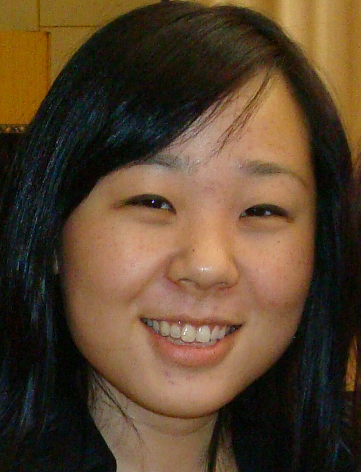 |  | Cellular Phone: 010 5130 1404  Email: Haeshin86@yahoo.com
Experience
2005-2006 | TECC Education Center: Arcadia, CA  Assistant Teacher  - Instructed a class of primary school students grade K-5  - Assigned daily homework  - Aided students in subjects of English and History
Summer 2006 | Seoul, Korea  English Tutor  - Private tutored elementary and college students in English conversation, and reading skills  - Assigned daily homework  - Planned daily lesson plans for elementary and college students
Fall 2007  Summer 2008  Winter 2009 | Seoul, Korea  English Tutor  - Private tutored college students in English conversation and reading skills  Wonju, Korea  Neungyule Global English Camp Instructor (능률교육 영어 캠프 강사)  - Instructed Kindergarten and Elementary school children during a two week English Camp in English reading, writing, comprehension, and grammar  Goyang, Korea  Hyundai English Camp Instructor  - Instructed Middle school children during a three week English Camp in English reading, writing, and comprehension
Education
2004-2008  Fall 2007 | Cal State University Long Beach – Long Beach, CA  B.A History  Yonsei University – Seoul, Korea  International Exchange Student
Interests
and Skills
- Fluent in Korean with a conversational command of Japanese and Spanish
- Native English speaker
- Passionate about travel, reading, and teaching

