Tim Sidlik
Birthday: 04/04/1980
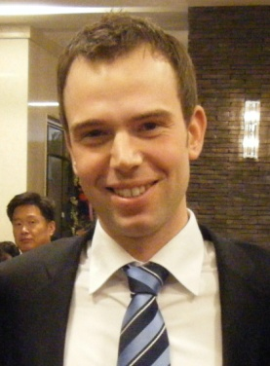
Nationality: American Visa: F-2
Gunpo, Korea
Phone: 010-3947-0403
timsidlik@gmail.com

QUALIFICATIONS

- Over 4 years experience teaching children and adults in Korea.
- Over 3 years of business English experience, along with business experience working at a large US bank.
- Extensive experience living in Korea and learning about Korean culture and education structure.
- Knowledgeable of ESL teaching techniques, grading methods and preparing materials, as well as, experience creating a fun and educational atmosphere for adults and children.
- A strong educational background; including courses in English, accounting, finance, economics, computer applications, and mathematics, eagerness to learn and take on responsibilities, and a range of work experience in Korea makes me well qualified for any position.
- Strong interpersonal and communication skills.
- View teaching and learning as a dynamic and interactive session.

EDUCATION

2009-Present Diploma in TESOL (500 hour course, completion anticipated in 2010)
Coursework to date: Teaching phonics, general teaching strategies, linguistics, grammar and methods and materials for the ESL classroom

1998-2002 B.A. Business Economics, Minor Political Science
University of New Hampshire.
Cum Laude Honors Graduate

EXPERIENCE

Adult and Business English - 1-08 to present
Seoul National University Hospital and Korea National Oil Corporation
- One-on-One and small group teaching, including business and academic writing classes. Responsible for developing course work, both written and conversation materials.
- Taught business English classes at a large university hospital, an adult academy specializing in business conversation and at the Korean National Oil Corporation.
- Taught one on one classes to university students specializing in GRE writing, OPIC exams, interview skills and business presentation and communication skills.
Children’s ESL - 10-07 to present
Suwon, Ansan and Gunpo Public Schools
- English Conversation Teacher; Gunpo, Anyang, Suwon and Ansan Public Elementary School.
- Taught an independent mother’s and teacher’s class program for adults
- Responsible to teaching and developing curriculum for elementary school children and parents.
Kindergarten - 05-06 to 08-07
Hope School Bucheon
- Employed as an English teacher for kindergarten and elementary school students. Responsible for teaching conversation classes, preparing appropriate activity materials, writing tests, grading oral and written exams and participating in other school activities.
Citizens Bank - 5/03-08/04
Banker
- Responsible for opening new accounts, originating personal and small business loans, identifying personal investment needs, and general banking duties.

