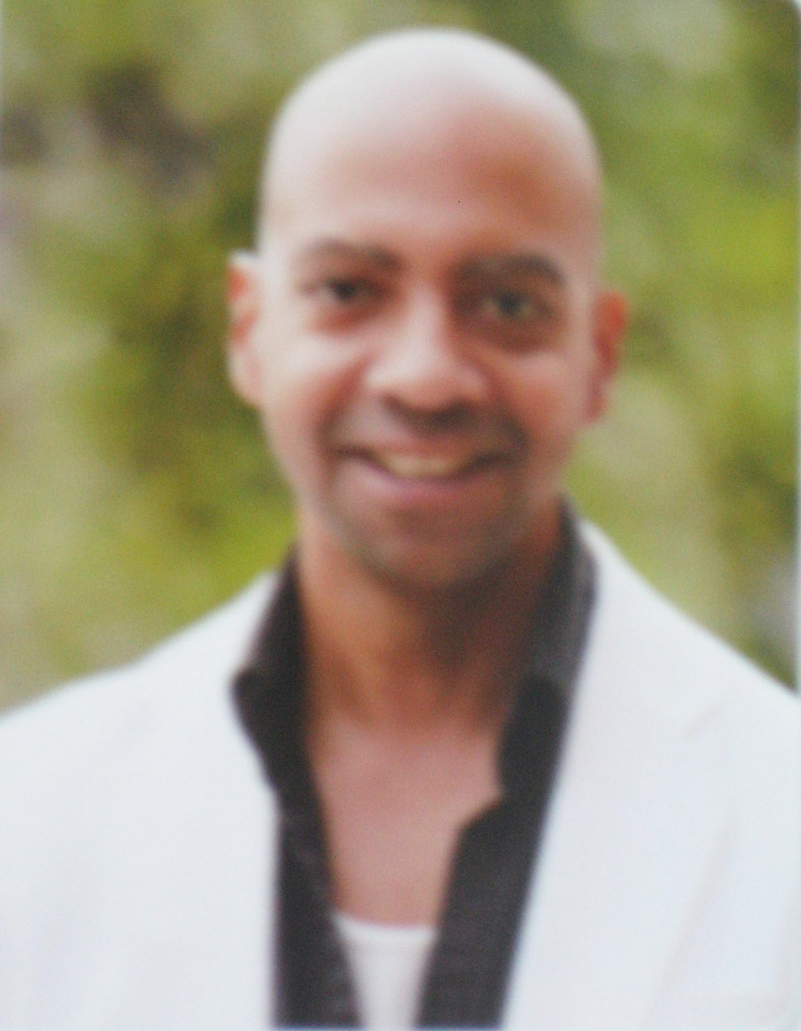
Todd Moyer
5020 Stone hill Drive Raleigh, NC. 27609 USA
.
Ph. (919) 789-4653 sterlingreps@yahoo.com
Cell (919) 986-0220

EDUCATION:
8/06-12/08 Cleveland State University, Cleveland, OH
Bachelor of Arts, Social Science
8/03- 6/06 Edinboro University, Edinboro PA. Elementary/ Special
Education (70 education credit hrs.)
9/79- 6/83 Central High School, Erie, PA

9/72- 6/79 Saint Patrick’s Elementary School, Erie, PA

EMPLOYMENT:

08/18/09- 08/26/10 Seoul Metropolitan Office of Education SMOE NSET,
Seoul, South Korea,Sinmun-no-2-ga, Jongno-gu 110-781 Tel: 02-3999-002(003 fax) International: 82-2-3999-002(003 fax)

Jang Chung Middle School 432-460, Sindang 2(i)-dong, Jung-gu, Seoul, Korea (02) 2233-9990
English ESL teacher/ Native speaker, lesson planning, tutor, summer/ winter camps.

7/08- 08/09 Torcasso Brothers 6504 Hammersmith Dr, Raleigh, NC 27613. 919-961-4713
General labor, construction and remodeling, carpentry, tile, flooring.

08/03- 6/08 Full time student, Summer and semester break employment
Satellite TV installations, General contracting, summer literacy/ tutor programs and craft shows.

9/93- 12/02 Waros Glass 2318 Glendale Ter, Alexandria, VA 22303 703-329-0604

Chief Glass Artist, Stained, Etched and Carved Glass design, fabrication and restoration. Commercial, residential and liturgical. Glass painting, enameling, mosaic and faceted glass specialty.

Teaching Experience:

08/09-08/26/2010 Seoul Metropolitan Office of Education (SMOE); Seoul, South Korea

JangChung Middle School 432-460, Sindang 2(i)-dong, Jung-gu, Seoul, Korea

English ESL teacher/ Native speaker, English teacher in a public Middle school.

Teaching thirty students per lesson, per forty five-minute class period. Preparing lesson materials

to fit the Korean National curriculum.

Before and after school tutor (8 hours/ week) School summer and winter English camps (60 hours)

09/2006 - 05/2007 Cleveland City Library Cleveland Ohio USA

Volunteer After School Tutor Reading / Language arts

AGE 10-15 25 hr/ week

03/13/2006 - 03/17/2006 Joanna Connell Elementary School Erie PA. USA

English/ Language Arts

AGE 9-10 6 hr

09/2005 - 03/2006 Bethesda Community Center Erie, PA. USA

Volunteer after school program Homework, English, math, and social studies

AGE 10-15 20 hr/ week

SKILLS:
Excellent interpersonal, written and verbal communication and organizational skills.

70 Elementary/ Middle and Special Education credit hrs.

Strong Communication, Political Science, Psychology, Sociology, Philosophy and Natural Science coursework.

Magna Cum Laud, Deans List, Academic Success Scholarship.

Competitor and coach for Model United Nations and mock trials competitions, debate team,

advocacy debate and policy debate.

Hi-Q, Forensics, Prepared Oratory, Improvisation and Extemporaneous speaking.

Knowledgeable in MS Word, PowerPoint, Excel, Adobe, HTML, Java.

References:

Kirk Brodows: Teacher Daegu International School Esiapolis, Bongmu-dong, Dong-gu, Daegu, Korea 010-5595-2172
School: (82-53) 985-1212 Fax: (82-53)985-1213

Erin Kelly: Teacher JoAnna Connell Elementary school 1820 E. 38th Street, Erie, PA 16510
(814) 453-4874
School: 814-874-6785 Fax: 814-874-6789

Rachel Lee (Seung-ah Lee) SMOE NSET Coordinator, Seoul, South Korea,Sinmun-no-2-ga, Jongno-gu 110-781 Tel: 02-3999-002(003 fax) International: 82-2-3999-002(003 fax)

Jang Chung Middle School 432-460, Sindang 2(i)-dong, Jung-gu, Seoul, Korea (02) 2233-9990

Lee Jong Dei English Co-teacher leejon77@naver.com (02) 2233-9990, Cell: (010) 2228-4418

Kee Sei Chan기세찬, Vice-principle kseichan@hanmail.net (02) 2233-9990, Cell: 016-243-4703

Kim So Youn English Co-teacher lemois@naver.com (02) 2233-9990, Cell: 071-705-4005
Administrative translator/ contact person.

