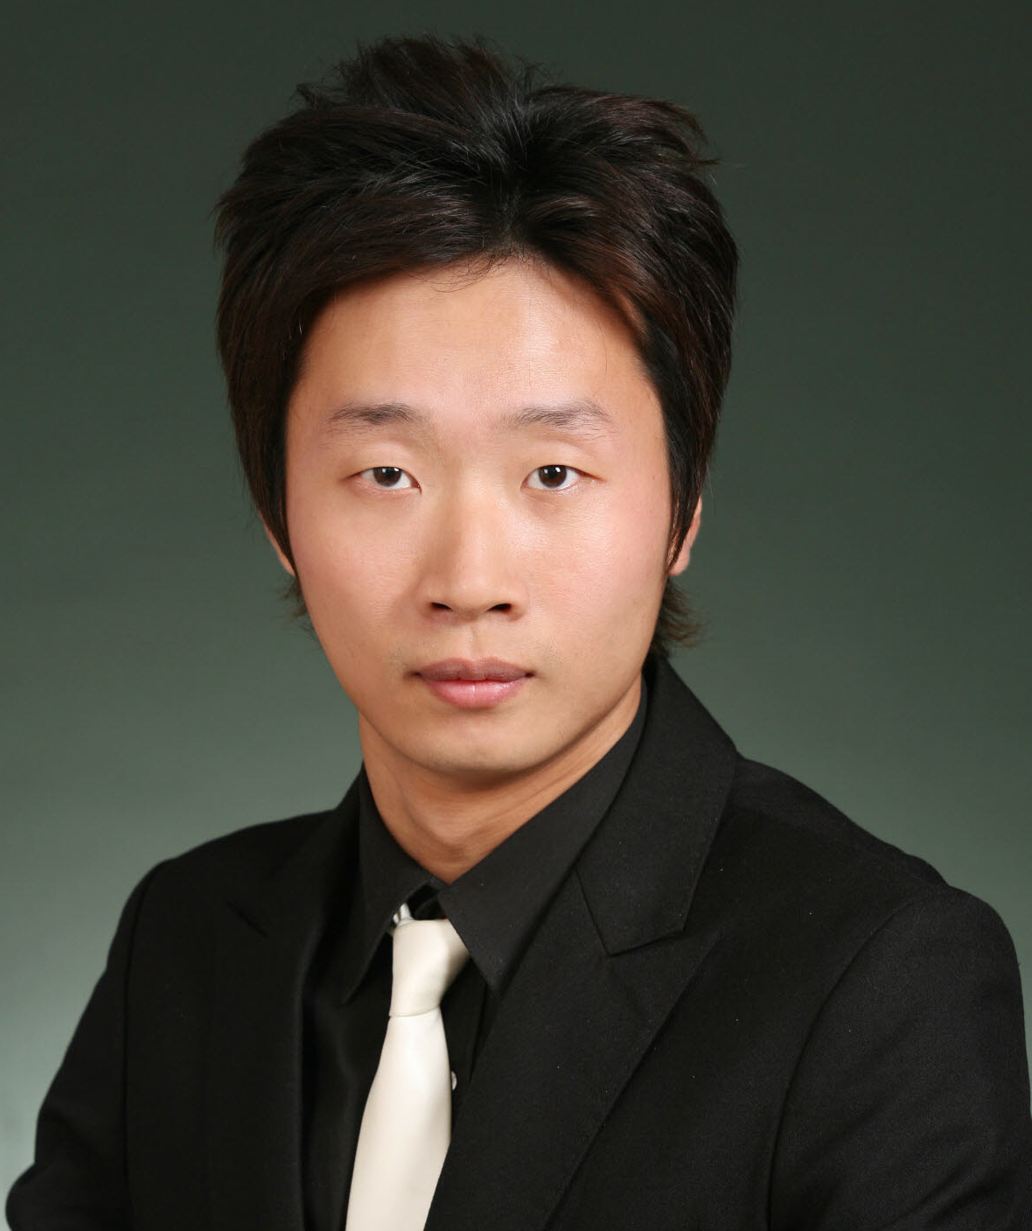
Yong Han (Clark) Lee
Nationality Korean
Date of Birth December 6, 1981
Email occupati@hotmail.com
Address Gyeonggi Province, Suwon City, Jangan-gu, Yeonmu-dong,
Sungwon Apartment #905
Cell phone 010-7389-4347

Highlight of Qualifications

- Canadian TESOL certified
- Bilingual (Korean/English) speaker with 8 years of overseas education in Canada
- 4 years of EFL teaching experience to all levels and ages (children and adults)
- Talented, supportive, creative, & patient teacher
- Enjoy working in environments where new tasks and responsibilities are presented

Related Experience

- Manhattan English Institute Seoul, Korea
Instructor/Tutor 2007-Present
- Teach Adult Conversation, Business Communication, TOEIC, Interview English,
& Writing to intermediate level students and above

- KOTRA Seoul, Korea
International Interpreter& Translator 2006-2008
- Interpreted & translated for a variety of International buyers at COEX & KINTEX

- Minjok Sakwan Institute Pyeongchon, Korea
EFL Instructor 2006-2007
- Prepared Korean middle and high school students for the National Entrance exam
(taught all language skills & systems)
- Responsible for all lesson preparation, choice of materials, and creation, and grading of tests
& assignments

- Chomsky International English Institute Pyeongchon, Korea
EFL Instructor 2005-2006
- Taught Listening & Grammar to elementary, middle, & high school students
- Responsible for all lesson preparation, choice of materials, and creation, and grading of tests
and assignments

Education

- Bachelor of Arts – Tourism & Hotel Restaurant Management
Korea National Open University 2008

- TESOL Certificate
King George International College 2007

